|  |  |  |  |  |  |
| --- | --- | --- | --- | --- | --- |
| **Course code** | **Course Title** | **No. of Periods/Weeks** | **Total No. of periods** | **Marks for**  **FA** | **Marks for SA** |
| CM-105 | **Basics Of**  **Computer**  **Engineering** | 3 | 90 | 20 | 80 |

|  |  |  |  |
| --- | --- | --- | --- |
| **S. No.** | **Chapter/Unit Title** | **No. of Periods** | **CO’s Mapped** |
| 1. | Fundamentals of Computers | 15 | CO1,CO3,CO4 |
| 2. | Programming Methodology | 10 | CO2 |
| 3. | Operating System basics | 20 | CO1,CO3 |
| 4. | Computer Hardware and Networking  Basics | 25 | CO1,CO4,CO5 |
| 5. | Emerging Trends in Computer  Technologies | 20 | CO2,CO6 |
| **Total Periods** | | 90 |  |

|  |  |
| --- | --- |
| **Course Objectives** | Upon completion of the course the student shall be able to |
| i) know the fundamentals of Computers  ii)familiarize programming methodologies like algorithms and  flowcharts  iii) understand Operating system basics  iv) familiarize Emerging Technologies |

|  |  |  |  |
| --- | --- | --- | --- |
| **Course**  **Outcomes** | Upon completion of the course the student shall be able to | | |
| CO1 | CM-105.1 | Explain computer fundamentals |
| CO2 | CM-105.2 | Explain various flowchart, algorithm methods |
| CO3 | CM-105.3 | Explain the importance of Basic Computer operating  systems |
| CO4 | CM-105.4 | Analyze functioning of various Hardware components |
| CO5 | CM-105.5 | Explain Networking process in computers |
| CO6 | CM-105.6 | Explain basics of emerging technologies in the world |

**Learning Outcomes:**

**1.0 Fundamentals of Digital Computer**

1.1. Define various terms related to computers – Computer, Hardware , Software, Firmware,

High Level Language , Low Level Language

1.2. Draw and explain block diagram of a Computer in detail

1.3. Describe the current family of CPUs used in Computers.

1.4. State the use of storage devices used in a Computer.

1.5. List the two types of memory used in a Computer.

1.6. State the importance of cache memory.

1.7. Explain the generations of computers.

1.8. Classification of computers - based on a) size, b) processor.

1.9. State the importance of binary number system for use in Digital Computers

**2.0 Implement Programming Methodology**.

2.1. State the different steps involved in problem solving.

2.2. Define algorithm.

2.3. List four characteristics of algorithm.

2.4. Define a program

2.5. Differentiate between program and algorithm.

2.6. State the steps involved in algorithm development.

2.7. Differentiate between algorithm and flowchart.

2.8. Develop algorithms for simple problems.

2.9. Draw the symbols used in flowcharts.

2.10. Draw flowcharts for simple problems.

**3.0 Operating Systems basics**

3.1. Describe the need for an operating system.

3.2. List the various operating systems used presently.

3.3. List and explain

3.3.1. Types of dos commands

3.3.2. Any 10 Internal Commands

3.3.3. Any 5 External Commands

3.3.4. Features of Windows desktop.

3.3.5. Components of a Window.

3.4. State the function of each component of a Window.

3.5. Describe the Method of starting a program using start button

3.6. Explain usage of maximize, minimize, restore down and close buttons.

3.7. State the meaning of a file ,folder.

3.8. Describe the Method of viewing the contents of hard disk drive using Explorer

3.9. Describe the Method of finding a file using search option.

3.10. Use control panel for

3.10.1. installing and uninstalling software

3.10.2. installing and uninstalling hardware

3.10.3. Changing the system date and time

3.10.4. Installing a printer

3.11. Explain Drive space using system tool option of Accessories group

3.12. Explain Disk defragmentation using System tools

3.13. Explain the procedure for changing resolution, color, appearance, screensaver options of

the display

**4.0 Computer Hardware and Networking Basics**

4.1 Hardware Basics

4.1.1 Identify hardware used for I/P, O/P & inside computer case, system board

components used for communication among devices

4.1.2 Software - 3 types of Software: ROM BIOS, OS, application software

4.1.3 Explain Functions of BIOS

4.1.4 Explain boot process

4.1.5 Explain POST and important beep codes

4.1.6 Describe about different connectors.

4.2 Networking Basics

4.1.1. Explain meaning of a computer network.

4.1.2. Describe the concept of a Local Area Network, Wide Area Network

4.1.3. Compare Internet and Intranet

4.1.4. Describe about internet service provider.

4.1.5. Explain the role of a modem in accessing the Internet.

4.1.6. Describe address format and IP address

4.1.7. What is browser and List various browsers

4.1.8. Explain the role of search engines with examples.

4.1.9. Explain Internet Security.

**5.0 Emerging Trends in Computer Technology**

5.1. Introduction to Machine Learning

5.1.1. Define Machine Learning, Compare Traditional Programming with Machine Learning

5.1.2. List the applications and key elements of Machine Learning

5.1.3. Define the terms in relation to approaches to Machine Learning(Decision tree learning,

Association rule learning, Artificial neural networks, Deep Learning, Inductive Learning,

Genetic algorithms, Clustering)

5.1.4. Explain Inductive Learning

5.1.5. Classify the Machine Learning

5.2. Introduction to Big data

5.2.1. Define and list sources of Big data

5.2.2. Evolution of data/big data

5.2.3. List and explain the characteristics of big data – the three V‘s of big data

5.2.4. Describe Storing and selecting of Big Data

5.2.5. State the Need of Big Data

5.2.6. List types of tools used in Big Data

5.2.7. List applications of big data

5.3. Basics of Ethical Hacking

5.3.1. Define Ethical Hacking and List the categories of Hackers

5.3.2. Describe Roles and responsibilities of Ethical Hackers

5.3.3. List and explain the phases in Ethical Hacking and Explain Penetrate testing

5.4. Virtual Reality concepts

5.4.1. Define the terms Virtual Reality, Tele presence, Cyberspace, Tel existence, HCI (Human-

Computer Interaction), Haptics, Haptics technologies, augmented reality and mixed

reality

5.4.2. Discuss the evolution of Virtual Reality

**1.0 Fundamentals of Digital Computer:**

**1.1 Define various terms related to computers:**

**Computer:**

A computer is a programmable electronic device that accepts raw data as input and processes it with a set of instructions (a program) to produce the result as output. It renders output just after performing mathematical and logical operations and can save the output for future use. It can process numerical as well as non-numerical calculations. The term "computer" is derived from the Latin word "computare" which means to calculate.

A computer is designed to execute applications and provides a variety of solutions through integrated hardware and software components. It works with the help of programs and represents the decimal numbers through a string of binary digits. It also has a memory that stores the data, programs, and result of processing. The components of a computer such as machinery that includes wires, transistors, circuits, hard disk are called hardware. Whereas, the programs and data are called software.

It is believed that the Analytical Engine was the first computer which was invented by Charles Babbage in 1837. It used punch cards as read-only memory. Charles Babbage is also known as the father of the computer.

**Hardware :**

Hardware refers to the physical components of a computer. Computer Hardware is any part of the computer that we can touch these parts. These are the primary electronic devices used to build up the computer. Examples of hardware in a computer are the Processor, Memory Devices, Monitor, Printer, Keyboard, Mouse, and the Central Processing Unit.

**Computer Software:**

Software is a collection of instructions, procedures, and documentation that performs different tasks on a computer system. we can say also Computer Software is a programming code executed on a computer processor. The code can be machine-level code or the code written for an operating system. Examples of software are Ms Word, Excel, PowerPoint, Google Chrome, Photoshop, MySQL, etc.

|  |  |  |  |
| --- | --- | --- | --- |
| **S. No.** | **Parameters** | **Hardware** | **Software** |
|  | **Basic Definition** | Hardware is a physical part of the computer that causes the processing of data. | Software is a set of instructions that tells a computer exactly what to do. |
|  | **Development** | It is manufactured. | It is developed and engineered. |
|  | **Tangible** | Hardware is tangible as hardware is a physical electronic device, that can be touched. | Software is intangible as we can see and also use the software but can’t touch them. |
|  | **Durability** | Hardware typically wears out over time. | The software does not wear out with time. However, it may contain flaws and glitches. |
|  | **Types** | It has **four** main categories: input devices, output devices, storage, and internal components. | It is mainly divided into System software and Application software. |
|  | **Machine-Level language** | Only machine-level language is known to be understood by hardware. | The program accepts human-readable input, interprets it in machine-level language, and sends it to hardware for additional processing. |
|  | **Replacement** | If hardware is damaged, it is replaced with a new one. | If the software is damaged, its backup copy can be reinstalled. |
|  | **Failures** | Dust, overheating, dust, and other factors are commonly responsible for hardware failures. | Overloading, systematic error, major-minor version error, and other factors are commonly responsible for software failures. |
|  | **Examples** | Ex: Keyboard, Mouse, Monitor, Printer, CPU, Hard disk, RAM, ROM, etc. | Ex: MS Word, Excel, PowerPoint, Photoshop, MySQL, etc. |

**Firmware:**

Firmware is a software program on the hardware device, which perform functions like basic input/output tasks and offers necessary instructions for the device to communicate with other computing devices. It is a set of instructions programmed that is permanently etched into a hardware device like video cards, BIOS, keyboards, or hard drives. Without using special programs, it cannot be modifying or deleted by an end-user, unlike normal software. And it remains on that device whether it is on or off. But firmware is typically stored in the flash ROM, which is actually a kind of flash memory and allows users to erase and rewrite information.

Generally, it was designed for high-level software and can be considered as "semi-permanent" because it remains the same unless it is not updated. In order to work with a new operating system, you need to update the firmware of certain devices like video cards and hard drives. CD and DVD drive manufacturers for making the drives powerful to read faster media often make firmware updates available for users. Sometimes manufacturers release firmware updates, which help to make the system more powerful and capable of working speedily. Firmware manufacturer's website contains firmware updates; you can find them with the help of going to the "Support" or "Downloads" options of the website.

**High level language and low level language:**

Both High level language and low level language are the [programming languages types](https://www.geeksforgeeks.org/introduction-to-programming-languages/).

The main difference between high level language and low level language is that, Programmers can easily understand or interpret or compile the high level language in comparison of machine. On the other hand, Machine can easily understand the low level language in comparison of human beings.

Examples of high level languages are [C](https://www.geeksforgeeks.org/c/), [C++](https://www.geeksforgeeks.org/c-plus-plus/), [Java](https://www.geeksforgeeks.org/java/), [Python](https://www.geeksforgeeks.org/python-programming-language/), etc.

Let’s see the difference between high level and low level languages:

|  |  |  |
| --- | --- | --- |
| S.NO | High Level Language | Low Level Language |
| 1. | It is programmer friendly language. | It is a machine friendly language. |
| 2. | High level language is less memory efficient. | Low level language is high memory efficient. |
| 3. | It is easy to understand. | It is tough to understand. |
| 4. | It is simple to debug. | It is complex to debug comparatively. |
| 5. | It is simple to maintain. | It is complex to maintain comparatively. |
| 6. | It is portable. | It is non-portable. |
| 7. | It can run on any platform. | It is machine-dependent. |
| 8. | It needs compiler or interpreter for translation. | It needs assembler for translation. |
| 9. | It is used widely for programming. | It is not commonly used now-a-days in programming. |

**1.2 Draw and explain block diagram of a Computer in detail**

**Computer Block Diagram System**: Mainly computer system consists of three parts, that are central processing unit (CPU), [Input Devices](https://www.tutorialandexample.com/input-devices-of-computer/), and [Output Devices](https://www.tutorialandexample.com/output-devices-of-computer/). The Central Processing Unit (CPU) is divided into two parts again: arithmetic logic unit (ALU) and the control unit (CU). The set of instruction is in the form of raw data.

A large amount of data is stored in the computer memory with the help of primary and secondary storage devices. The CPU is like the heart/brain of the computer. The user does not get the desired output, without the necessary option taken by the CPU.  The Central processing unit (CPU) is responsible for the processing of all the instructions which are given by the user to the computer system.

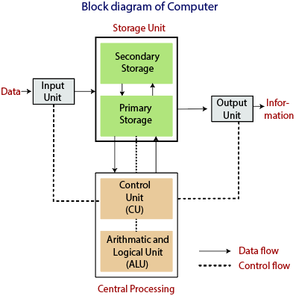

The data is entered through input devices such as the keyboard, mouse, etc. This set of instruction is processed by the CPU after getting the input by the user, and then the computer system produces the output. The computer can show the output with the help of output devices to the user, such as  monitor, printer, etc.

* CPU (Central Processing Unit)
* Storage Unit
* ALU(Arithmetic Logic Unit)
* Control Unit

**Central Processing Unit (CPU)**

The computer system is nothing without the [Central processing Unit](https://en.wikipedia.org/wiki/Central_processing_unit) so, it is also known as the brain or heat of computer. The CPU is an electronic hardware device which can perform different types of operations such as arithmetic and logical operation.

The CPU contains two parts: the arithmetic logic unit and control unit. We have discussed briefly the arithmetic unit, logical unit, and control unit which are given below:

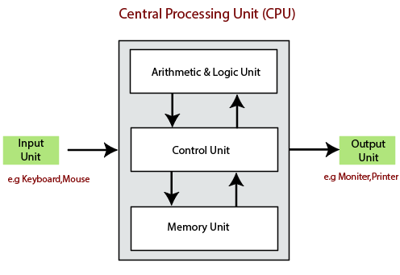

**Control Unit**

The control unit (CU) controls all the activities or operations which are performed inside the computer system. It receives instructions or information directly from the main memory of the computer.

When the control unit receives an instruction set or information, it converts the instruction set to control signals then; these signals are sent to the central processor for further processing. The control unit understands which operation to execute, accurately, and in which order.

**Arithmetic and Logical Unit**

The arithmetic and logical unit is the combinational digital electronic circuit that can perform arithmetic operations on integer binary numbers. It presents the arithmetic and logical operation. The outputs of ALU will change asynchronously in response to the input. The basic arithmetic and bitwise logic functions are supported by ALU.

**Storage Unit**

The information or set of guidelines are stored in the storage unit of the computer system. The storage unit provides the space to store the data or instruction of processed data. The information or data is saved or hold in computer memory or storage device. The data storage is the core function and fundamental of the computer components.

**1.3. Describe the current family of CPUs used in Computers.**

**Introduction to CPU types**

In Types of CPU, CPU is expanded as a central processing unit which is the main and central processor in the electronic circuitry located inside the system. It executes commands according to the computer program. It performs fundamental arithmetic logic, input and output operations, control circuits that follow the program fed in the computer. The term CPU is known as a processor which comprises of the control unit and process unit differentiating the core elements of a computer apart from the external devices like I/O circuitry and main memory.

**Types of CPU**

The CPU is a vital element that manages all the calculations and commands which are transferred to other components of the computer and its peripherals. The rapid speed of CPU obeys to command of the input program. The components are dependent and powerful when linked to the CPU. So it is necessary to choose the right one and program it accordingly. The leading manufacturers of CPU are AMD and Intel. In the past, the processors are employed to find the right and robust processor.

The Intel 486 is rapid than 386, but after introducing the Pentium processor, all the processors are named like Duron, Celeron, Pentium, and Athlon. The various types of the processor are built in different architecture like 64 bit and 32 bit with maximum speed and flexible capacity. The major types of CPU are classified as single-core, dual-core, Quad-core, Hexa core, Octa-core, and Deca core processor which is explained below.

**1. Single-core CPU**

It is the oldest type of CPU which is available and employed in most of the personal and official computers. The single-core CPU can execute only one command at a time and its not efficient in multi-tasking. It signifies that there is a markable declination in performance if more than a single application is executed. If one operation is started, the second process should wait until the first one is finished. But if it is fed with multiple operations, the performance of the computer is drastically reduced. The performance of a single-core CPU is based on its clock speed by measuring its power.

**2. Dual-core CPU**

It is a single CPU that comprises of two strong cores and functions like dual CPU acting like one. Unlike the CPU with a single core, the processor must switch back and forth within a variable array of data streams and if or more thread is executed, the dual-core CPU manages the multitasking effectively. To utilize the dual-core CPU effectively, the running programs and operating system should have a unique code called simultaneous multi-threading technology embedded in it. Dual-core CPU is rapid than a single core but it is not robust as quad-core CPU

**3. Quad-core CPU**

The quad-core CPU is a refined model of multiple core CPU features and design with four cores on a single CPU. Similar to dual-core CPU, that divides the workload in between the cores, and quad-core enables for effective multitasking. It doesn’t signify any single operation which is four times faster rapid than others. Unless the applications and program executed on it by SMT code will fasten the speed and becomes unnoticeable. Such types of CPU are used in people who need to execute multiple different programs at the same time as gamers, series of supreme commander that is optimized in multiple core CPU.

**4. Hexa Core processors**

It is another multiple core processor which is available with six cores and can execute the task which works rapidly than the quad-core and dual-core processors. For users of the personal computer, the processors of Hexacore is simple and now the Intel is launched with Inter core i7 in 2010 with Hexa core processor. But here the users of smart phones use only quad-core and dual-core processors. Nowadays, smart phones are available with hexacore processors.

**5. Octa-core processors**

The dual-core is built with two cores, four cores are built-in quad-core, Hexa comes with six cores where the octa processors are developed with eight independent cores to execute an effective task that is efficient and even acts rapidly than quad-core processors. Trending octa-core processors comprises of a dual set of quad-core processors that divides different activities between the various types. Many times, the minimum powered core sets are employed to produce advanced tasks. If there is any emergency or requirement, the rapid four sets of cores will be kicked in. In precise, the octa-core is perfectly defined with dual-code core and adjust it accordingly to give the effective performance.

**6. Deca-core processor**

The processor with double core comprises two cores, 4 cores are available with quad cores, six cores are available in hexacore processors. Deca-core is available with ten independent systems that are deployed to execute and manage the task that is successful than other processors that are developed until now. Owning a PC, or any device made with a deca-core processor is the best option. It is faster than other processors and very successful in multi-tasking. Deca-core processors are trending with its advanced features. Most of the smart phones are now available with Deca core processors with low-cost and never become outdated. Surely, most gadgets in the market are updated with new processors to give more useful purposes to people.

**Mainstream processors of CPU**

The mid-range processors are called mainstream processors which is comparatively larger and manages high-performance tasks like video editing, 3D gaming, and other multimedia oriented applications. It is similar to budget-friendly processors that are implemented to execute the fundamental task in a cost-effective method. Such a CPU can be easily managed to operate office programs, photo editing, web browsing, and other basic tasks.

**1.4 State the use of storage devices used in a Computer.**

A storage unit is a part of the computer system which is employed to store the information and instructions to be processed. A storage device is an integral part of the computer hardware which stores information/data to process the result of any computational work. Without a storage device, a computer would not be able to run or even boot up. Or in other words, we can say that a storage device is hardware that is used for storing, porting, or extracting data files. It can also store information/data both temporarily and permanently. Computer storage is of two types:

**Primary Storage Devices**: It is also known as internal memory and main memory. This is a section of the CPU that holds program instructions, input data, and intermediate results. It is generally smaller in size. RAM (Random Access Memory) and ROM (Read Only Memory) are examples of primary storage.

1.Volatile Memory : RAM

2.Non Volatile Memory : ROM

**Secondary Storage Devices**: Secondary storage is a memory that is stored external to the computer.  It is mainly used for the permanent and long-term storage of programs and data. Hard Disk, CD, DVD, Pen/Flash drive, SSD, etc, are examples of secondary storage.

**1.Magnetic Storage Device** : Floppy disk, Hard disk drive

**2.Flash memory Devices** : Pen drive , Solid state drive (SSD), Memory card

**3.Optical storage Devices** : CD, DVD, Blue-Ray

**4.Cloud storage Devices** : AWS ,Azure

**1.5 List the two types of memory used in a Computer:**

**Primary Storage Devices**: It is also known as internal memory and main memory. This is a section of the CPU that holds program instructions, input data, and intermediate results. It is generally smaller in size. RAM (Random Access Memory) and ROM (Read Only Memory) are examples of primary storage.

1.Volatile Memory : RAM

2.Non Volatile Memory : ROM

**Secondary Storage Devices**: Secondary storage is a memory that is stored external to the computer.  It is mainly used for the permanent and long-term storage of programs and data. Hard Disk, CD, DVD, Pen/Flash drive, SSD, etc, are examples of secondary storage.

**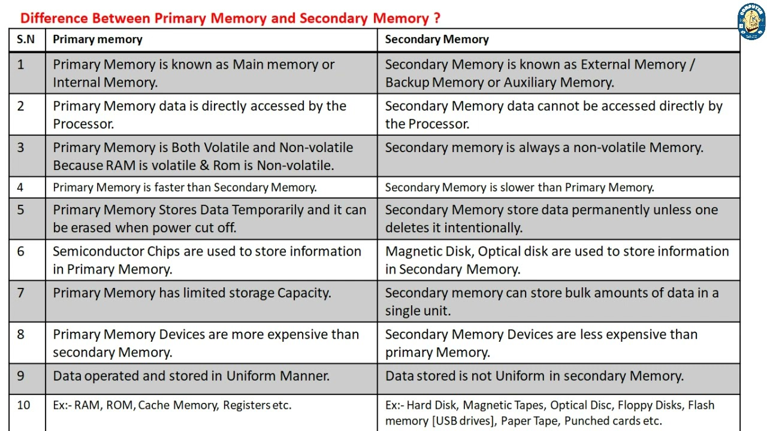**

**(i)** **RAM**: It stands for Random Access Memory. It is used to store information that is used immediately or we can say that it is a temporary memory. Computers bring the software installed on a hard disk to RAM to process it and to be used by the user. Once, the computer is turned off, the data is deleted. With the help of RAM, computers can perform multiple tasks like loading applications, browsing the web, editing a spreadsheet, experiencing the newest game, etc. It allows you to modify quickly among these tasks, remembering where you’re in one task once you switch to a different task. It is also used to load and run applications, like your spreadsheet program, answer commands, like all edits you made within the spreadsheet, or toggle between multiple programs, like once you left the spreadsheet to see the email. Memory is nearly always being actively employed by your computer. It ranges from 1GB – 32GB/64GB depending upon the specifications. There are different types of RAM, although they all serve the same purpose, the most common ones are :

**SRAM**: It stands for Static Random Access Memory. It consists of circuits that retain stored information as long as the power is supply is on. It is also known as volatile memory. It is used to build Cache memory. The access time of SRAM is lower and it is much faster as compared to DRAM but in terms of cost, it is costly as compared to DRAM.

**DRAM**: It stands for Dynamic Random Access Memory. It is used to stores binary bits in the form of electrical charges that are applied to capacitors. The access time of DRAM is slower as compare to SRAM but it is cheaper than SRAM and has a high packaging density.

**SDRAM**: It stands for Synchronous Dynamic Random Access Memory. It is faster than DRAM. It is widely used in computers and others. After SDRAM was introduced, the upgraded version of double data rate RAM, i.e., DDR1, DDR2, DDR3, and DDR4 was entered into the market and widely used in home/office desktops and laptops.

**(ii)** **ROM**: It stands for Read-Only Memory. The data written or stored in these devices are non-volatile, i.e, once the data is stored in the memory cannot be modified or deleted. The memory from which will only read but cannot write it. This type of memory is non-volatile. The information is stored permanently during manufacture only once. ROM stores instructions that are used to start a computer. This operation is referred to as bootstrap. It is also used in other electronic items like washers and microwaves. ROM chips can only store few megabytes (MB) of data, which ranges between 4 and 8 MB per ROM chip. There are two types of ROM:

**PROM**: PROM is Programmable Read-Only Memory. These are ROMs that can be programmed. A special PROM programmer is employed to enter the program on the PROM. Once the chip has been programmed, information on the PROM can’t be altered. PROM is non-volatile, that is data is not lost when power is switched off.

**EPROM**: Another sort of memory is that the Erasable Programmable Read-Only Memory. It is possible to erase the info which has been previously stored on an EPROM and write new data onto the chip.

**1.6 State the Importance of Cache Memory:**

Cache Memory is a special very high-speed memory. It is used to speed up and synchronizing with high-speed CPU. Cache memory is costlier than main memory or disk memory but economical than CPU registers. Cache memory is an extremely fast memory type that acts as a buffer between RAM and the CPU. It holds frequently requested data and instructions so that they are immediately available to the CPU when needed. Cache memory is used to reduce the average time to access data from the Main memory. The cache is a smaller and faster memory which stores copies of the data from frequently used main memory locations. There are various different independent caches in a CPU, which store instructions and data.

**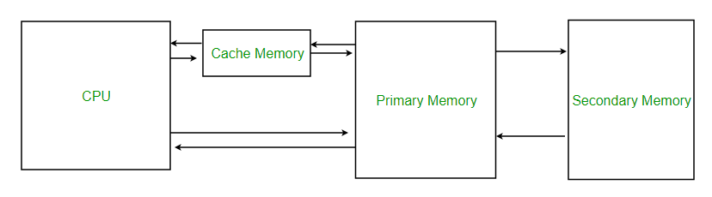**

**1.7 Explain the generations of computers:**

The modern computer took its shape with the arrival of your time. It had been around 16th century when the evolution of the computer started. The initial computer faced many changes, obviously for the betterment. It continuously improved itself in terms of speed, accuracy, size, and price to urge the form of the fashionable day computer. This long period is often conveniently divided into the subsequent phases called computer generations:

First Generation Computers (1940-1956)

Second Generation Computers (1956-1963)

Third Generation Computers (1964-1971)

Fourth Generation Computers (1971-Present)

Fifth Generation Computers (Present and Beyond)

Before there are graphing calculators, spreadsheets, and computer algebra systems, mathematicians and inventors searched for solutions to ease the burden of calculation.

Below are the 8 mechanical calculators before modern computers were invented.

1. Abacus (ca. 2700 BC)

2. Pascal’s Calculator (1652)

3. Stepped Reckoner (1694)

4. Arithmometer (1820)

5. Comptometer (1887) and Comptograph (1889)

6. The Difference Engine (1822)

7. Analytical Engine (1834)

8. The Millionaire (1893)

**First Generation Computers: Vacuum Tubes (1940-1956)**

The technology behind the primary generation computers was a fragile glass device, which was called vacuum tubes. These computers were very heavy and really large in size. These weren’t very reliable and programming on them was a really tedious task as they used high-level programming language and used no OS. First-generation computers were used for calculation, storage, and control purpose. They were too bulky and large that they needed a full room and consume rot of electricity.

**Main first generation computers are:**

ENIAC: Electronic Numerical Integrator and Computer, built by J. Presper Eckert and John V. Mauchly was a general-purpose computer. It had been very heavy, large, and contained 18,000 vacuum tubes.

EDVAC: Electronic Discrete Variable Automatic Computer was designed by von Neumann. It could store data also as instruction and thus the speed was enhanced.

UNIVAC: Universal Automatic Computer was developed in 1952 by Eckert and Mauchly.

Main characteristics of first generation computers are:

|  |  |
| --- | --- |
| Main electronic component | Vacuum tube. |
| Programming language | Machine language. |
| Main memory | Magnetic tapes and magnetic drums. |
| Input/output devices | Paper tape and punched cards. |
| Speed and size | Very slow and very large in size (often taking up entire room). |
| Examples of the first generation | IBM 650, IBM 701, ENIAC, UNIVAC1, etc. |

**Second Generation Computers: Transistors (1956-1963)**

Second-generation computers used the technology of transistors rather than bulky vacuum tubes. Another feature was the core storage. A transistor may be a device composed of semiconductor material that amplifies a sign or opens or closes a circuit.

Transistors were invented in Bell Labs. The use of transistors made it possible to perform powerfully and with due speed. It reduced the dimensions and price and thankfully the warmth too, which was generated by vacuum tubes. Central Processing Unit (CPU), memory, programming language and input, and output units also came into the force within the second  generation.

Programming language was shifted from high level to programming language and made programming comparatively a simple task for programmers. Languages used for programming during this era were FORTRAN (1956), ALGOL (1958), and COBOL (1959).

Main characteristics of second generation computers are:-

|  |  |
| --- | --- |
| Main electronic component | Transistor. |
| Programming language | Machine language and assembly language. |
| Memory | Magnetic core and magnetic tape/disk. |
| Input/output devices | Magnetic tape and punched cards. |
| Power and size | Smaller in size, low power consumption, and generated less heat (in comparison with the first generation computers). |
| Examples of second generation | PDP-8, IBM1400 series, IBM 7090 and 7094, UNIVAC 1107, CDC 3600 etc. |

**Third Generation Computers: Integrated Circuits. (1964-1971)**

During the third generation, technology envisaged a shift from huge transistors to integrated circuits, also referred to as IC. Here a variety of transistors were placed on silicon chips, called semiconductors. The most feature of this era’s computer was the speed and reliability. IC was made from silicon and also called silicon chips.

A single IC, has many transistors, registers, and capacitors built on one thin slice of silicon. The value size was reduced and memory space and dealing efficiency were increased during this generation. Programming was now wiped out Higher level languages like BASIC (Beginners All-purpose Symbolic Instruction Code). Minicomputers find their shape during this era.

Main characteristics of third generation computers are:

|  |  |
| --- | --- |
| Main electronic component | Integrated circuits (ICs) |
| Programming language | High-level language |
| Memory | Large magnetic core, magnetic tape/disk |
| Input / output devices | Magnetic tape, monitor, keyboard, printer, etc. |
| Examples of third generation | IBM 360, IBM 370, PDP-11, NCR 395, B6500, UNIVAC 1108, etc. |

**Fourth Generation Computers: Micro-processors (1971-Present)**

In 1971 First microprocessors were used, the large scale of integration LSI circuits built on one chip called microprocessors. The most advantage of this technology is that one microprocessor can contain all the circuits required to perform arithmetic, logic, and control functions on one chip.

The computers using microchips were called microcomputers. This generation provided the even smaller size of computers, with larger capacities. That’s not enough, then Very Large Scale Integrated (VLSI) circuits replaced LSI circuits. The Intel 4004chip, developed in 1971, located all the components of the pc from the central processing unit and memory to input/ output controls on one chip and allowed the dimensions to reduce drastically.

Technologies like multiprocessing, multiprogramming, time-sharing, operating speed, and virtual memory made it a more user-friendly and customary device. The concept of private computers and computer networks came into being within the fourth generation.

Main characteristics of fourth generation computers are:

|  |  |
| --- | --- |
| Main electronic component | Very large-scale integration (VLSI) and the microprocessor (VLSI has thousands of transistors on a single microchip). |
| Memory | semiconductor memory (such as RAM, ROM, etc.) |
| Input/output devices | pointing devices, optical scanning, keyboard, monitor, printer, etc. |
| Examples of fourth generation | IBM PC, STAR 1000, APPLE II, Apple Macintosh, Alter 8800, etc. |

**Fifth Generation Computers**

The technology behind the fifth generation of computers is AI. It allows computers to behave like humans. It is often seen in programs like voice recognition, area of medicines, and entertainment. Within the field of games playing also it’s shown remarkable performance where computers are capable of beating human competitors.

The speed is highest, size is that the smallest and area of use has remarkably increased within the fifth generation computers. Though not a hundred percent AI has been achieved to date but keeping in sight the present developments, it is often said that this dream also will become a reality very soon.

Main characteristics of fifth generation computers are:

|  |  |
| --- | --- |
| Main electronic component | Based on artificial intelligence, uses the Ultra Large-Scale Integration (ULSI) technology and parallel processing method (ULSI has millions of transistors on a single microchip and Parallel processing method use two or more microprocessors to run tasks simultaneously). |
| Language | Understand natural language (human language). |
| Size | Portable and small in size. |
| Input / output device | Trackpad (or touchpad), touch screen, pen, speech input (recognize voice/speech), light scanner, printer, keyboard, monitor, mouse, etc. |
| Example of fifth generation | Desktops, laptops, tablets, smart phones, etc. |

**1.8 Classification of computers - based on a) size, b) processor.**

**Classification Of Computer Based on Size:**

Classification of computers are based on their architecture, speed of executing commands or instructions, peripheral used and also their uses. Microcomputers are usually used in home and offices and only a single user can perform the task using a microcomputer. Its storage and data handling capacity are limited as per the requirement for home and office work. The another type of computer is called minicomputer which has usually larger storage and can handle multiuser at a time. This chapter includes the classification of computers.

**Computer's Classification**

Computers are classified on different parameters, such as, storage capacity, processing speed and component (CPU) used in computers. Depending upon the components used and features of different computers, they are classified into four groups, Microcomputers, Minicomputers, Mainframe computers and Supercomputers.

**Micro Computers**

A PC can be defined as a small, relatively inexpensive computer designed for an individual user. PCs are based on the microprocessor technology that enables manufacturers to put an entire CPU on one chip. Businesses use personal computers for word processing, accounting, desktop publishing, and for running spreadsheet and database management applications. At home, the most popular use for personal computers is playing games and surfing the Internet.

Although personal computers are designed as single-user systems, these systems are normally linked together to form a network. In terms of power, nowadays high-end models of the Macintosh and PC offer the same computing power and graphics capability as low-end workstations by Sun Microsystems, Hewlett-Packard, and Dell.

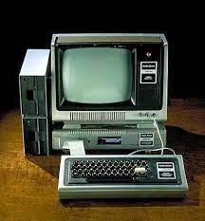

**Workstation**

A workstation computer has greater memory capability and more extensive mathematical abilities. It is connected with other workstation computers or personal computer to exchange data and mostly used for scientific applications. It also supports multitasking applications.

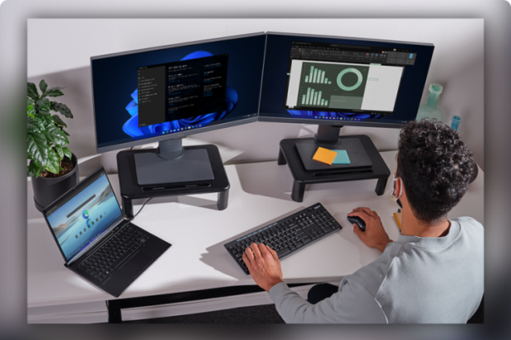

**Mini Computers**

Minicomputers were introduced in early 1960s. They were faster than micro computers. Basically these computers were mainly multi-user systems, where many users work on the systems. Generally these types of computers had larger memories and greater storage capacity. They had large instruction set and address field. These kinds of computers have efficient storage for handling of text, in comparison to lower bit machines. Due to more efficient processor, speed and memory size, minicomputer was used in variety of applications and could support business applications along with the scientific applications. Minicomputer was a multi-user system which means more than one user could use this system simultaneously.

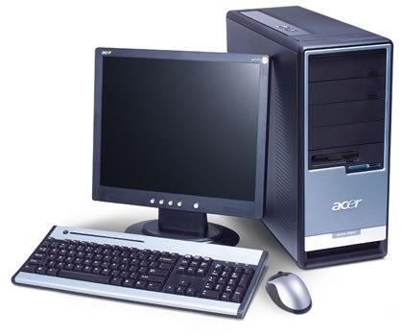

**Comparison of Micro and Mini computers**

|  |  |  |
| --- | --- | --- |
| Features | Micro computer | Mini computer |
| Primary memory | Shall memory | Larger memory |
| Word length | Small word length | Larger word length |
| Cost low | Low | High |
| Processor | Low | High |

**Mainframe Computers**

Mainframe computers are large and expensive machines. The word length of mainframe computers may be 48, 60 or 64 bits, memory capacity being in some megabytes and storage capacity in some terabytes. Generally they handle huge volumes of information and data. In terms of speed, they are having significant processing capacity. They are used in research organizations, large industries, airlines reservation where a large database has to be maintained.

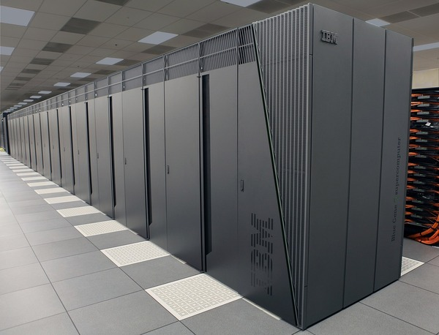

**Super Computers**

Super Computers are the fastest computer in current era. The processing capabilities of super computer lies in the range of GIPS2, word length 64-128 or may be in 256 or so. The memory capacity of super computer is in some gigabytes or in terabytes. The storage capacity of this type of computer is in exabytes.

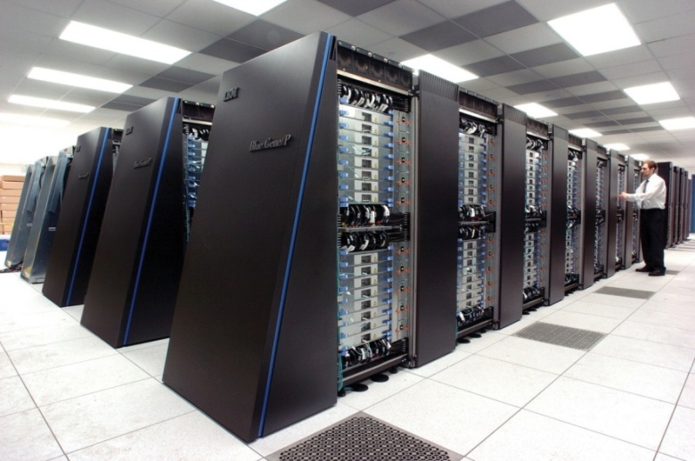

The parallel processing of a super computer makes it very fast because it contains number of CPU that operates parallel. They are used at some research centers and government agencies involving sophisticated scientific and engineering tasks. Super computers are used for the followings:

* Nuclear and plasma physics
* Rocket research and development
* Atomic research

**Classification Of Computer Based on processor:**

Computers are classified on the basis of their data processing speed better known as clock speed and the word length. The word length that is processed by a CUP at a time is one of the important feature of that CPU.

Computers can be classified into:

1. Sequential Computers

2. Parallel Computers

**Sequential Computer:**

Traditionally software has been written for a serial computation

* A problem is broken into a discrete series of instructions
* Instructions are executed sequentially one after another
* Executed on a single processor
* Only one instruction may execute at any moment in time

**Performance Of a Sequential Processor:**

The performance of a simple, sequential machine is determined by the clock cycle time, and the average number of clock cycles per instruction.

* The clock cycle time is dependent on the implementation technology.
* It also depends on the complexity of the most complex operation which has to happen within a single cycle.

**Parallel Computer**

* A single computer with multiple processors/cores
* Instructions from each part execute simultaneously on different processors

Who is Using Parallel Computing?

**Science and Engineering:**

* Atmosphere, Earth, Environment
* Mechanical Engineering – from prosthetic to spacecraft
* Electrical Engineering, Circuit Design, Microelectronics

**Industrial and Commercial:**

* “Big Data”, databases, data mining
* Medical imaging and diagnosis

**1.9 State the importance of binary number system for use in Digital Computers:**

Binary may refer to any of the following:

Binary is a base-2 number system invented by [Gottfried Leibniz](https://www.computerhope.com/people/gottfried_leibniz.htm) that's made up of only two numbers or digits: 0 (zero) and 1 (one). This numbering system is the basis for all binary code, which is used to write digital data such as the [computer processor](https://www.computerhope.com/jargon/c/cpu.htm) instructions used every day.

**How does binary work?**

The 0s and 1s in binary represent [OFF or ON](https://www.computerhope.com/jargon/o/onoff.htm), respectively. In a [transistor](https://www.computerhope.com/jargon/t/transist.htm), a "0" represents no flow of electricity, and "1" represents electricity being allowed to flow. In this way, numbers are represented physically inside the computing device, permitting calculations. This concept is further explained in our section on [how to read binary numbers](https://www.computerhope.com/jargon/b/binary.htm#read).

**Why do computers use binary?**

Binary is still the primary language for computers and used with electronics and computer hardware for the following reasons.

It is a simple and elegant design.

Binary's 0 and 1 method is quick to detect an electrical signal's off (false) or on (true) state.

Having only two states placed far apart in an electrical signal makes it less susceptible to electrical interference.

The positive and negative poles of [magnetic media](https://www.computerhope.com/jargon/m/magnmedi.htm) are quickly translated to binary.

Binary is the most efficient way to control logic [circuits](https://www.computerhope.com/jargon/c/circuit.htm).

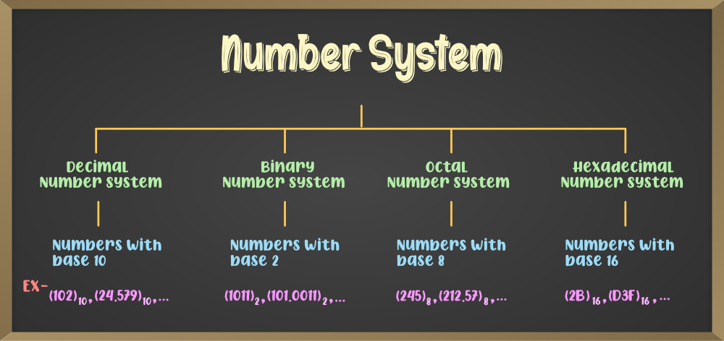

**Decimal to the Binary Conversion formula.**

In general, decimal to any number system conversion procedure will be,

1. Take the number modulo base i.e. number % base

2. Write down the result. i.e. remainder

3. Divide the number by base i.e. number / base

4. repeat the process until the number greater than 0. (number > 0)

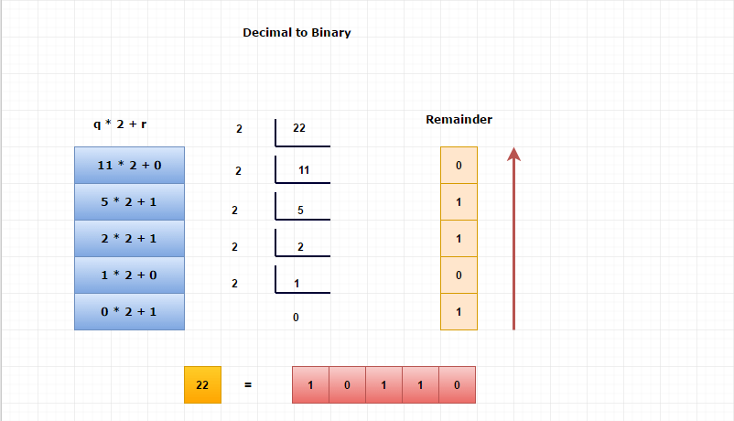

**Binary to Decimal Conversion**

**∑( ni \* ( base ^ position) )**

∑ denotes the summation operation.

^ denotes the power operation.

\* denotes the multiplication operation.

where,

ni is each digit of a number

**Example:**

Let's convert (10110)2 into the decimal number

where,

The position of 0 is 0.

The position of 1 is 1.

The position of 1 is 2.

The position of 0 is 3.

The Position of 1 is 4.

And the base value = 2.

(10110)2

=1\*(24) + 0\*(23) + 1\*(22)+ 1\*(21) + 0\*(20)

=16+0+4+2+0

=(22)10

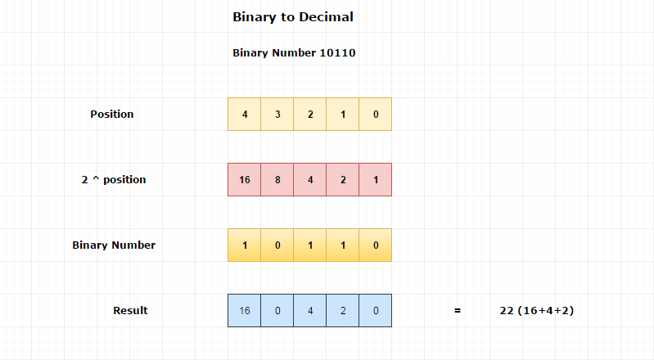**2.0 Implement Programming Methodology.**

**2.1 State the different steps involved in problem solving :**

Structure:

* Introduction
* Procedure (steps involved in problem solving)
* Algorithm
* Flow Chart
* Symbols used in Flow Charts
* Pseudo Code

Procedure (Steps Involved in Problem Solving):

A computer cannot solve a problem on its own. One has to provide step by step solutions of the problem to the computer. In fact, the task of problem solving is not that of the computer. It is the programmer who has to write down the solution to the problem in terms of simple operations which the computer can understand and execute.

In order to solve a problem by the computer, one has to pass though certain stages or steps. They are

1. Understanding the problem

2. Analyzing the problem

3. Developing the solution

4. Coding and implementation.

1. Understanding the problem: Here we try to understand the problem to be solved in totally. Before with the next stage or step, we should be absolutely sure about the objectives of the given problem.
2. Analyzing the problem: After understanding thoroughly the problem to be solved, we look different ways of solving the problem and evaluate each of these methods. The idea here is to search an appropriate solution to the problem under consideration. The end result of this stage is a broad overview of the sequence of operations that are to be carries out to solve the given problem.
3. Developing the solution: Here the overview of the sequence of operations that was the result of analysis stage is expanded to form a detailed step by step solution to the problem under consideration.
4. Coding and implementation: The last stage of the problem solving is the conversion of the detailed sequence of operations in to a language that the computer can understand. Here each step is converted to its equivalent instruction or instructions in the computer language that has been chosen for the implantation.

**2.2 Define algorithm:**

A set of sequential steps usually written in Ordinary Language to solve a given problem is called Algorithm.

It may be possible to solve to problem in more than one ways, resulting in more than one algorithm. The choice of various algorithms depends on the factors like reliability, accuracy and easy to modify. The most important factor in the choice of algorithm is the time requirement to execute it, after writing code in High-level language with the help of a computer. The algorithm which will need the least time when executed is considered the best.

**2.3 List four characteristics of algorithm.**

An algorithm must possess the following properties

**1. Finiteness**: An algorithm must terminate in a finite number of steps

**2. Definiteness**: Each step of the algorithm must be precisely and unambiguously stated

**3. Effectiveness**: Each step must be effective, in the sense that it should be primitive easily convert able into program statement) can be performed exactly in a finite amount of time.

**4. Generality**: The algorithm must be complete in itself so that it can be used to solve problems of a specific type for any input data.

**5. Input/output**: Each algorithm must take zero, one or more quantities as input data produce one or more output values. An algorithm can be written in English like sentences or in any standard representation sometimes, algorithm written in English like languages are called Pseudo Code

**Example**

1. Suppose we want to find the average of three numbers, the algorithm is as follows

**Step 1** :Read the numbers a, b, c

**Step 2** :Compute the sum of a, b and c

**Step 3** :Divide the sum by 3

**Step 4** :Store the result in variable d

**Step 5** :Print the value of d

**Step 6** :End of the program

**Write an algorithm to find the largest of three numbers X, Y,Z.**

Step 1: Read the numbers X,Y,Z.

Step 2: if (X > Y)

Big = X

else BIG = Y

Step 3 : if (BIG < Z)

Step 4: Big = Z

Step 5: Print the largest number i.e. Big

Step 6: Stop.

**2.4 Define a program:**

A computer program is a set of instructions and as a term it can be used as a verb as well as a noun. **In terms of a verb,** it is used as a process of creating a software program by using programming language**. In terms of a noun**, an application, program, or application software is used to perform a specific task on the computer.

For example, Microsoft PowerPoint is an application, which provides a way to create documents related to the presentation. Furthermore, a browser is also an application, which allows us to browse any website. The program enables the computer to perform a particular operation. As without application software (programs), a computer is able to operate with the operating system, but it cannot perform any specific task. For example, if you want to create a Word document, you have to install Microsoft Word on your computer. It is a program or application software that instructs the computer how to create, edit, and save a document or a file.

**2.5 Differentiate between Program and Algorithm:**

|  |  |
| --- | --- |
| **Algorithm** | **Flowchart** |
| Algorithm is a list of steps to solve a problem. | Program is a code to solve a problem. |
| Includes English Sentences. | Includes coding lines written in Programming Language. |
| Easy to understand. | Understood by the person who is aware of that programming language. |
| Easy to write. | Only written by programmers. |
| Generalized solution to a problem. | Specialized solution to a problem. |
| No rules are to be followed. | Programming language rules must be followed. |
| Written in formal language. | Written only in programming language. |
| Not understood by the compiler. | Understood by the compiler. |

**2.6 State the steps involved in algorithm development.**

An algorithm can be defined as “**a complete, unambiguous, finite number of logical steps for solving a specific problem** “

**Step1 : Identification of input**: For an algorithm, there are quantities to be supplied called input and these are fed externally. The input is to be indentified first for any specified problem.

**Step2 : Identification of output**: From an algorithm, at least one quantity is produced, called for any specified problem.

**Step3 : Identification the processing operations** : All the calculations to be performed in order to lead to output from the input are to be identified in an orderly manner.

**Step4 : Processing Definiteness** : The instructions composing the algorithm must be clear and there should not be any ambiguity in them.

**Step5 : Processing Finiteness** : If we go through the algorithm, then for all cases, the algorithm should terminate after a finite number of steps.

**Step6 : Possessing Effectiveness** : The instructions in the algorithm must be sufficiently basic and in practice they can be carries out easily.

**2.7 Differentiate between Algorithm and Flowchart:**

Flowcharts are nothing but the graphical representation of the data or the algorithm for a better understanding of the code visually. It displays step-by-step solutions to a problem, algorithm, or process. It is a pictorial way of representing steps that are preferred by most beginner-level programmers to understand algorithms of computer science, thus it contributes to troubleshooting the issues in the algorithm. A flowchart is a picture of boxes that indicates the process flow in a sequential manner. Since a flowchart is a pictorial representation of a process or algorithm, it’s easy to interpret and understand the process. To draw a flowchart, certain rules need to be followed which are followed by all professionals to draw a flowchart and is widely accepted all over the countries.

**Use of a flowchart**

Following are the uses of a flowchart:

* It is a pictorial representation of an algorithm that increases the readability of the program.
* Complex programs can be drawn in a simple way using a flowchart.
* It helps team members get an insight into the process and use this knowledge to collect data, detect problems, develop software, etc.
* A flowchart is a basic step for designing a new process or add extra features.
* Communication with other people becomes easy by drawing flowcharts and sharing them.

|  |  |
| --- | --- |
| **Algorithm** | **Flowchart** |
| 1. A method of representing the step-by-step logical procedure for solving a problem | 1. Flowchart is diagrammatic representation of an algorithm. It is constructed using different types of boxes and symbols. |
| 2. It contains step-by-step English descriptions, each step representing a particular operation leading to solution of problem | 2. The flowchart employs a series of blocks and arrows, each of which represents a particular step in an algorithm. |
| 3. These are particularly useful for small problems | 3. These are useful for detailed representations of complicated program. |
| 4. For complex programs, algorithms prove to be Inadequate | 4. For complex programs, Flowcharts prove to be adequate |

**2.8 Develop algorithms for simple problems:**

1. **Write an algorithm to calculate the simple interest using the formula.**

Simple interest = P\*N\* R/100.

Where P is principle Amount, N is the number of years and R is the rate

of interest.

Step 1: Read the three input quantities’ P, N and R.

Step 2 : Calculate simple interest as

Simple interest = P\* N\* R/100

Step 3: Print simple interest.

Step 4: Stop.

2. **Area of Triangle**: Write an algorithm to find the area of the triangle.

Let b, c be the sides of the triangle ABC and A the included angle between

the given sides.

Step 1: Input the given elements of the triangle namely sides b, c and angle

between the sides A.

Step 2: Area = (1/2) \*b\*C\* sin A

Step 3: Output the Area

Step 4: Stop.

**3. Write an algorithm to find the largest of three numbers X, Y,Z.**

Step 1: Read the numbers X,Y,Z.

Step 2: if (X > Y)

Big = X

else BIG = Y

Step 3 : if (BIG < Z)

Step 4: Big = Z

Step 5: Print the largest number i.e. Big

Step 6: Stop.

**4. Write algorithm to find the factorial of a given number N**

Step 1: Fact <-- 1

Step 2: I <-- 0

Step 3: read N

Step 4: While I < N do

4.1 I <-- I + 1

4.2. Fact <-- Fact\* I

Step 5: Write “Factorial of”, N, “is”, Fact

Step 6: end.

**2.9 Draw the symbols used in Flowcharts:**

|  |  |  |
| --- | --- | --- |
| Symbol | Purpose | Description |
| Flowline symbol in flowchart of programming | Flow line | Indicates the flow of logic by connecting symbols. |
| Terminal symbol in flowchart of programming | Terminal(Stop/Start) | Represents the start and the end of a flowchart. |
| Input/Output symbol in flowchart of programming | Input/ Output | Used for input and output operation. |
| Processing symbol in flowchart of programming | Processing | Used for arithmetic operations and data-manipulations. |
| Decision making symbol in flowchart of programming | Decision | Used for decision making between two or more alternatives. |
| On-page connector symbol in flowchart of programming | On-page Connector | Used to join different flow line |
| Off-page connector symbol in flowchart of programming | Off-page Connector | Used to connect the flowchart portion on a different page. |
| Predefined process symbol in flowchart of programming | Predefined Process/Function | Represents a group of statements performing one processing task. |

**2.10 Draw flowcharts for simple problems:**

### ****Example 1: Print “Hello World.” On-screen****

A chart of a simple program of printing a “Hello World” message onto the screen should be like this:

**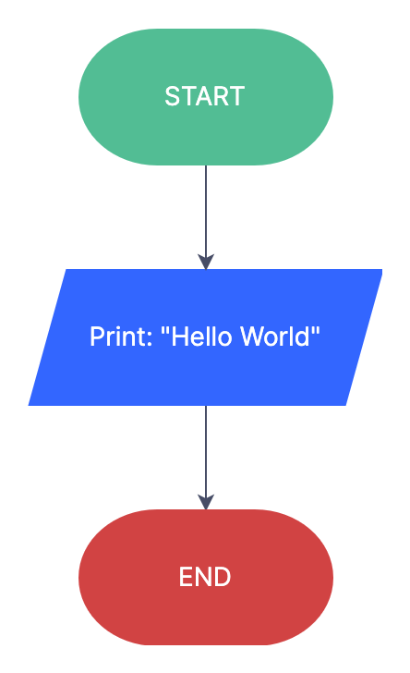**

**Example 2: Calculate The Average Of Two Numbers.**

As you may have already known, to calculate the average of two numbers, you can sum up those two numbers and divide the result by 2. In other words, the formula for calculating the average of two numbers is: (number 1 + number 2)/2.

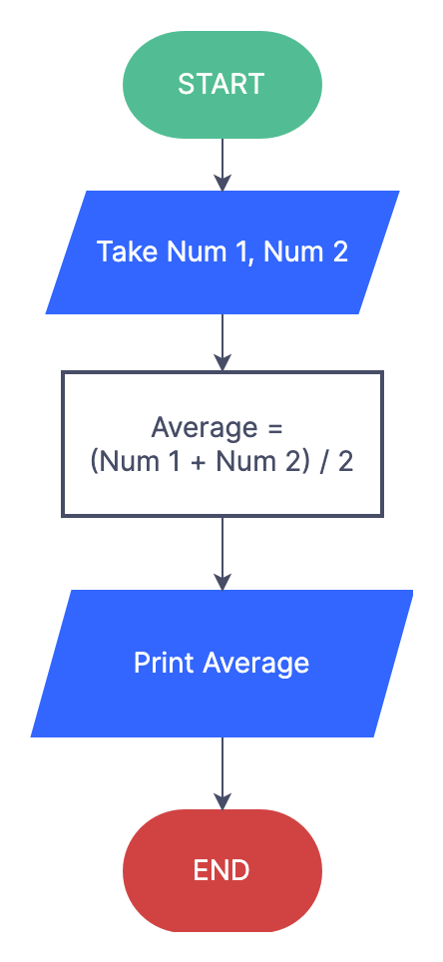

**Example 3: Input Number And Check If They Are Odd Or Even**

Another relatively simple program is checking odd/even numbers. It is a basic conditional operation that involves: inputting a number, determining whether it is odd or even, printing the result on-screen. The chart should be something like this:

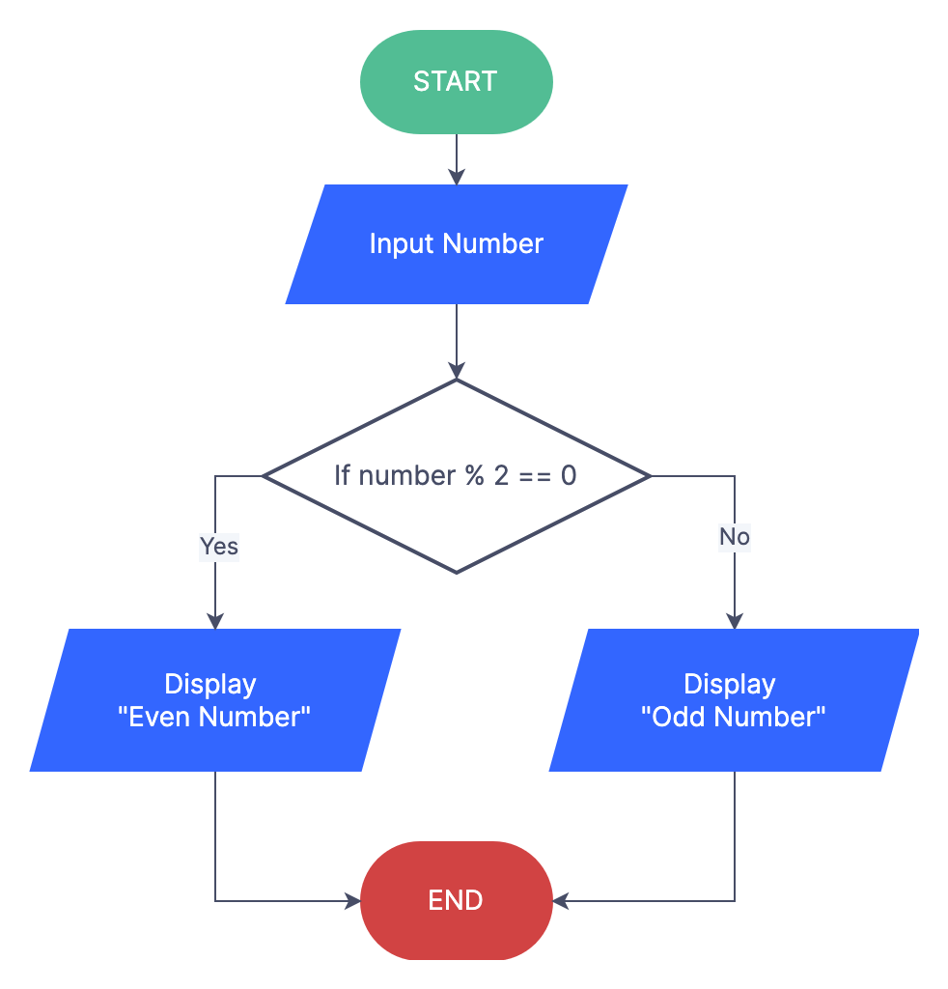

**3.0 Operating Systems basics**

**3.1. Describe the need for an operating system:**

**The goal of an Operating System:** The fundamental goal of an Operating System is to execute user programs and to make tasks easier. Various application programs along with hardware systems are used to perform this work. Operating System is software that manages and controls the entire set of resources and effectively utilizes every part of a computer.   
The figure shows how OS acts as a medium between hardware units and application programs.

needofos.png

**Need for Operating System:**

**OS as a platform for Application programs:**                                                                                                                        
The operating system provides a platform, on top of which, other programs, called application programs can run. These application programs help the users to perform a specific task easily. It acts as an interface between the computer and the user. It is designed in such a manner that it operates, controls, and executes various applications on the computer.                                                                                                                                                 
 **Managing Input-Output unit:**                                                                                                                                                
Operating System also allows the computer to manage its own resources such as memory, monitor, keyboard, printer, etc. Management of these resources is required for effective utilization. The operating system controls the various system input-output resources and allocates them to the users or programs as per their requirements.

**Consistent user interface:**                                                                                                                                                          
Operating System provides the user with an easy-to-work user interface, so the user doesn’t have to learn a different UI every time and can focus on the content and be productive as quickly as possible. Operating System provides templates, and UI components to make the working of a computer, really easy for the user.  
 **Multitasking:**   
Operating System manages memory and allows multiple programs to run in their own space and even communicate with each other through shared memory. Multitasking gives users a good experience as they can perform several tasks on a computer at a time.

**3.2. List the various operating systems used presently:**

## Introduction to Computer Operating System

In this article, we will see an outline on Types of Computer Operating System. Each modern device requires an operating system, whether it’s a desktop or a laptop computer, or a smart phone or a video game system. This is the main computer program that is placed between the software and the hardware, distributes space and computing assets into applications, manages files and enforces rules on security.

### What is Operating System?

An OS (Operating System) is a software that acts as an interface between the end-user and the hardware of the computer. To perform other programs, every computer must have at least one OS. Applications such as Chrome, Games, MS Word, etc requires an environment where it runs and does its task. The OS allows you to communicate without being able to speak the language of your machine. Without an [operating system](https://www.educba.com/features-of-operating-system/), the user cannot use a computer or mobile device.

### Types of Computer Operating Systems

Operating Systems are usually pre-installed in on any computer. Below we will discuss different types of Operating System:

#### 1. Apple iOS

Apple’s iOS is a popular operating system for smartphones. It works on Apple hardware, including iPhone’s and iPad tablets. iOS features include an application shop where users can buy and download free apps, strong safety and encryption focus to limit what unauthorized users can remove from the phone and a simple, streamlined interface with minimal hardware buttons.

#### 2. Microsoft Windows

Since 1985 Microsoft Windows has been in one form or another and remains the most common home and office software operating system. The latest versions are also used in some devices, including Windows 10, and the OS is also used on some internet and server computers. Windows may be used by machines from a variety of companies. Windows ‘ original versions worked with a previous Microsoft OS called MS-DOS modern interface on top of traditional DOS text-driven commands. Microsoft Windows UI’s signature features include windows themselves – panel-screens that represent individual applications in a rectangular shape. The start menu of Windows helped generations of users to find their programs and files.

#### 3. Apple MAC OS

Apple’s macOS is running on Apple laptops and desktops as the successor of the popular operating system OS X. Because of its research into AT&T’s Bell Labs in the 1960s on the historic Unix family of operating systems, macOS shares certain features with other Unix-related systems, including Linux. Although the graphical interfaces are different, many of the programming interfaces and command-line features are similar. Signature elements in macOS include the dock used to check for programs and files that are commonly used, single keyboard keys, including the Command key. macOS is famous for its user-friendly functionalities like Siri, Apple’s video chatting software, FaceTime and a natural-voice personal assistant.

#### 4. Linux Operating System

Linux is a  computer operating system which is similar to Unix built under the development and distribution model of free and open-source software. Linux’s popular feature is the Linux kernel, the first operating system kernel released by Linus Torvalds on September 17, 1991. The operating system is loading itself into memory and begins to control the computer’s resources. After that, it offers certain tools for other applications that the client wants to run. Most of the embedded systems run Linux today. Electronic gadgets such as internet router, washing machine, TV, refrigerator, etc can be run on Linux. Hence Linux is also one of the most popular operating systems nowadays.

**3.3. List And Explain:**

**3.3.1. Types Of Dos Commands:**

* MS-DOS is an acronym for MicroSoft Disk Operating System.
* It is a CUI based operating system.
* It provides user with a command prompt (generally called as C:\) where various command could be typed.
* When one operates in the DOS environment, one interacts with the command interpreter, which interprets the commands given by user.

**What is Command**

* It is a string of characters which tells the computer what to do.
* When one types commands to a computer, one is conversing with the operating system's command interpreter.
* For example, to copy a file called file.txt from the one drive drive to the another drive, one could type

C:\> copy a:\file.txt c:\

The word "copy" is a DOS command which causes files to be copied from one location to another

**3.3.2. Any 10 Internal Commands:**

Internal Commands are built into the operating system as the part of a file called COMMAND.COM

When you type an Internal Command MS-DOS will perform it immediately. All of the internal commands are part of the shell which could be command.com or cmd.exe (depending on your version of MS-DOS or Windows) and are not separate files on the hard drive. As long as you can open a command line you can run any of the internal commands included with your version of MS-DOS

#### Example Of Ms-dos Internal Command Are:

1. DIR: The dir command displays information about files and directories, and how many spaces available

C:\> dir

2. CLS: It is a command that allows you to clear the complete contents of the screen and leave only a prompt

C:\> cls

3. COPY CON: Creates a file.

C:\> copy con <filename>

< Write your Contents Here>

Press Ctrl-Z (^Z) to finish writing.

Ex: C:\> copy con test.dat

Lets Make UCO a top class Bank.

Ctrl-Z (^Z)

1 file(s) copied. (A Message will be shown on the system)

This will create a file named test.dat having some data.

4. edit: Edits a file.

C:\> start <filename>

This will open a editor window where the contents of file can be seen. These contents could also be edited here and on saving, the contents of file will change.

type: Displays the content of a file.

C:\> type <filename>

This will display the contents of file on the computer. The contents of file could only be viewed but could not be changed, as in the case of edit.

MKDIR/MD: Allows you to create directories in MS-DOS..

C:\> md (directory name>

This will create a directory with the specified name.

cd: is a command used to switch directories in MS-DOS.

C:\> cd (directory name>

This will change the directory from current directory to the specified directory.

rd: Remove Directory.

C:\> rd (directory name>

If the directory is needed to be removed permanently from the computer, use this command. For this command to be executed it is necessary that the directory should be empty and user should be on a directory above it.

copy: Copies a file.

C:\> copy <source> <destination>

D:\python> copy abc.txt xyz.txt

D:\python> copy \*.pdf \java

This will copy the file from the source location to the specified destination. The command creates a copy of the file on the destination i.e. the file would be found on both the location.

move: Moves a file.

C:\> move <source> <destination>

This will move the file from the source location to the specified destination. The file from the source location would be removed and would be moved to the destination.

ren: Renames a file.

C:\> ren <old filename> <new filename>

This will change the name (rename) of the file to a new name as specified.

del: Deletes a file.

C:\> del <filename>

This will delete the file permanently from the system.

PATH – Path is used to specify the location where MS-DOS looks when using a command.

VOL – Displays the volume of information about the designated drive.

**3.3.3. Any 5 External Commands:**

These external commands are for performing advanced tasks and they do need some external file support as they are not stored in COMMAND.COM. There are also Batch commands or Batch files which are text files that contain a list of internal and/or external commands which are executed in sequence when the batch file is executed. AUTOEXEC.BAT gets executed automatically on booting.

#### Examples of External Commands are:-

1. DELTREE- Short for delete tree, deltree is a command used to delete files and directories permanently from the computer.
2. TREE- Allows the user to view a listing of files and folders in an easy to read the listing.
3. PRINT – The print command allows users to print a text file to a line printer, in the background.
4. FIND – Allows you to search for text within a file.
5. XCOPY – Xcopy is a powerful version of the copy command with additional features; has the capability of moving files, directories, and even whole drives from one location to another.
6. DISK COMP- Compares the contents of a floppy disk in the source drive to the contents of a floppy disk in the target drive.
7. FORMAT – Format is used to erase information off of a computer diskette or fixed drive.
8. ATTRIB – Attrib allows a user to change the attributes of a file or files.
9. SORT- Sorts the input and displays the output to the screen.
10. CHKDSK- Chkdsk is a utility that checks the computer’s hard drive status for any cross-linked or any additional errors with the hard drive.
11. FORMAT – Format a diskette.
12. PRINT – Printing a file.
13. MOVE- Allows you to move files or directories from one folder to another, or from one drive to another.

## Introduction to Windows

In this topic, we are going to learn about the Introduction to Windows. Microsoft Windows is a multitasking operating system developed by Microsoft Corporation which uses Graphical User Interface to interact with the users. Microsoft was originally named “Traf-O-Data” in 1972, was renamed as “Micro-soft” in November 1975, then “Microsoft” on November 26, 1976. Microsoft entered the marketplace in August 1981 by releasing version 1.0 of the operating system Microsoft DOS (MS-DOS), a 16-bit command-line operating system. Bill Gates and Paul Allen founded Microsoft and windows operating system has been its primary product.

In this Introduction to Windows, we will also clear you about the latest OS release of Windows is “Windows 10” which was launched in the year 2015.

In a nutshell, below is how Microsoft windows evolved over time:

* Windows 1.0 – Nov 1985
* Windows 2.0 – Dec 1987
* Windows 3.0 – May 1990
* Windows 95 – Aug 1995
* Windows 98 – June 1998
* Windows ME – Sep 2000
* Windows XP – Oct 2001
* Windows Vista – Nov 2006
* Windows 7 – July 2009
* Windows 8.0 – Oct 2012
* Windows 8.1 – Oct 2013
* Windows 10 – July 2015

**Features of Windows**

As we learned about Introduction to Windows in the above section, so let’s explore the main Features of Windows:

* **Windows Search:**We can have numerous files and contents located on our system and sometimes we may run out of memory about the exact location of our file. Windows Search is a search function included with Windows that allows the user to search their entire computer
* **Windows File Transfer:**We may have the need to transfer in or transfer out the files and contents from our machine to other devices such as other computers or mobiles and tablets. We can do this by using an Easy Transfer Cable, CDs or DVDs, a USB flash drive, wireless Bluetooth, a network folder, or an external hard disk.
* **Windows Updates:**Windows includes an automatic update feature with the intended purpose of keeping its operating system safe and up-to-date.
* **Windows taskbar:**At the bottom most part of your windows, you will see a row which is known as the taskbar. It has the currently running applications, you can also pin applications that you frequently use by using an option Pin to Taskbar”. The taskbar is the main navigation tool for Windows
* **Remote Desktop Connection:**This feature of windows allows you to connect to another system and work remotely on another system.

**3.3.4. Features of Windows desktop.**

The desktop is the onscreen work area provided by Microsoft Windows, analogous to a physical desktop. It consists of a work area and taskbar. The work area may span multiple monitors.

**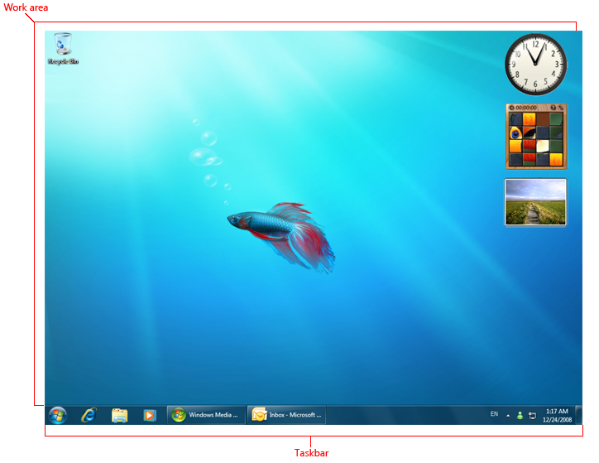**

**A typical Windows desktop.**

The active monitor is the monitor where the active program is running. The default monitor is the one with the Start menu, taskbar, and notification area.

**Design concepts**

The Windows desktop has the following program access points:

* **Work area.** The onscreen area where users can perform their work, as well as store programs, documents, and their shortcuts. While technically the desktop includes the taskbar, in most contexts it refers just to the work area.
* **Start button.** The access point for all programs and special Windows places (Documents, Pictures, Music, Games, Computer, Control Panel), with "most recently used" lists for quick access to recently used programs and documents.
* **Taskbar.** The access point for running programs that have desktop presence. While technically the taskbar spans the entire bar from the Start button to the notification area, in most contexts taskbar refers to the area in between, containing the taskbar buttons. This area is sometimes referred to as the taskband.
* **Notification area.** A short-term source for notifications and status, as well as an access point for system- and program-related features that have no presence on the desktop.

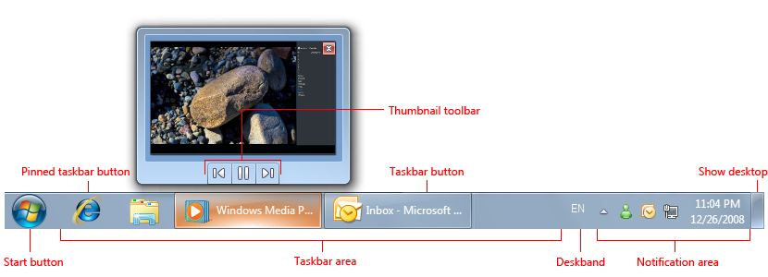

**3.3.5. Components of a Window:**

**Main Components of Windows**

After learning about the Introduction to Windows, we are now going to study about the main components of Windows. The main components of the Windows Operating System are the following:

* Configuration and maintenance
* User interface
* Applications and utilities
* Windows Server components
* File systems
* Core components
* Services
* Networking
* Scripting and command-line
* Security

When coming to GUI components, we have the following as the main components:

#### Desktop

It is the very first screen that you will see once the windows start. Here you will see “My Computer”, “My Documents”, “Start Menu”, “Recycle Bin”, and the shortcuts of any applications that you might have created.

#### Taskbar

At the bottom, you will see a row which is known as the taskbar. It has the currently running applications, you can also pin applications that you frequently use by using an option Pin to Taskbar”.

#### Start Menu

This is located in the bottom left corner of Windows OS GUI. This is the place where the user can search for any setting and for any application for their use. Users can uninstall or repair applications from the control panel. The user can do a lot of activities just by searching through the start menu.

#### My Computer

When you double click on “My Computer” menu, it will let you navigate between your different computer drives and the control panel tools. You can see and manage the contents that are inside your drive.

#### Recycle Bin

When you delete an item from any of your drives by making use of “delete” button or even by simply clicking right clicking and selecting “delete” option, it is not deleted completely, instead, it is moved to “Recycle Bin” folder of Windows. You can recover your content if you have deleted it by mistake from here or if you choose to delete the items from here, it will get deleted permanently. Should you wish to delete the item in first go itself without moving it to recycle bin, you can use the key “Shift+Del”

**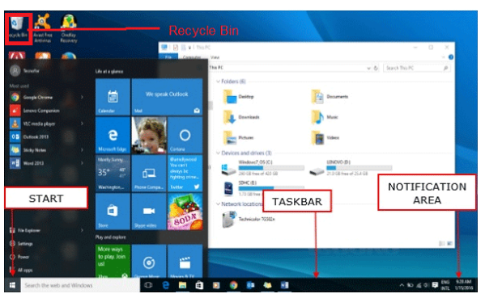**

**3.4. State the function of each component of a Window.**

**Table of Contents**

Microsoft Windows, the most widely used operating system in the world, employs the metaphor of a window for navigation and file management. Understanding the parts of a window is the first step to knowing how to navigate through the operating system.

**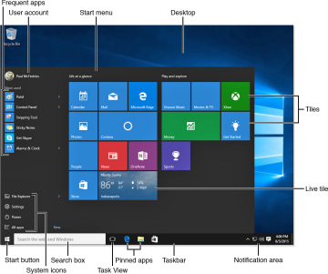**

**The Title Bar**

At the top of every window is the title bar. The center of the title bar displays either the name of the program you are currently working in or relevant information about what is happening in the program at any given moment. When the window is not maximized, this is where you can click and drag to move the window to a new location on the screen.

**Minimize, Maximize, Close Buttons**

In the upper right-hand corner of the window are the three buttons used to minimize, maximize, and close the window. Minimizing the window shrinks it to nothing and places it out of sight. Maximizing the window makes it fill the screen and locks it into position so that it cannot be moved by dragging the title bar. Closing the window shuts down the program.

**The Scroll Bar**

On the right side of the window is the scroll bar, which appears only if there is information to be displayed beyond the bottom range of the current window size. Clicking and dragging on the slider in the scroll bar moves the contents of the window up or down so you can view all of the data available.

**The Menu Bar**

Most programs will have a menu bar visible in the upper left-hand corner of the window. The menu bar appears as the text for most programs and usually starts with “File” at the far left. Accessing the menu allows you to view various commands available to that program, including closing the program or the window.

**The Work Space**

The workspace is all of the areas inside the window where data for the current program is displayed. usually, the workspace will have a white background, but it is possible to customize this in all versions of Windows, and it may vary by program.

**3.5. Describe the Method of starting a program using start button:**

The Start or Start button was first introduced with [Microsoft](https://www.computerhope.com/comp/msoft.htm) [Windows 95](https://www.computerhope.com/jargon/w/win95.htm) and is found in all releases of Windows since. Start allows you to access your computer [programs](https://www.computerhope.com/jargon/p/program.htm) and configure Microsoft Windows easily by accessing the [Start menu](https://www.computerhope.com/jargon/s/startmen.htm).

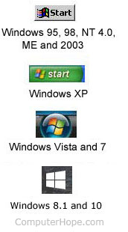

To open the Start menu—which contains all your apps, settings, and files—do either of the following:

* On the center or left end of the taskbar, select the **Start**icon  .
* In Windows 10 and earlier versions, the Windows Start is at the bottom left part of the desktop screen. However, Start can be placed at the top-left or top-right part of the screen by moving the Windows [taskbar](https://www.computerhope.com/jargon/t/taskbar.htm). In [Windows 11](https://www.computerhope.com/jargon/w/windows-11.htm), Start is located in the middle of the taskbar. Clicking Start opens the [Start menu](https://www.computerhope.com/jargon/s/startmen.htm) (except in Windows 8) that gives you access to all the installed programs, and other Windows features. Below is a visual example of the Start button and its location in Windows 7.

**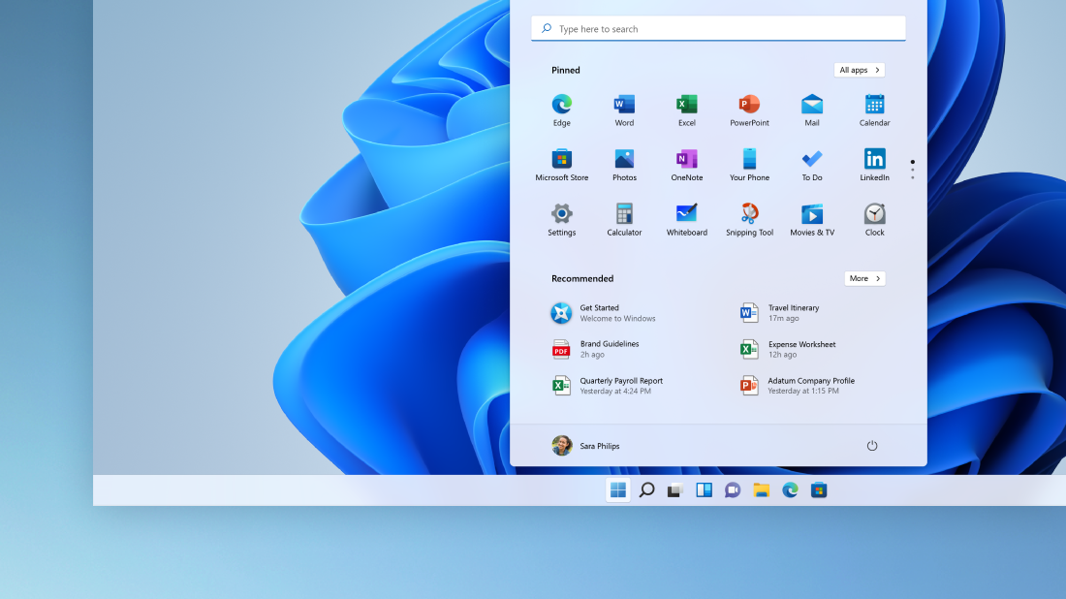**

**3.6. Explain usage of Maximize, Minimize, Restore Down And Close Buttons:**

# Maximizing, Minimizing, and Restoring Windows

When you first create a window, it displays as a default size. To modify the size of the window, you can maximize, minimize, or restore the window to make the best use of your desktop space.

A brief description of the window size controls are listed below:

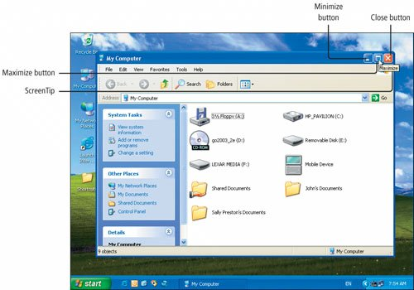

## https://help.tradestation.com/09_01/tradestationhelp/image/windows%20-%20maximize%20button.gif  Maximize Button

Maximizing a window refers to enlarging it to fit the size of your entire screen. The menus and toolbars remain, but the title bar disappears. Essentially, you want to maximize the space used by the window.

* To maximize a window, click image\maximize.gif on the right corner of a window's title bar or a minimized window (referred to as an icon).

In a Chart Analysis window, you can also double-click the right mouse button to maximize the window. To restore the window, double right-click the right mouse button again.

## https://help.tradestation.com/09_01/tradestationhelp/image/windows%20-%20minimize%20button.gif  Minimize Button

Minimizing a window refers to collapsing the window into an icon. The window is still open (and therefore analysis techniques are still calculating), but it takes up very little screen space.

* To minimize a window, click image\minimize.gif on the window's title bar.

## https://help.tradestation.com/09_01/tradestationhelp/image/windows%20-%20restore%20button.gif  Restore Button

Restoring a window refers to returning the window to its original state. If the window was in its default state and is maximized or minimized, restoring the window returns the window to its default state. If the window maximized and then minimized, restoring the window returns the window to the maximized state.

* To restore a window to its original state, click image\restore.gif on the right corner of a window's title bar or a window's icon.

**3.7. State the Meaning of a File ,Folder:**

A file is the common storage unit in a computer, and all programs and data are "written" into a file and "read" from a file. A folder holds one or more files, and a folder can be empty until it is filled. A folder can also contain other folders, and there can be many levels of folders within folders. Folders within a folder are technically known as "subfolders," but this distinction is often disregarded.  
  
Folders provide a method for organizing files much like a manila file folder contains paper documents in a file cabinet. In fact, files that contain text are often called documents.  
  
Folders are also called "directories," and they are created on the hard drive (HD) or solid state drive (SSD) when the operating system and applications are installed. Files are always stored in folders. In fact, even the computer's desktop is a special kind of folder that displays its contents across the screen .  
**File Extensions**  
Files are identified by a short "extension" following a period at the end of their name. For example, ABC.JPG is a JPEG image, ABC.DOC is a Microsoft Word document file, and ABC.EXE is an executable application in Windows. Although extensions can be added to folder names, extensions are primarily a file convention.

**3.8. Describe the Method of *viewing the contents of hard disk drive using Explorer:***

Viewing the contents of a hard drive is possible using Windows Explorer, a tool integrated into Windows operating systems since Windows 95. This tool makes browsing through hard drive folders a breeze, but that assumes the hard drive is accessible to the computer. If your business shuffles through many hard drives, you eventually need to access an internal hard drive that’s not actually installed on your system. This is still possible using a specialized adapter. However, to view all files and folders, you may also need to tweak your system settings to view files that are designated as hidden or system files.

**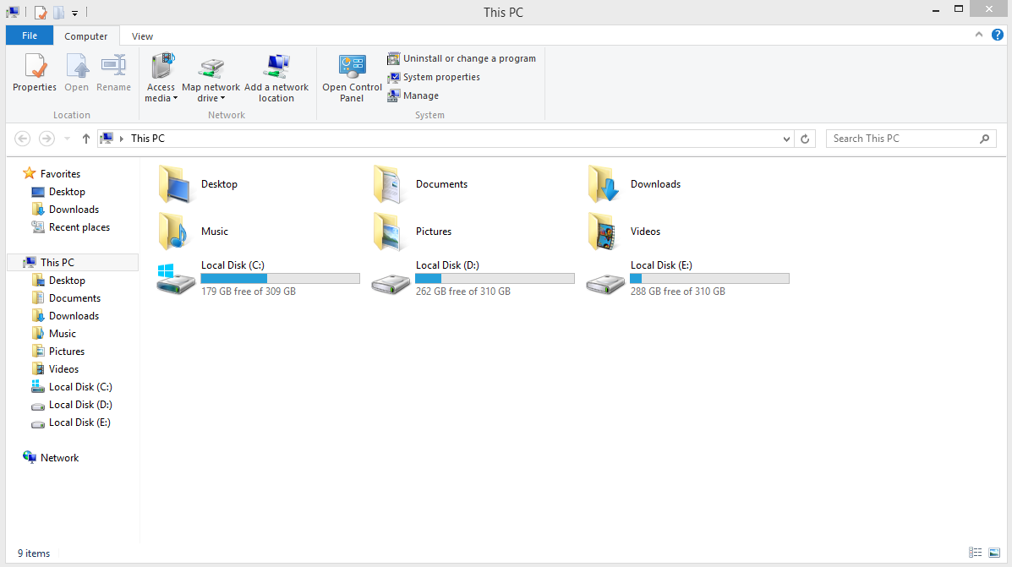**

## Windows Explorer

1. Click "Start" and select "Computer" to open Windows Explorer.

2. Double-click the hard drive's letter from the right pane's Hard Disk Drives section to view the drive's contents. To view files within folders, double-click the folder.

3. Right-click the drive letter and select "Eject" when you are finished browsing the drive.

**Viewing All Files**

1. Click "Organize" in the Windows Explorer toolbar and select "Folder and Search Options."

2. Click the "View" tab.

3. Click "Show Hidden Files, Folders, and Drives" in the Advanced Settings section.

4. Uncheck "Hide Protected Operating System Files (Recommended)" in the Advanced Settings section and click "Yes" in the confirmation dialog box. Click "OK."

**3.9. Describe The Method Of Finding A File Using Search Option:**

Find your files in Windows 10 using one of these methods.

**Search from the taskbar:**Type the name of a document (or a keyword from it) into the search box on the taskbar. You'll see results for documents across your PC and OneDrive. To filter your search, you can select the **Documents** tab—and then your search results will only show documents.

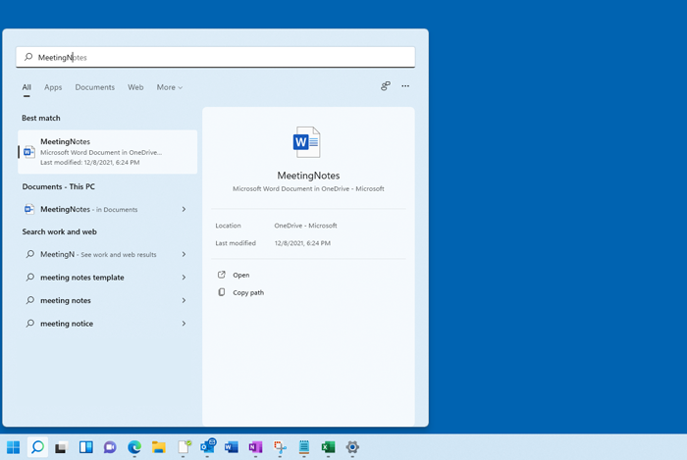

**Search File Explorer:** Open **File Explorer ** from the taskbar or select and hold the **Start ** menu (or right-click), select **File Explorer  **, then select a search location:

* To quickly find relevant files from your PC and the cloud, search from **Home**.

**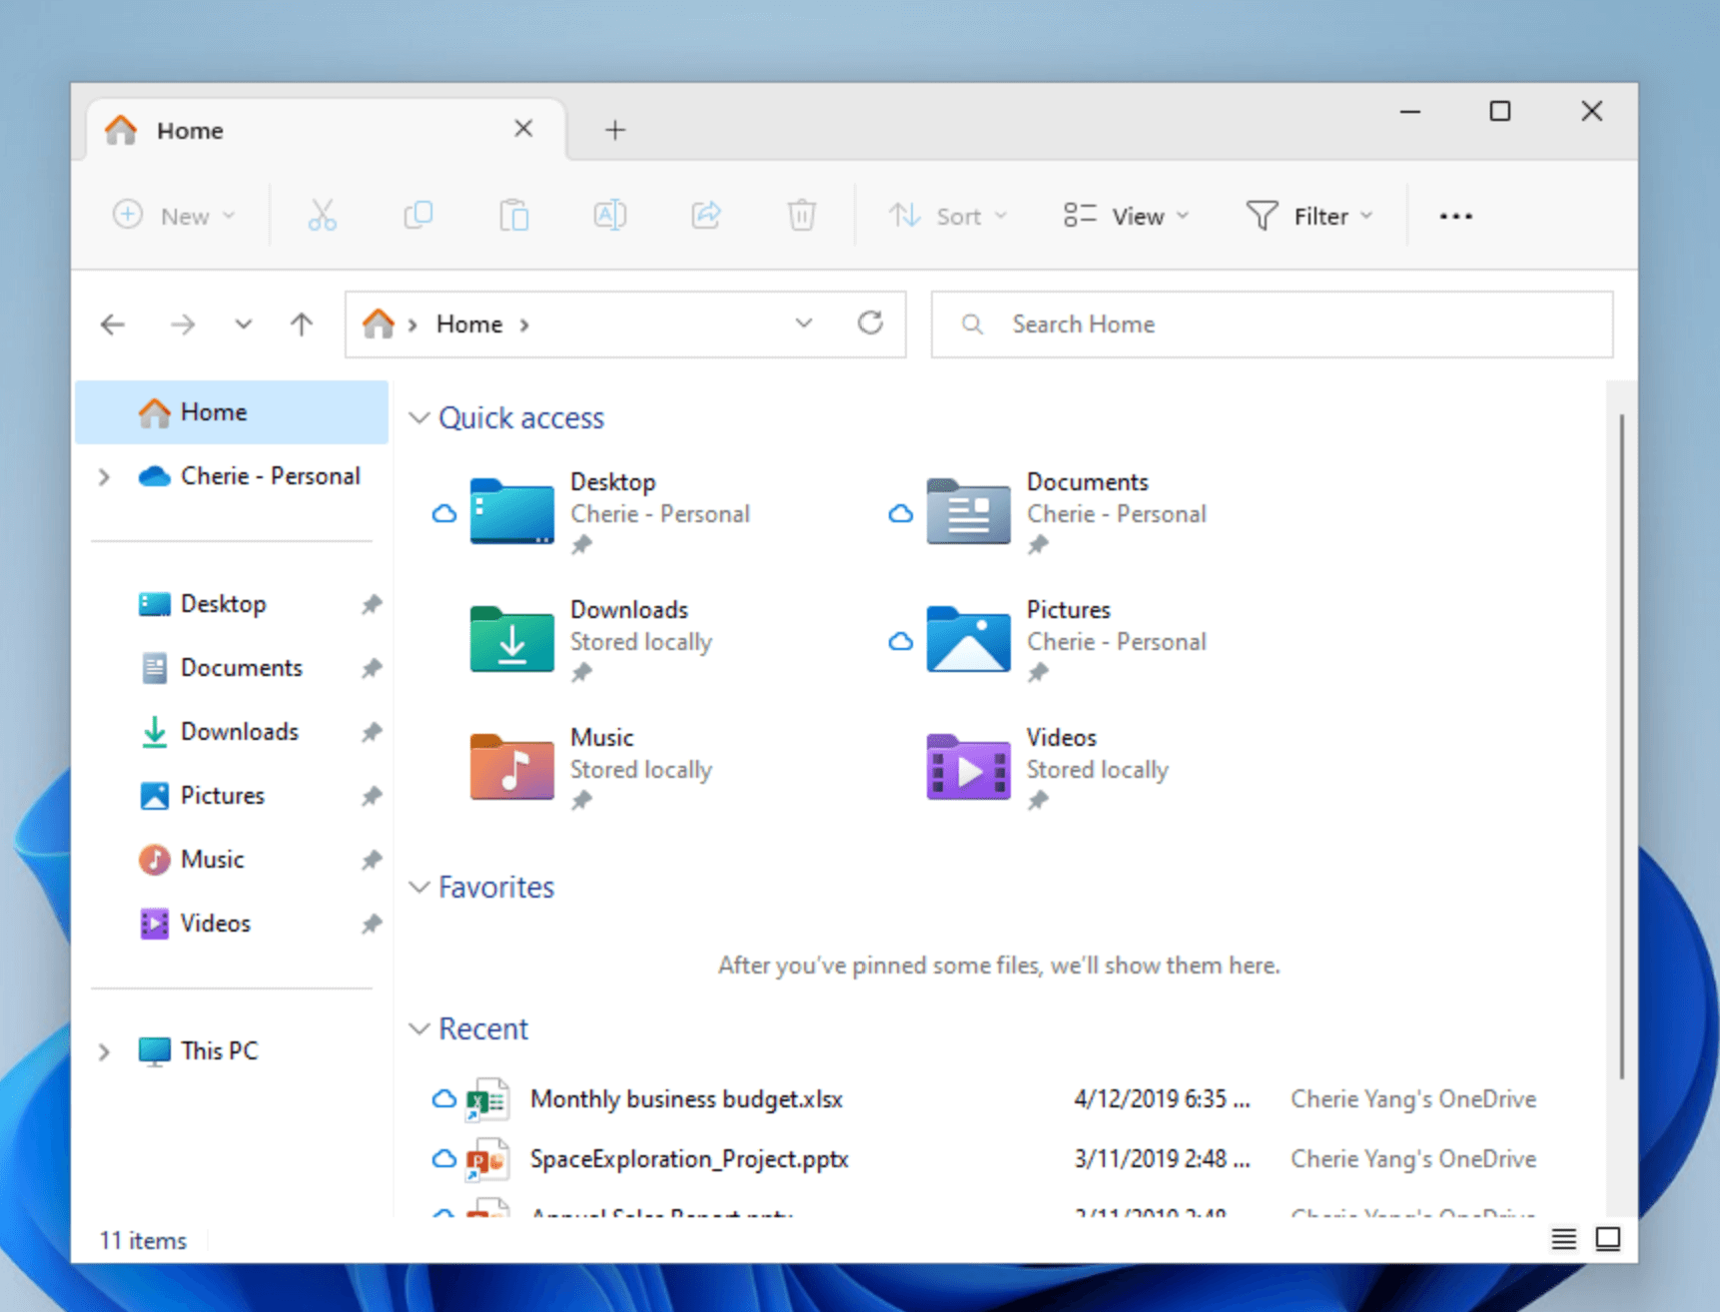**

* To find files stored inside a folder, search from a folder like **Downloads**.
* To do a slow but in-depth search, search from **This PC** instead of **Home**.

**3.10. Use Control Panel For:**

**3.10.1. installing and uninstalling software:/ 3.10.2. installing and uninstalling hardware:**

**Installation steps**

Now you can easily install and uninstall

Following are step-by-step instructions for installing Python. If you have not done so already, you will need to **download the Python setup file** before following these installation steps.

## 1. Open the setup file

You should have saved the downloaded file somewhere on your computer. Find the file, and **double-click** it to open it.

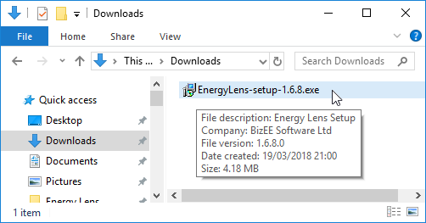

(If you can't find the setup file on your computer, you may need to download it again, making a careful note of where on your computer you save it.)

## 2. Handle the security warning, if it appears

Depending on your Windows security settings, you may get a security warning:

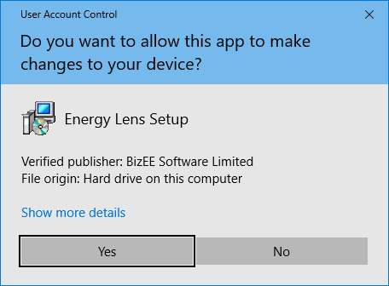

If you do get a security warning like the one shown above, click the **"Yes"** button to continue with the installation.

## 3. Follow the steps of the setup wizard

The Energy Lens setup wizard should automatically start. The first screen is shown below:

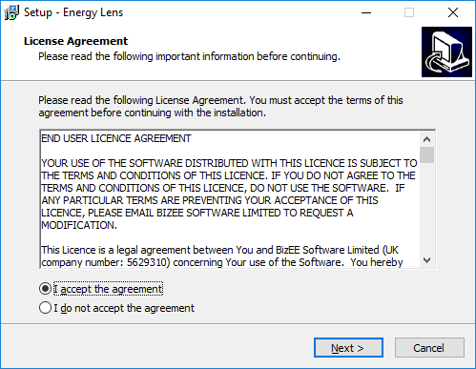

Click **"Next >"** to continue through each stage of the wizard. Once you have reached the end, you should see the following screen:

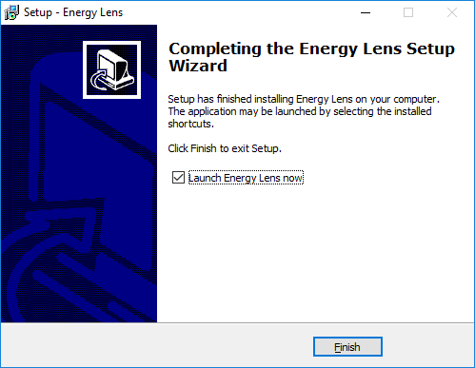

Click the **"Finish"** button to complete the installation.

## 4. Getting started with Energy Lens

The last page of the installation wizard gives you the option of automatically launching Energy Lens (see the screenshot above). If you unchecked this option before clicking the **"Finish"** button, take a look at the getting started instructions: they explain how to open Energy Lens and how to access the help-files.

**Uninstallation steps :**

Now we can easily uninstall any software from computer or laptop

**Follow few simple steps to Uninstall Python Software**

* click start --> Control panel. the control panel window appears
* Double-click the Add or Remove Programs icon. A list of the programs installed on your computer appears.
* Select **Python Software**  and click the Remove button. A warning message before uninstalling the software will be displayed on the screen.
* Click the Yes button to un-install the software
* Click OK button.

**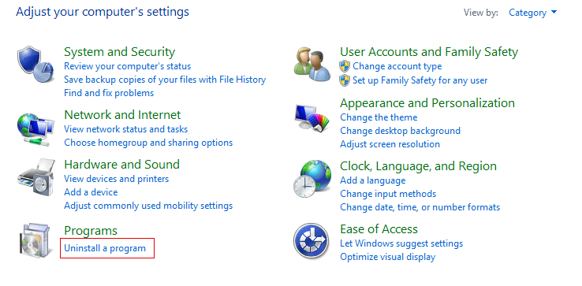**

**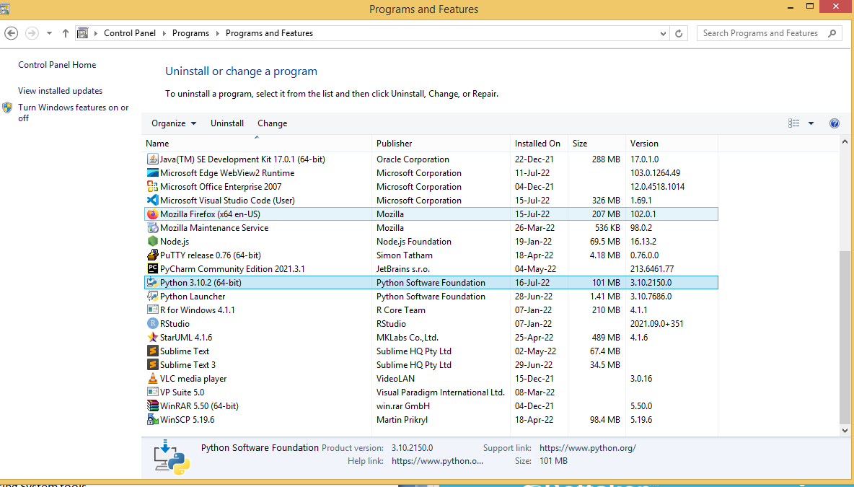**

**3.10.3. Changing the system date and time:**

Date & Time Option are used to update the system date and time. These are the steps required to update date and time:-

1. Double click on the **Date/Time** option from **Control Panel** or Double Click on the clock on the right most corner of the Taskbar
2. Click on the current date on the calendar appeared
3. Choose correct Month & Year from the Month & Year field respectively.
4. To change the time use up or down arrow , either click on the time field and directly type the current time.
5. To select correct time zone click on the arrow and select correct time zone.
6. Click on **Apply**Button and then click on **Ok** Button.

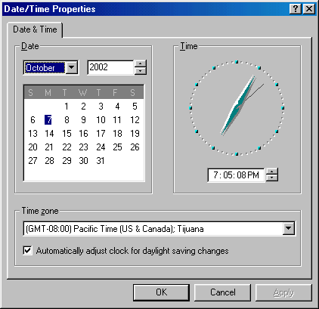**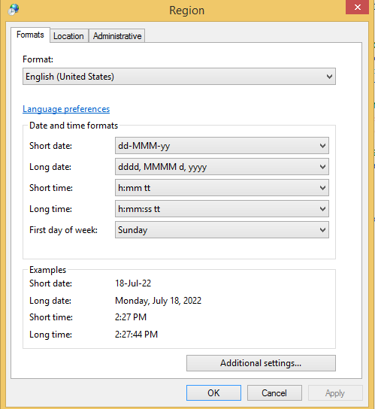**

**3.10.4. Installing a printer:**

The printers option is the shortcut for the printer folder which we have already discussed in the My Computer. After double clicking on this option we get the printer folder. Here we can change the various settings of printer like to install new printer, remove any printer or to set any printer as default. To install new printer follow these steps:-

1. Double click on the **Printers**icon to open the printers folder.
2. Double click on the **Add New Printer** icon to install new printer.
3. In the appeared dialog box press **Next** button.
4. Then computer will show a list of printers of different manufacturers. Select one, of which the printer you have. If the name of printer is not in the list then click on **Have Disk** button. and specify the path for printer driver.
5. Press **Next** button
6. Select the port for printer. Click **Next**button.
7. Select **Yes** to set the new printer as default printer. Click**Next** button.
8. Click**Finish** button.

**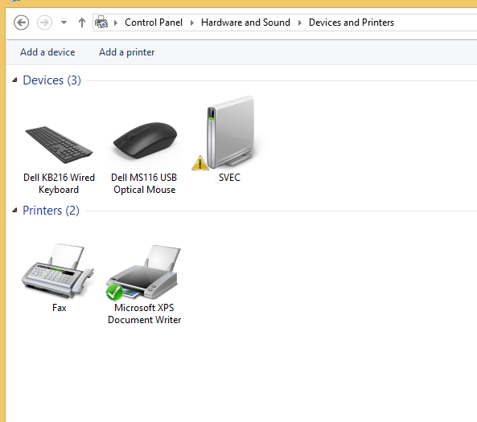 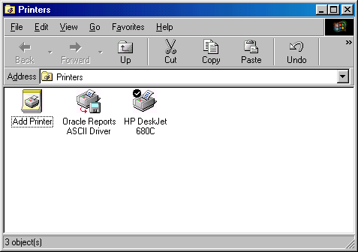**

**3.11. Explain Drive space using system tool option of Accessories group:**

Alternatively referred to as **disk space**, **disk storage**, or **storage capacity**, **disk capacity** is the maximum amount of data a disc, disk, or drive is capable holding. Disk capacity is displayed in MB (megabytes), GB (gigabytes), or TB (terabytes). All types of media capable of storing information have a disk capacity, a CD, DVD, floppy disk, hard drive, memory stick/card, and USB thumb drive.

As information is saved to a disk, the disk usage is increased. However, the disk capacity always remains the same. For example, a 200 GB hard drive with 150 GB of installed programs has 50 GB of free space but still has a total capacity of 200 GB. When a device reaches its capacity, it cannot hold any more information.

## Disk capacity examples

The images below show the total disk capacity of a hard drive, how much space is being used, and what's available. In the first picture, the Capacity (115 GB) is shown under the Free space. In the second picture, the used space and capacity is shown on the same line. For example, the Primary Drive (C:) has a disk capacity of 232 GB, with 39.1 GB free.

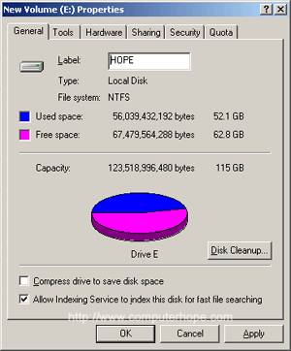

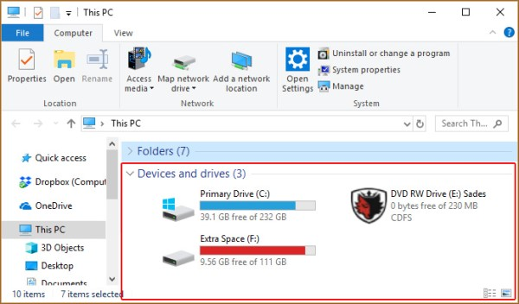

## Partition capacity

A hard drive can be [partitioned](https://www.computerhope.com/jargon/p/partition.htm) into sections that give the appearance of a new drive. When a drive is partitioned, its overall disk capacity remains the same. However, because the partitions are treated as new drives, each partition has a different capacity.

For example, a 200 GB hard drive partitioned into two drives of 100 GB (C: and D: drive) would report that the D: drive has a capacity of 100 GB even though it's part of a 200 GB hard drive.

**3.12. Explain Disk Defragmentation Using System Tools**

**Disk Defragmentation :**

**Fragment** a small piece that comes from something large.

**Disk Fragmentation :** Fragmentation of disk means allocating data in non-sequence form. Usually, data is stored in hard drive in sequence form and data header is keep following incoming data so that it is easy to read data efficiently but when we delete some older data from this sequence. Sequence of data management is disturbed and data is looking like scatter form and also when we update older data with a bigger size of data Operating System split entire data into small packets and store data in different locations of storage area.

**Types Of Fragmentation :**

**Internal Fragmentation:**   
Internal fragmentation happens when memory is split into mounted sized blocks. Whenever a method request for memory, mounted sized block is allotted to method. just in case memory allotted to method is somewhat larger than memory requested, then distinction between allotted and requested memory is that internal fragmentation.

[**External Fragmentation**](https://www.geeksforgeeks.org/difference-between-internal-and-external-fragmentation/) **:**  
External fragmentation happens when there’s a sufficient quantity of area within memory to satisfy the memory request of a method. however, the process’s memory request cannot be fulfilled because the memory offered is during a non-contiguous manner. Either you apply a first-fit or best-fit memory allocation strategy it’ll cause external fragmentation.

**Data Fragmentation :**  
In data fragmentation, data is stored in non-sequential form.



**Defragmentation of Disk :**

1. Right-click on any drive available on your computer which we want to Defragment then click on the tools section and after optimize.

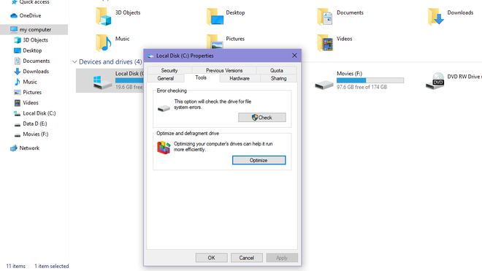

    2. After Optimize it will check the total fragmented available in the selected disk and click on Optimize.

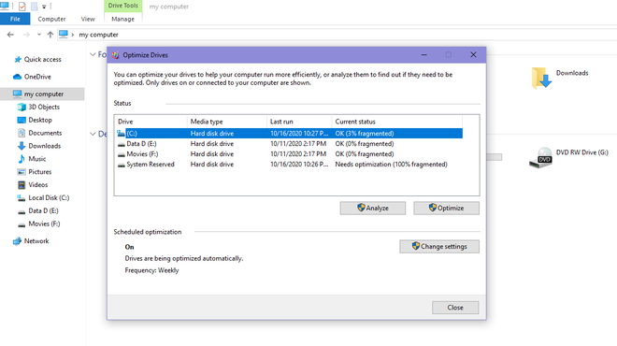

3. It will take some time and after this process 0% Fragment will be present in the disc.

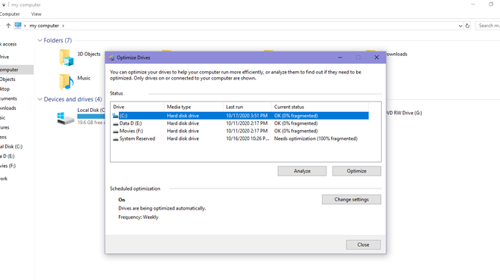

**3.13. Explain The Procedure For Changing Resolution, Color, Appearance, Screensaver Options Of The Display**

Screen savers can be useful for locking your computer while you're away, or displaying your favorite photos as a slideshow. The following sections show you how to change your screen saver and adjust its properties. To proceed, choose your operating system from the list below and follow the instructions.

## Windows Vista, 7, 8, and 10

1. Press the Windows key, type **Change screen saver**, then press Enter.
2. In the *Screen Saver Settings* window, click the **down arrow**.

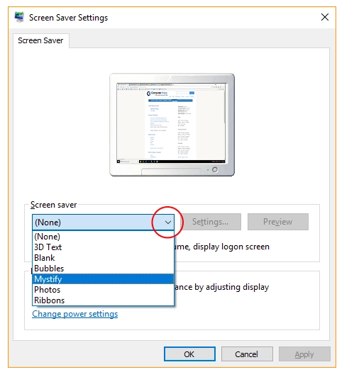

1. Select a screen saver from the drop-down menu.
2. Once you've chosen a screen saver, you have a few options. To change how long the computer waits before starting the screen saver, click the up or down arrows for the *Wait* option to your preferred timing. If you're using the **Photos** screen saver option, you can change the timing between pictures in **Settings**, then choose between slow, medium, and fast on the *Slide show speed*. When you're finished, click **Apply** (**A**) and then **OK** (**B**).

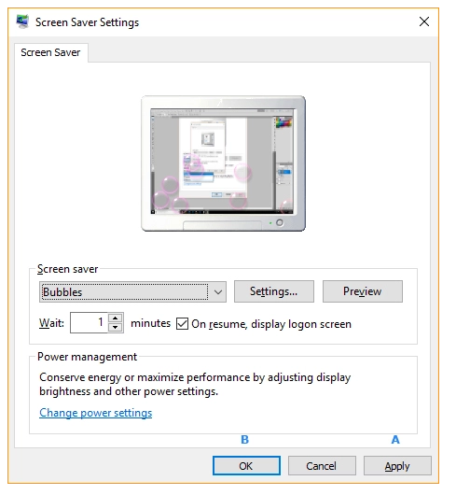

Setting the resolution in Windows 11, and Windows 10:

* Close all open programs.
* You can either right-click Start, and then click Control Panel or click on start and type Control Panel and click the icon that appears.
* In the Control Panel window, click System, and then click Display.
* Select the monitor that you want to change, if more than one monitor is connected to your computer.
* Click the Resolution drop-down box to see a list of recommended resolutions for that display.
* Click the resolution that you want, and then click Apply.
* Click **keep changes** if you want to keep the new settings.
* If not select **revert**.

**Adjusting the Refresh Rate in Windows 10**

Adjusting the Refresh Rate in Windows 10

1. Close all open programs.
2. You can either right-click **Start**, and then click **Control Panel** or click on start and type **Control Panel** and click the icon that appears.
3. In the **Control Panel** window, click **System**, and then click **Display**.
4. Select the monitor that you want to change, if more than one monitor is connected to your computer.
5. Click the **Display Adapter Properties** link.
6. Click the **Monitor** tab.
7. Click the **Screen refresh rate** drop-down menu under **Monitor settings**.
8. Select the **refresh rate that you want** from the available options, and then click **Apply**.
9. When you are informed that Windows is adjusting the refresh rate, click **OK**.

**4.0 Computer Hardware and Networking Basics**

**4.1 Hardware Basics**

* Computer hardware is a collective term used to describe any of the physical components of an analog or digital [computer](https://www.techtarget.com/searchwindowsserver/definition/computer). The term *hardware* distinguishes the tangible aspects of a computing device from [software](https://www.techtarget.com/searchapparchitecture/definition/software), which consists of written, machine-readable instructions or [programs](https://www.techtarget.com/searchsoftwarequality/definition/program) that tell physical components what to do and when to execute the instructions.
* Hardware and software are complementary. A computing device can function efficiently and produce useful output only when both hardware and software work together appropriately.
* Computer hardware can be categorized as being either internal or external components. Generally, internal hardware components are those necessary for the proper functioning of the computer, while external hardware components are attached to the computer to add or enhance functionality.

**4.1.1 Identify Hardware Used For I/P, O/P & Inside Computer Case, System Board Components Used For Communication Among Devices**

A motherboard is the main [printed circuit board](https://en.wikipedia.org/wiki/Printed_circuit_board) (PCB) in general-purpose computers and other expandable systems. It holds and allows communication between many of the crucial electronic components of a system, such as the [central processing unit](https://en.wikipedia.org/wiki/Central_processing_unit) (CPU) and [memory](https://en.wikipedia.org/wiki/Computer_memory), and provides connectors for other [peripherals](https://en.wikipedia.org/wiki/Peripherals). Unlike a [backplane](https://en.wikipedia.org/wiki/Backplane), a motherboard usually contains significant sub-systems, such as the central processor, the [chipset](https://en.wikipedia.org/wiki/Chipset)'s [input/output](https://en.wikipedia.org/wiki/Input/output) and memory controllers, [interface](https://en.wikipedia.org/wiki/Interface_(computing)) connectors, and other components integrated for general use.

Motherboard means specifically a PCB with expansion capabilities. As the name suggests, this board is often referred to as the "mother" of all components attached to it, which often include peripherals, interface cards, and daughter boards: sound cards, video cards, network cards, host bus adapters, TV tuner cards.

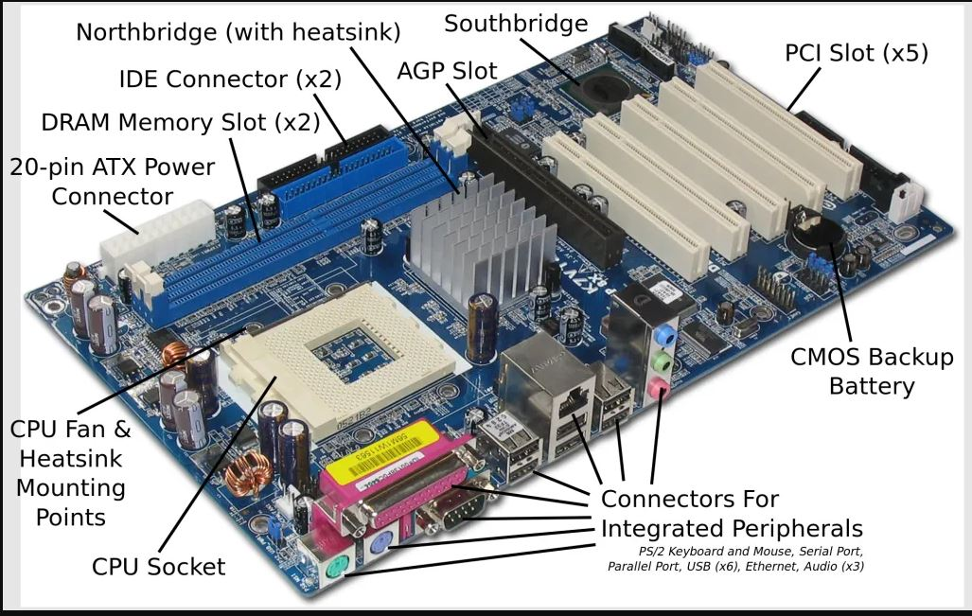

|  |  |
| --- | --- |
| **Chipset**: a chipset is a group of ICS that are designed to work together and are usually marked as a single product.  A chipset controls communication between processor and external devices | chip.jpg |
| **SMPS**:A switched-mode power supply (switching-mode power supply,  is an electronic power supply that incorporates a switching regulator to convert electrical power efficiently. An SMPS transfers power from a DC or AC source (often mains power, see AC adapter) to DC loads, such as a personal computer, while converting voltage | smps.jpg |
| **Disk drivers:** a disk drive is a physical drive in a computer capable of holding and retrieving information | **hdd.jpg** |
| **Mouse**: A computer mouse is a hand-held [pointing device](https://en.wikipedia.org/wiki/Pointing_device) that detects two-dimensional motion relative to a surface. This motion is typically translated into the motion of a [pointer](https://en.wikipedia.org/wiki/Pointer_(user_interface)) on a display, which allows a smooth control of the [graphical user interface](https://en.wikipedia.org/wiki/Graphical_user_interface) of a computer. |  |
| **Keyboard**: A computer keyboard is a peripheral input device modeled after the typewriter keyboard which uses an arrangement of buttons or keys to act as mechanical levers or electronic switches. Replacing early punched cards and paper tape technology, interaction via teleprinter -style keyboards have been the main input method for computers since the 1970s, supplemented by the computer mouse since the 1980s. |  |
| **Monitor:** A monitor is an output device that displays video images and text. a monitor is made up of circuitry, a screen , a power supply, buttons to adjust screen setting, and casing that holds all of these components. |  |
| **Printer:** A printer is an external hardware output device that takes the electronic data stored on a computer or other device and generates a hard copy of it. Printers are one of the most popular computer peripherals and commonly used to print text and phone. | **printer.jpg** |
| **Speaker:** A computer speaker is a hardware device that connects to a computer to generate sound. The signal used to produce the sound that comes from a computer speaker is created by the computers sound card. |  |
| **Modem:** A modem or Broadband modem is hardware device that connects a computer or router to a broadband network. For example, a cable modem and DSL Modem are two examples of Modems. | **modem.jpg** |
| **USB ports:** short form of Universal Serial Bus, USB is a plug-and-play interface that allows a computer to communicate with peripheral and other devices.USB connected devices cover a broad range ,any thing from keyboard, mouse, music players flash driver. | **usb.jpg** |
| **Parallel Ports:** A parallel port isa type of socket found on personal computers for interfacing with various peripherals. it is also known as a printer port or Centronics port | **ppp.png** |
| **Serial Port:** A serial port is a serial communication physical interface through which information transfers in or out one bit at a time. | **serail.jpg** |
| **PCI:** Peripheral component Interconnect, PCI was introduced by Intel in 1992.The PCI bus came in both 32-bit and 64-bit versions and was used to attach hardware to a computer. | **pci.jpg** |
| **RAM:** RAM stands for Random Access Memory. It is a hardware device that allows information to be stored and retrieved on a computer. |  |

**4.1.2 Software - 3 Types Of Software: ROM BIOS, OS, Application Software**

**Computer Software:** Software is a collection of instructions, procedures, and documentation that performs different tasks on a computer system. we can say also Computer Software is a programming code executed on a computer processor. The code can be machine-level code or the code written for an operating system. Examples of software are Ms Word, Excel, PowerPoint, Google Chrome, Photoshop, MySQL, etc.

# ROM BIOS

Basic Input / Output System- The first and last program executed by each and every computers used today. It operates on flag system which is a mechanical language i.e. zeros and ones. It works on the flow that is designed and integrated at the time of manufacturing the motherboard. Usually the motherboard holds the ROM and ROM contain the BIOS program module.

The BIOS is initiated when power is turned on and it checks for the basic hardware components in the system to start the operating system. The operating systems are built in a way to find a specific file by the BIOS which are the map to guide the BIOS further. These programs take charge of BIOS and use it to access peripheral components like keyboard, etc.The first program initiated while using Windows is NTLDR.dll. If this file went missing or renamed, the BIOS will throw an error displaying that the needed file is missing.

Normally the BIOS is programmed in a way as non-rewritable block of code. Because it is the first program to be executed and deals directly with the hardware components; if it’s misused or damaged ,the entire PC becomes useless and worth for none.

**Operating system**

An Operating System (OS) is an interface between a computer user and computer hardware. An operating system is a software which performs all the basic tasks like file management, memory management, process management, handling input and output, and controlling peripheral devices such as disk drives and printers.

Some popular Operating Systems include Linux Operating System, Windows Operating System, VMS, OS/400, AIX, z/OS, etc.

## Definition

An operating system is a program that acts as an interface between the user and the computer hardware and controls the execution of all kinds of programs.

**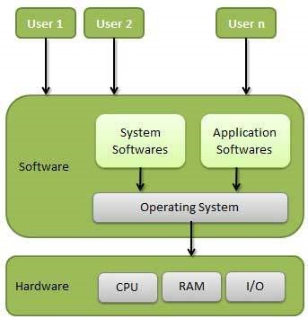**

**Application Software:**

The term “application software” refers to software that performs specific functions for a user. When a user interacts directly with a piece of software, it is called application software. The sole purpose of application software is to assist the user in doing specified tasks. Microsoft Word and Excel, as well as popular web browsers like Firefox and Google Chrome, are examples of application software. It also encompasses the category of mobile apps, which includes apps like WhatsApp for communication and games like Candy Crush Saga. There are also app versions of popular services, such as weather or transportation information, as well as apps that allow users to connect with businesses. Global Positioning System (GPS), Graphics, multimedia, presentation software, desktop publishing software, and so on are examples of such software.

**Types Of Application Software:**

Application software can also be categorized based on its chargeability and accessibility. Here is some application software:

* **Freeware:** It is offered for free, as the name implies. You can utilize freeware application software that you can obtain from the Internet. This software, on the other hand, does not allow you to change it or charge a fee for sharing it. Examples include Adobe PDF, Mozilla Firefox, and Google Chrome.
* **Shareware:** This is given away to users for free as a trial, usually with a limited-time offer. If consumers want to keep using this application software, they will have to pay. WinZip, Anti-virus, and Adobe Reader are instances of shareware.
* **Open-source:** This type of application software comes with the source code, allowing you to edit and even add features to it. These could be offered for free or for a fee. Open-source application software includes Moodle and Apache Web Server.
* **Closed source:** This category includes the majority of the application software programs used nowadays. These are normally charged, and the source code is usually protected by intellectual property rights or patents. It usually comes with a set of restrictions. Microsoft Windows, Adobe Flash Player, WinRAR, macOS, and other operating systems are examples.

**4.1.3 Explain Functions Of BIOS**

A computer's basic input/output system (BIOS) is a program that's stored in nonvolatile memory such as read-only memory (ROM) or flash memory, making it firmware. The BIOS (sometimes called ROM BIOS) is always the first program that executes when a computer is powered up.

Here's what happens during the boot process (see steps in diagram below):

1. Power is turned on.
2. The CPU hands control over to the BIOS.
3. The BIOS runs a program called Power-On Self Test, which determines how much memory the computer has and then confirms that critical low-level hardware is operating correctly. Any errors are indicated by sequences of audible beeps. After this, the BIOS disables all configurable devices.
4. The BIOS identifies all of the computer's peripheral devices, such as hard drives and expansion cards. It first looks for plug-and-play devices and assigns a number to each, but it doesn't enable the devices at this time.
5. The BIOS locates the primary boot or initial program load (IPL) device. This is usually a storage device such as a hard drive, floppy drive or CD-ROM that holds the operating system, but it can be a network card connected to a server. The BIOS also locates all of the system's secondary IPL devices.
6. The BIOS builds a system resource table, assigning conflict-free resources according to which devices it found and the configuration data stored in nonvolatile RAM.
7. It selects and enables the primary input (keyboard) and output (monitor) devices, so that if trouble occurs during the boot process, the BIOS can display a recovery screen and allow the user to select a stored configuration of system settings that are known to work. The BIOS captured these settings the last time the computer booted successfully, and it stores them in nonvolatile RAM.
8. It scans for non-plug-and-play devices, including the Peripheral Component Interconnect (PCI) bus, and adds data from their ROMs to its resource table.
9. The BIOS resolves device conflicts and configures the chosen boot device.
10. It enables plug-and-play devices by calling their option ROMs with appropriate parameters.
11. It starts the bootstrap loader. If, for some reason, the default IPL fails to load the operating system, the BIOS tries the next IPL device in the list.
12. The IPL device loads the operating system into memory.
13. The BIOS hands over control to the operating system, which may make other resource assignments.

**4.1.4 Explain Boot Process**

Booting is the process of starting a computer. It can be initiated by hardware such as a button press or by a software command. After it is switched on, a CPU has no software in its main memory, so some processes must load software into memory before execution. This may be done by hardware or firmware in the [CPU](https://www.javatpoint.com/cpu-full-form)

or by a separate processor in the computer system.

Restarting a computer also is called rebooting, which can be "**hard**", e.g., after electrical power to the [CPU](https://www.javatpoint.com/central-processing-unit)

is switched from off to on, or "**soft**", where the power is not cut. On some systems, a soft boot may optionally clear RAM to zero. Hard and soft booting can be initiated by hardware such as a button press or a software command. Booting is complete when the operative runtime system, typically the operating system and some applications, is attained.

The process of returning a computer from a state of sleep does not involve booting; however, restoring it from a state of hibernation does. Minimally, some embedded systems do not require a noticeable boot sequence to begin functioning and, when turned on, may run operational programs that are stored in ROM. All computer systems are state machines and a reboot may be the only method to return to a designated zero-state from an unintended, locked state.

### Sequencing of Booting

Booting is a start-up sequence that starts the operating system of a computer when it is turned on. A boot sequence is the initial set of operations that the computer performs when it is switched on. Every computer has a boot sequence.

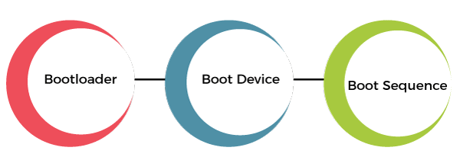

**1. Boot Loader:** Computers powered by the central processing unit can only execute code found in the system's memory. Modern operating systems and application program code and data are stored on nonvolatile memories. When a computer is first powered on, it must initially rely only on the code and data stored in nonvolatile portions of the system's memory. The operating system is not really loaded at boot time, and the computer's hardware cannot perform many complex systems actions.

The program that starts the chain reaction that ends with the entire operating system being loaded is the boot loader or bootstrap loader. The boot loader's only job is to load other software for the operating system to start.

**2. Boot Devices:** The boot device is the device from which the operating system is loaded. A modern PC BIOS (Basic Input/Output System) supports booting from various devices. These include the local hard disk drive, optical drive, floppy drive, a network interface card, and a USB device. The BIOS will allow the user to configure a boot order. If the boot order is set to:

* CD Drive
* Hard Disk Drive
* Network

The BIOS will try to boot from the [CD](https://www.javatpoint.com/cd)

drive first, and if that fails, then it will try to boot from the [hard disk drive](https://www.javatpoint.com/hdd)

, and if that fails, then it will try to boot from the network, and if that fails, then it won't boot at all.

**3. Boot Sequence:** There is a standard boot sequence that all personal computers use. First, the CPU runs an instruction in memory for the BIOS. That instruction contains a jump instruction that transfers to the BIOS start-up program. This program runs a power-on self-test (POST) to check that devices the computer will rely on are functioning properly. Then, the BIOS goes through the configured boot sequence until it finds a bootable device. Once BIOS has found a bootable device, BIOS loads the bootsector and transfers execution to the boot sector. If the boot device is a hard drive, it will be a master boot record (MBR).

The MBR code checks the partition table for an active partition. If one is found, the MBR code loads that partition's boot sector and executes it. The boot sector is often operating system specific, and however, in most operating systems, its main function is to load and execute the operating system kernel, which continues start-up. Suppose there is no active partition, or the active partition's boot sector is invalid. In that case, the MBR may load a secondary boot loader which will select a partition and load its boot sector, which usually loads the corresponding operating system kernel.

**Types of Booting**

There are two types of booting in an operating system.

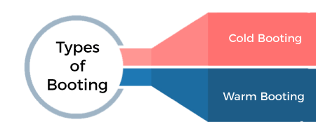

1. **Cold Booting:** When the computer starts for the first time or is in a shut-down state and switch on the power button to start the system, this type of process to start the computer is called cold booting. During cold booting, the system will read all the instructions from the ROM (BIOS) and the Operating System will be automatically get loaded into the system. This booting takes more time than Hot or Warm Booting.
2. **Warm Booting:** Warm or Hot Booting process is when computer systems come to no response or hang state, and then the system is allowed to restart during on condition. It is also referred to as rebooting. There are many reasons for this state, and the only solution is to reboot the computer. Rebooting may be required when we install new software or hardware. The system requires a reboot to set software or hardware configuration changes, or sometimes systems may behave abnormally or may not respond properly. In such a case, the system has to be a force restart. Most commonly **[Ctrl+Alt+Del](https://en.wikipedia.org/wiki/Control-Alt-Delete" \t "_blank)**

button is used to reboot the system. Else, in some systems, the external reset button may be available to reboot the system.

### Booting Process in Operating System

When our computer is switched on, it can be started by hardware such as a button press, or by software command, a computer's central processing unit (CPU) has no software in its main memory, there is some process which must load software into main memory before it can be executed. Below are the six steps to describe the boot process in the operating system, such as:

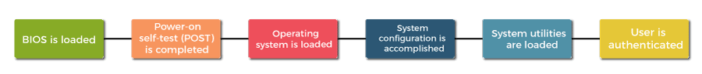

**Step 1:** Once the computer system is turned on, **BIOS** (Basic Input /Output System) performs a series of activities or functionality tests on programs stored in ROM, called on **POST** (Power-on Self Test) that checks to see whether peripherals in the system are in perfect order or not.

**Step 2:** After the BIOS is done with pre-boot activities or functionality test, it read bootable sequence from **CMOS** (Common Metal Oxide Semiconductor) and looks for master boot record in the first physical sector of the bootable disk as per boot device sequence specified in **CMOS**. For example, if the boot device sequence is:

* Floppy Disk
* Hard Disk
* CDROM

**Step 3:** After this, the master boot record will search first in a [floppy disk drive](https://www.javatpoint.com/what-is-a-floppy-disk)

. If not found, then the hard disk drive will search for the master boot record. But if the master boot record is not even present on the hard disk, then the CDROM drive will search. If the system cannot read the master boot record from any of these sources, ROM displays **"No Boot device found"** and halted the system. On finding the master boot record from a particular bootable disk drive, the operating system loader, also called Bootstrap loader, is loaded from the boot sector of that bootable drive· into memory. A bootstrap loader is a special program that is present in the boot sector of a bootable drive.

**Step 4:** The bootstrap loader first loads the **IO.SYS** file. After this, **MSDOS.SYS** file is loaded, which is the core file of the DOS operating system.

**Step 5:** After this, **MSDOS.SYS** file searches to find Command Interpreter in **CONFIG.SYS** file, and when it finds, it loads into memory. If no Command Interpreter is specified in the **CONFIG.SYS** file, the **COMMAND.COM** file is loaded as the default Command Interpreter of the DOS operating system.

**Step 6:** The last file is to be loaded and executed is the **AUTOEXEC.BAT** file that contains a sequence of DOS commands. After this, the prompt is displayed. We can see the drive letter of bootable drive displayed on the computer system, which indicates that the operating system has been successfully on the system from that drive.

**4.1.5 Explain POST and important Beep Codes**

The POST (Power On Self Test) is a collection of test programs. The function of these programs is testing the various functional units in the PC and verifying whether they are working or not. The POST programs are automatically executed whenever the PC is turned on or reset.

If the computer passes the POST the computer will have a single beep as the computer starts and the computer will continue to start normally. However, if the computer fails the POST, the computer will either not beep at all or will generate a beep code, which tells the user the source of the problem.

**The steps of a POST:**

Each time the  computer boots up the computer must past the POST. Below is the common steps a POST performs each time your computer starts.

1.     Test the power supply to ensure that is turned on and that it releases its reset signal.

2.     CPU must exit the reset status mode and there after be able to execute instructions.

3.     BIOS checksum must be valid, meaning that it must be readable.

4.     CMOS checksum must be valid, meaning that it must be readavle.

5.     CPU must be able to read all forms of memory such as the memory controller, memory bus and memory module.

6.     The first 64KB of memory must be operational and have the capability to be read and written to and from, and capable of containing the POST code.

7.     I/O bus/controller must be accessible.

8.     I/O bus must be able to write/read from the video subsystem and be able to read all video RAM.

If the computer does not pass any of the above tests, your computer will receive an irregular POST is a beep code that is different from the standard one or two beeps. This could be either no beeps at all or a combination of different beeps indicating  what is causing the computer not to past the POST.

|  |  |
| --- | --- |
| 1 short beep | Normal post –system is ok |
| 2 short beeps | Post error –error code shown on screen |
| 3 no beep | Power supply or system board problem |
| Continuous beep | Power supply, system board or keyboard problem |
| Repeating short beeps | Power supply or system board problem |
| 1 long, 1 short beep | System board problem |
| 1 long. 2 short beeps | Display adapter problem (MDA, CGA) |
| 1 long, 3 short beeps | Enhanced Graphics Adapter (EGA) |
| 3 long beeps | 3270 keyboard card |

**4.1.6 Describe about different connectors.**

**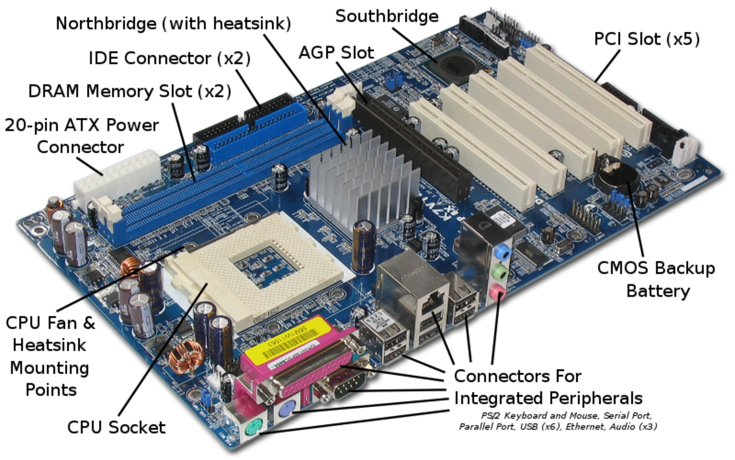**

**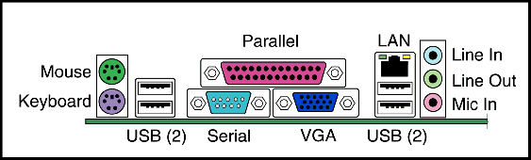**

**4.2 Networking Basics**

**4.1.1. Explain Meaning Of A Computer Network.**

A computer network is a system that connects numerous independent computers in order to share information (data) and resources. The integration of computers and other different devices allows users to communicate more easily. A computer network is a collection of two or more computer systems that are linked together. A network connection can be established using either cable or wireless media. Hardware and software are used to connect computers and tools in any network.                                                                                                            
A computer network consists of various kinds of nodes. Servers, networking hardware, personal computers, and other specialized or general-purpose hosts can all be nodes in a computer network. Hostnames and network addresses are used to identify them.

**Criteria of good network:**

1. **Performance:** It can be measured in many ways, including transmit time and response time. Transit time is the amount of time required for a message to travel from one device to another. Response time is the elapsed time between an inquiry and a response. The performance of the network depends on a number of factors, including the number of users, the type of medium & hardware
2. **Reliability:** In the addition to accuracy is measured by frequency of failure, the time it takes a link to recover from failure, and the network’s robustness in catastrophe.
3. **Security:** Network security issues include protecting data from unauthorized access, protecting data from damage and development, and implementing policies and procedures for recovery from breaches and data loss.

**4.1.2. Describe the concept of a Local Area Network, Wide Area Network**

**Types of Networks**

**Division based on the communication medium**

* **Wired Network:** As we all know, “wired” refers to any physical medium made up of cables. Copper wire, twisted pair, or fiber optic cables are all options. A wired network employs wires to link devices to the Internet or another network, such as laptops or desktop PCs.
* **Wireless Network:** “Wireless” means without wire, media that is made up of electromagnetic waves (EM Waves) or infrared waves. Antennas or sensors will be present on all wireless devices. Cellular phones, wireless sensors, TV remotes, satellite disc receivers, and laptops with WLAN cards are all examples of wireless devices. For data or voice communication, a wireless network uses radio frequency waves rather than wires.

**Division Based On Area Covered**

* **Local Area Network (LAN):** A LAN is a network that covers an area of around 10 kilometers. For example, a college network or an office network. Depending upon the needs of the organization, a LAN can be a single office, building, or Campus. We can have two PCs and one printer in-home office or it can extend throughout a company and include audio and video devices. Each host in LAN has an identifier, an address that defines hists in LAN. A packet sent by the host to another host carries both the source host’s and the destination host’s address.
* **Metropolitan Area Network (MAN):** MAN refers to a network that covers an entire city. For example: consider the cable television network.
* **Wide Area Network (WAN):** WAN refers to a network that connects countries or continents. For example, the Internet allows users to access a distributed system called www from anywhere around the globe.WAN interconnects connecting devices such as switches, routers, or modems. A LAN is normally privately owned by an organization that uses it. We see two distinct examples of WANs today: point-to-point WANs and Switched WANs

**4.1.3. Compare Internet And Intranet**

Generally, most people are confused between the internet and the intranet. While there are exist lots of differences to differentiate them.

**Internet:**   
Internet is used to connect the different networks of computers simultaneously. It is a public network therefore anyone can access the internet. On the internet, there are multiple users and it provides an unlimited of information to the users.

**Intranet:**   
Intranet is the type of internet that is used privately. It is a private network therefore anyone can’t access the intranet. On the intranet, there is a limited number of users and it provides a piece of limited information to its users.

**Types Of Network**

Now, we shall see the difference between the internet and intranet:

|  |  |  |
| --- | --- | --- |
| S.NO | Internet | Intranet |
| 1. | Internet is used to connect different networks of computers simultaneously. | Intranet is owned by private firms. |
| 2. | On the internet, there are multiple users. | On an intranet, there are limited users. |
| 3. | Internet is unsafe. | Intranet is safe. |
| 4. | On the internet, there is more number of visitors. | In the intranet, there is less number of visitors. |
| 5. | Internet is a public network. | Intranet is a private network. |
| 6. | Anyone can access the Internet. | In this, anyone can’t access the Intranet. |
| 7. | The Internet provides unlimited information. | Intranet provides limited information. |
| 8. | Using Social media on your phone or researching resources via Google. | A company used to communicate internally with its employees and share information |

**4.1.4. Describe About Internet Service Provider.**

ISP stands for Internet Service Provider. It is a company that provides access to the internet and similar services such as Website designing and virtual hosting. For example, when you connect to the Internet, the connection between your Internet-enabled device and the internet is executed through a specific transmission technology that involves the transfer of information packets through an Internet Protocol route.

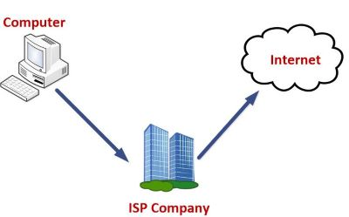

Data is transmitted through different technologies, including cable modem, dial-up, DSL, high speed interconnects. Accordingly, based on the method of data transmission, the Internet access provided by ISPs can be divided into many types, some of which are as follows:

**Dial-up Internet access:** It is the oldest technology to provide Internet access by modem to modem connection using telephone lines. In this method, the user's computer is connected to a modem with a telephone line. This method has become outdated today due to slow connection speed. However, in remote areas, this method can be used where the broadband network is not available.

**DSL:** DSL, which stands for 'digital subscriber line' is an advanced version of the dial-up Internet access method. It uses high frequency to execute a connection over the telephone network and allows the internet and the phone connection to run on the same telephone line. This method offers an Asymmetric Digital Subscriber (ADSL), where the upload speed is less than the download speed, and a Symmetric Digital Subscriber Line (SDSL), which offers equal upload and download speeds. Out of these two, ADSL is more popular among users and is popularly known as DSL.

**Wireless Broadband (WiBB):** It is a modern broadband technology for Internet access. It allows high-speed wireless internet within a large area. To use this technology, you are required to place a dish on the top of your house and point it to the transmitter of your Wireless Internet Service Provider (WISP).

**Wi-Fi Internet:** It is the short form for "wireless fidelity," which is a wireless networking technology that provides wireless high-speed Internet connections using radio waves. To use the internet, you are required to be within the range of wi-fi network. It is commonly used in public places such as hotels, airports, restaurants to provide internet access to customers.

**ISDN:** It is a short form of Integrated Services Digital Network. It is a telephone system network which integrates a high-quality digital transmission of voice and data over the same standard phone line. It offers a fast upstream and downstream Internet connection speed and allows both voice calls and data transfer.

**Ethernet:** It is a wired LAN (Local Area Network) where computers are connected within a primary physical space. It enables devices to communicate with each other via a protocol (a set of rules or common network language). It may provide different speeds such as 10 Mbps, 100 Mbps and 10 Gbps.

**4.1.5. Explain The Role Of A Modem In Accessing The Internet.**

**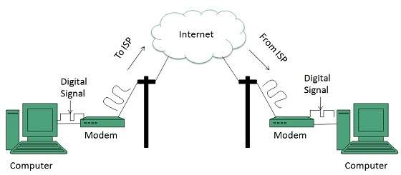**

A modem transforms data into a signal so that it can be sent and received over a cable, phone line, or satellite connection. A modem is an asynchronous tool that is capable of transmitting data in the form of small packets. Once the data is received, the system that secures it takes the packets and reassembles the data. Before, when the phone line was the best way to access the Internet, the modem transforms the data from analog to digital for two-way communication between networks. With today's high-speed digital modems, there is no need to do the analog to digital conversion. The term "modem" is formed from the combination of modulation and demodulation. These are the technical terms used for the conversion that happens between analog and digital signals.

Dial-Up Modems As mentioned earlier, dial-up modems change data from analog to digital so that the data can be transmitted from the telephone lines to the computers. The external dial-up modem is plugged into a telephone line at one end and a computer on the other end. The internal dial-up modem is integrated into the network by the computer makers. When you use a dial-up modem to connect to a network, you will be hearing sounds. It is similar to the sound you hear on the phone when you are dialing a phone number, then you will be hearing a squealing noise. This sound pattern will verify that the connection process is taking place. The more modern models of dial-up modems can send data at 56,000 bps maximum rate. This is why they are also known as high-speed modems. The external broadband modems are plugged into a home gateway device or broadband router on one end, and the cable line or external internet interface is on the other end. The gateway or router leads the signals to all the devices in your home. Most Internet service providers give their customers modem hardware. Some Internet service providers charge a monthly fee while others include it for free as part of the package.

**4.1.6. Describe Address Format And IP Address**

**IP Address Format And Table**

IP address is a short form of "Internet Protocol Address." It is a unique number provided to every device connected to the internet network, such as Android phone, laptop, Mac, etc. An IP address is represented in an integer number separated by a dot (.), for example, 192.167.12.46.

## Types of IP Address

An IP address is categorized into two different types based on the number of IP address it contains. These are:

* IPv4 (Internet Protocol version 4)
* IPv6 (Internet Protocol version 6)

### What is IPv4?

IPv4 is version 4 of IP. It is a current version and the most commonly used [IP](https://www.javatpoint.com/ip)

address. It is a 32-bit address written in four numbers separated by a dot (.), i.e., periods. This address is unique for each device. For example, 66.94.29.13

### What is IPv6?

IPv4 produces 4 billion addresses, and the developers think that these addresses are enough, but they were wrong. IPv6 is the next generation of IP addresses. The main difference between IPv4 and IPv6 is the address size of IP addresses. The IPv4 is a 32-bit address, whereas IPv6 is a 128-bit hexadecimal address. IPv6 provides a large address space, and it contains a simple header as compared to IPv4.

## P Address Format

Originally IP addresses were divided into five different categories called **classes**. These divided IP classes are class A, class B, class C, class D, and class E. Out of these, classes A, B, and C are most important. Each address class defines a different number of bits for its **network prefix (network address)** and **host number (host address)**. The starting address bits decide from which class an address belongs.

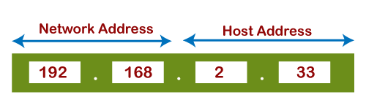

**Network Address:** The network address specifies the unique number which is assigned to your network. In the above figure, the network address takes two bytes of IP address.

**Host Address:** A host address is a specific address number assigned to each host machine. With the help of the host address, each machine is identified in your network. The network address will be the same for each host in a network, but they must vary in host address.

### Address Format IPv4

The address format of IPv4 is represented into **4-octets** (32-bit), which is divided into three different classes, namely class A, class B, and class C.

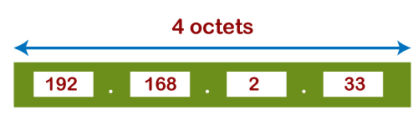

The above diagram shows the address format of IPv4. An IPv4 is a 32-bit decimal address. It contains four octets or fields separated by 'dot,' and each field is 8-bit in size. The number that each field contains should be in the range of 0-255.

### Class A

**Class A** address uses only first higher order octet (byte) to identify the network prefix, and remaining three octets (bytes) are used to define the individual host addresses. The class A address ranges between 0.0.0.0 to 127.255.255.255. The first bit of the first octet is always set to 0 (zero), and next 7 bits determine network address, and the remaining 24 bits determine host address. So the first octet ranges from 0 to 127 (00000000 to 01111111).

### Class B

**Class B** addresses use the initial two octets (two bytes) to identify the network prefix, and the remaining two octets (two bytes) define host addresses. The class B addresses are range between 128.0.0.0 to 191.255.255.255. The first two bits of the first higher octet is always set to 10 (one and zero bit), and next 14 bits determines the network address and remaining 16 bits determines the host address. So the first octet ranges from 128 to 191 (10000000 to 10111111).

**Class C**

**Class C** addresses use the first three octets (three bytes) to identify the network prefix, and the remaining last octet (one byte) defines the host address. The class C address ranges between 192.0.0.0 to 223.255.255.255. The first three bit of the first octet is always set to 110, and next 21 bits specify network address and remaining 8 bits specify the host address. Its first octet ranges from 192 to 223 (11000000 to 11011111).

**Class D**

**Class D** IP address is reserved for multicast addresses. Its first four bits of the first octet are always set to 1110, and the remaining bits determine the host address in any IP address. The first higher octet bits are always set to 1110, and the remaining bits specify the host address. The class D address ranges between 224.0.0.0 to 239.255.255.255. In multicasting, data is not assigned to any particular host machine, so it is not require to find the host address from the IP address, and also, there is no subnet mask present in class D.

**Class E**

**Class E** IP address is reserved for experimental purposes and future use. It does not contain any subnet mask in it. The first higher octet bits are always set to 1111, and next remaining bits specify the host address. Class E address ranges between 240.0.0.0 to 255.255.255.255.

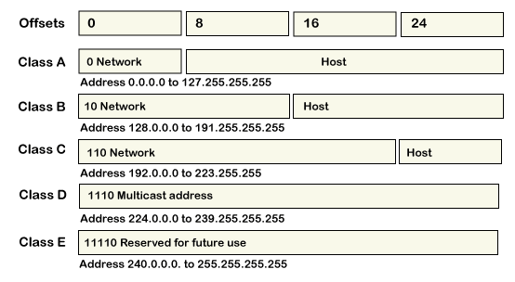

## IP Address Table

On the basis of ranges, IP addresses are categorized into five address classes which are given below.

|  |  |  |  |  |  |  |
| --- | --- | --- | --- | --- | --- | --- |
| **Class** | **Higher bits** | **Network address bits** | **Host address bits** | **No.of networks** | **No.of hosts per network** | **Range** |
| A | 0 | 8 | 24 | 27 | 224 | 0.0.0.0 to 125.255.255.255 |
| B | 10 | 16 | 16 | 214 | 216 | 128.0.0.0 to 191.255.255.255 |
| C | 110 | 24 | 8 | 221 | 28 | 192.0.0.0 to 223.255.255.255 |
| D | 1110 | Not defined and reserved for future | Not defined and reserved for future | Not defined and reserved for future | Not defined and reserved for future | 224.0.0.0 to 239.255.255.255 |
| E | 1111 | Not defined and reserved for future | Not defined and reserved for future | Not defined and reserved for future | Not defined and reserved for future | 240.0.0.0 to 255.255.255.255 |

**4.1.7. What Is Browser And List Various Browsers**

Web Browsers are software installed on your PC. To access the Web, you need a web browser, such as Netscape Navigator, Microsoft Internet Explorer or Mozilla Firefox.

Currently you must be using any sort of Web browser while you are navigating through our site tutorialspoint.com. On the Web, when you navigate through pages of information, this is commonly known as web browsing or web surfing.

There are four leading web browsers − Explorer, Firefox, Netscape, and Safari, but there are many others browsers available. You might be interested in knowing Complete Browser Statistics. Now we will see these browsers in bit more detail.

While developing a site, we should try to make it compatible to as many browsers as possible. Especially sites should be compatible to major browsers like Explorer, Firefox, Chrome, Netscape, Opera, and Safari.

## Internet ExplorerInternet Explorer

Internet Explorer (IE) is a product from software giant Microsoft. This is the most commonly used browser in the universe. This was introduced in 1995 along with Windows 95 launch and it has passed Netscape popularity in 1998.

## Internet ExplorerGoogle Chrome

This web browser is developed by Google and its beta version was first released on September 2, 2008 for Microsoft Windows. Today, chrome is known to be one of the most popular web browser with its global share of more than 50%.

## Internet ExplorerMozilla Firefox

Firefox is a new browser derived from Mozilla. It was released in 2004 and has grown to be the second most popular browser on the Internet.

## Safari BrowserSafari

Safari is a web browser developed by Apple Inc. and included in Mac OS X. It was first released as a public beta in January 2003. Safari has very good support for latest technologies like XHTML, CSS2 etc.

## Opera BrowserOpera

Opera is smaller and faster than most other browsers, yet it is full- featured. Fast, user-friendly, with keyboard interface, multiple windows, zoom functions, and more. Java and non Java-enabled versions available. Ideal for newcomers to the Internet, school children, handicap and as a front-end for CD-Rom and kiosks.

## Konqueror BrowserKonqueror

Konqueror is an Open Source web browser with HTML 4.01 compliance, supporting Java applets, JavaScript, CSS 1, CSS 2.1, as well as Netscape plugins. This works as a file manager as well as it supports basic file management on local UNIX filesystems, from simple cut/copy and paste operations to advanced remote and local network file browsing.

## Lynx BrowserLynx

Lynx is a fully-featured World Wide Web browser for users on Unix, VMS, and other platforms running cursor-addressable, character-cell terminals or emulators.

**4.1.8. Explain The Role Of Search Engines With Examples.**

Most of the time, people are confused between search engines and web browsers. For example, they mislead between Google and Chrome. They think Google and Chrome both are search engines or web browsers. But it is not correct. Google is a search engine, while Chrome is a [web browser](https://www.javatpoint.com/browsers)

For the brief, Google, Yahoo, and Bing are popular [search engines](https://www.javatpoint.com/how-search-engine-works)

## What is search engine?

A search engine

is a software program, which is designed to perform web searches on the World Wide Web (www)

. You can call the search engines as an **answering machine**. Search engines discover, process and organize internet content and provide it to users when searching for any information.

* A search engine is a platform on which a user can search the internet content.
* **Google, Yahoo, Bing, Baidu**, and **DuckDuckGo** are popular search engines. Google is one of the most used search engines worldwide that is used with the Chrome browser. So, almost everyone is familiar with it.
* According to the research, around 92.16% of searches are happening on Google, 2.18 on Bing, 1.52 on Yahoo, 1.14 on Baidu, and so on.

## How Does A Search Engine Work?

The three important tasks are performed by a search engine when a user search for anything on it: **Crawling, Indexing**, and **Ranking**.

Whenever a user searches for information on Google, he/she needs to type a query in the search bar. The search engine crawls the thousands of web pages on behalf of the user using their own crawlers.

**Note:** The web crawlers are commonly referred to as the search engine spiders or bots.

**Crawl:** Scour the internet for data.

**Index:** This process stores and organizes the content that is found from the crawling process. Basically, this step indexes the web pages which are relevant for the user's query to be displayed.

**Rank:** This process ranks the best content at the top, which is the best answer for the user's query. It means that the most relevant result shows on top of the web.

## Top 10 search engines

In this chapter, we have a list of the top 10 search engines. These search engines are put in the sequence according to their rank in popularity and usage. Search engines are listed by the statistics of Stat counter.

1. Google
2. Bing
3. Yahoo
4. Baidu
5. DuckDuckGo
6. Yandex
7. Ask.com
8. Ecosia
9. AOL
10. Internet Archive

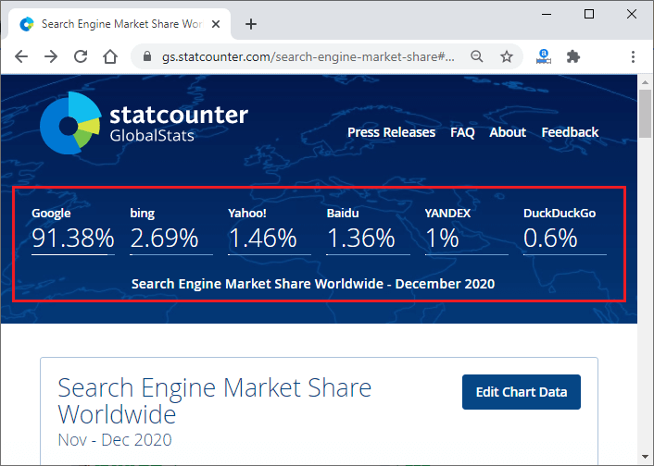

**4.1.9. Explain Internet Security.**

## Introduction

## What is internet security? - Definition and meaning

Internet security is a term that describes security for activities and transactions made over the internet. It’s a particular component of the larger ideas of cyber security and computer security, involving topics including browser security, online behavior and network security. We spend a large proportion of our lives online, and some of the internet security threats we can encounter include:

* Hacking, where unauthorized users gain access to computer systems, email accounts, or websites.
* Viruses or malicious software (known as malware) which can damage data or make systems vulnerable to other threats.
* Identity theft, where criminals can steal personal and financial information.

Individuals and organizations can protect themselves from these kinds of threats by practicing internet security.

## What are the most common internet security threats?

To ensure privacy and security on the internet, it’s important to be aware of different types of internet attacks. Common internet security threats include:

### Phishing

Phishing is a cyber-attack involving disguised emails. Hackers try to trick email recipients into believing that a message is genuine and relevant – a request from their bank or a note from a co-worker, for example – so that they click on a link or open an attachment. The goal is to deceive people into handing over their personal information or downloading malware.

Phishing is one of the oldest internet security threats, dating back to the 1990s. It has remained popular to this day since it is one of the cheapest and easiest ways for criminals to steal information. In recent years, phishing techniques and messages have become increasingly sophisticated.

### Hacking and remote access

Hackers are always looking to exploit a private network or system's vulnerabilities so they can steal confidential information and data. Remote access technology gives them another target to exploit. Remote access software allows users to access and control a computer remotely – and since the pandemic, with more people working remotely, its usage has increased.

The protocol which allows users to control a computer connected to the internet remotely is called Remote Desktop Protocol, or RDP. Because businesses of all sizes so widely use RDP, the chances of an improperly secured network are relatively high. Hackers use different techniques to exploit RDP vulnerabilities until they have full access to a network and its devices. They may carry out data theft themselves or else sell the credentials on the dark web.

### Malware and malvertising

Malware is a portmanteau of "malicious" and "software". It's a broad term related to viruses, worms, trojans, and other harmful programs that hackers use to cause havoc and steal sensitive information. Any software intended to damage a computer, server, or network can be described as malware.

Malvertising is a portmanteau of “malicious” and “advertising”. The term refers to online advertising, which distributes malware. Online advertising is a complex ecosystem involving publisher websites, ad exchanges, ad servers, retargeting networks, and content delivery networks. Malvertisers exploit this complexity to place malicious code in places that publishers and ad networks don’t always detect. Internet users who interact with a malicious ad could download malware onto their device or be redirected to malicious websites.

### Ransomware

Ransomware is a type of malware that prevents you from using your computer or accessing specific files on your computer unless a ransom is paid. It is often distributed as a trojan – that is, malware disguised as legitimate software. Once installed, it locks your system’s screen or certain files until you pay.

Because of their perceived anonymity, ransomware operators typically specify payment in cryptocurrencies such as [Bitcoin](https://www.kaspersky.com/resource-center/definitions/what-is-bitcoin). Ransom prices vary depending on the ransomware variant and the price or exchange rate of digital currencies. It isn’t always the case that if you pay, the criminals will release the encrypted files.

Ransomware attacks are on the rise, and new ransomware variants continue to emerge. Some of the most talked-about ransomware variants include [Maze](https://www.kaspersky.com/resource-center/definitions/what-is-maze-ransomware), Conti, GoldenEye, Bad Rabbit, Jigsaw, Locky, and [WannaCry](https://www.kaspersky.com/resource-center/threats/ransomware-wannacry).

### Botnets

The term [botnet](https://www.kaspersky.com/resource-center/threats/botnet-attacks) is a contraction of “robot network”. A botnet is a network of computers that have been intentionally infected by malware so they can carry out automated tasks on the internet without the permission or knowledge of the computers’ owners.

Once a botnet’s owner controls your computer, they can use it to carry out malicious activities. These include:

* Generating fake internet traffic on third party websites for financial gain.
* Using your machine’s power to assist in Distributed Denial of Service (DDoS) attacks to shut down websites.
* Emailing spam to millions of internet users.
* Committing fraud and identity theft.
* Attacking computers and servers.

Computers become part of a botnet in the same ways that they are infected by any other type of malware – for example, opening email attachments that download malware or visiting websites infected with malware. They can also spread from one computer to another via a network. The number of bots in a botnet varies and depends on the ability of the botnet owner to infect unprotected devices.

### Wi-Fi threats, in public and at home

Public Wi-Fi carries risks because the security on these networks – in coffee shops, shopping malls, airports, hotels, restaurants, and so on – is often lax or non-existent. The lack of security means that cybercriminals and identity thieves can monitor what you are doing online and steal your passwords and personal information. Other public Wi-Fi dangers include:

* **Packet sniffing** – attackers monitor and intercept unencrypted data as it travels across an unprotected network.
* **Man-in-the-middle-attacks** – attackers compromise a Wi-Fi hotspot to insert themselves into communications between the victim and the hotspot to intercept and modify data in transit.
* **Rogue Wi-Fi networks** – attackers set up a [honeypot](https://www.kaspersky.com/resource-center/threats/what-is-a-honeypot) in the form of free Wi-Fi to harvest valuable data. The attacker’s hotspot becomes the conduit for all data exchanged over the network.

You don't have to worry so much about someone spying on the Wi-Fi network at home because you own the network hardware. But there are still threats – in the US, internet service providers (ISPs) are allowed to sell data about their users. While the data is anonymized, it can still be an unsettling thought for those who value privacy and security on the internet. A VPN at home makes it much harder for outsiders to correlate your online activity to you.

**5.0 Emerging Trends in Computer Technology**

**5.1. Introduction to Machine Learning**

**Definition of Machine Learning:** Arthur Samuel, an early American leader in the field of computer gaming and artificial intelligence, coined the term “Machine Learning ” in 1959 while at IBM. He defined machine learning as “the field of study that gives computers the ability to learn without being explicitly programmed “. However, there is no universally accepted definition for machine learning. Different authors define the term differently. We give below two more definitions.

* Machine learning is programming computers to optimize a performance criterion using example data or past experience . We have a model defined up to some parameters, and learning is the execution of a computer program to optimize the parameters of the model using the training data or past experience. The model may be predictive to make predictions in the future, or descriptive to gain knowledge from data.
* The field of study known as machine learning is concerned with the question of how to construct computer programs that automatically improve with experience.

**Definition of learning:** A computer program is said to *learn* from experience E with respect to some class of tasks T and performance measure P , if its performance at tasks T, as measured by P , improves with experience E.

**Examples**

* Handwriting recognition learning problem
* Task T :  Recognizing and classifying handwritten words within images
* Performance P : Percent of words correctly classified
* Training experience E : A dataset of handwritten words with given classifications
* A robot driving learning problem
  + Task T : Driving on highways using vision sensors
  + Performance P : Average distance traveled before an error
  + Training experience E : A sequence of images and steering commands recorded while observing a human driver

**Definition:** A computer program which learns from experience is called a machine learning program or simply a learning program .

**5.1.1. Define Machine Learning, Compare Traditional Programming with Machine Learning**

Traditional computer programming has been around for more than a century, with the first known computer program dating back to the mid 1800s. **Traditional Programming**refers to any manually created program that uses input data and runs on a computer to produce the output.

But for decades now, an advanced type of programming has revolutionized business, particularly in the areas of intelligence and embedded analytics. In **Machine Learning** programming, also known as augmented analytics, the input data and output are fed to an algorithm to create a program. This yields powerful insights that can be used to predict future outcomes.

**Here’s a closer comparison of traditional programming versus machine learning:**

## ****Traditional Programming****

Traditional programming is a manual process—meaning a person (programmer) creates the program. But without anyone programming the logic, one has to manually formulate or code rules.

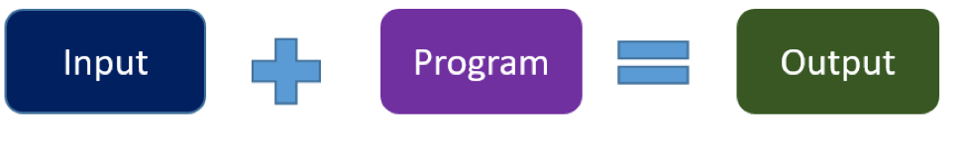

In machine learning, on the other hand, the algorithm automatically formulates the rules from the data.

## ****Machine Learning Programming****

Unlike traditional programming, machine learning is an automated process. It can increase the value of your embedded analytics in many areas, including data prep, natural language interfaces, automatic outlier detection, recommendations, and causality and significance detection. All of these features help speed user insights and reduce decision bias.

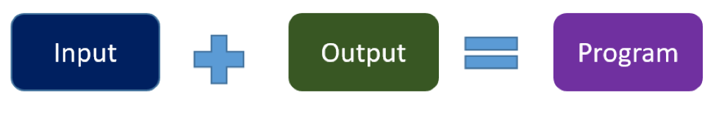

For example, if you feed in customer demographics and transactions as input data and use historical customer churn rates as your output data, the algorithm will formulate a program that can predict if a customer will churn or not. That program is called a **predictive model**.

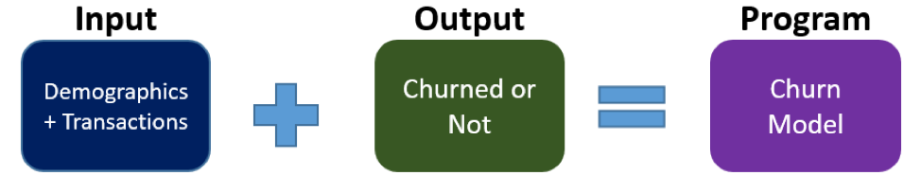

You can use this model to predict business outcomes in any situation where you have input and historical output data:

1. Identify the business question you would like to ask.
2. Identify the historical input.
3. Identify the historically observed output (i.e., data samples for when the condition is true and for when it’s false).

For instance, if you want to predict who will pay the bills late, identify the input (customer demographics, bills) and the output (pay late or not), and let the machine learning use this data to create your model.

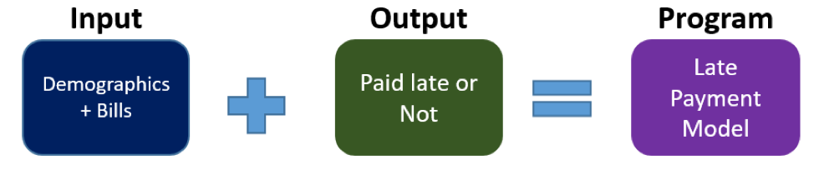

As you can see, machine learning can turn your business data into a financial asset. You can point the algorithm at your data so it can learn powerful rules that can be used to predict future outcomes. It’s no wonder predictive analytics is now the number one capability on product roadmaps.

**5.1.2. List the applications and key elements of Machine Learning**

**Applications of Machine learning**

Machine learning is a buzzword for today's technology, and it is growing very rapidly day by day. We are using machine learning in our daily life even without knowing it such as Google Maps, Google assistant, Alexa, etc. Below are some most trending real-world applications of Machine Learning:

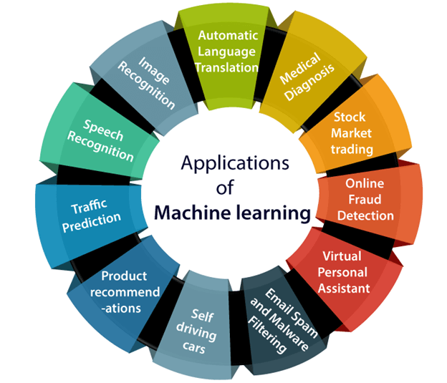

### 1. Image Recognition:

Image recognition is one of the most common applications of machine learning. It is used to identify objects, persons, places, digital images, etc. The popular use case of image recognition and face detection is,

**Automatic friend tagging suggestion**:

Face book provides us a feature of auto friend tagging suggestion. Whenever we upload a photo with our Facebook friends, then we automatically get a tagging suggestion with name, and the technology behind this is machine learning's **face detection** and **recognition algorithm**.

It is based on the Facebook project named "**Deep Face**," which is responsible for face recognition and person identification in the picture.

**2. Speech Recognition**

While using Google, we get an option of "**Search by voice**," it comes under speech recognition, and it's a popular application of machine learning.

Speech recognition is a process of converting voice instructions into text, and it is also known as "**Speech to text**", or "**Computer speech recognition**." At present, machine learning algorithms are widely used by various applications of speech recognition. **Google assistant**, **Siri**, **Cortana**, and **Alexa** are using speech recognition technology to follow the voice instructions.

**3. Traffic prediction:**

If we want to visit a new place, we take help of Google Maps, which shows us the correct path with the shortest route and predicts the traffic conditions.

It predicts the traffic conditions such as whether traffic is cleared, slow-moving, or heavily congested with the help of two ways:

* **Real Time location** of the vehicle form Google Map app and sensors
* **Average time has taken** on past days at the same time.

Everyone who is using Google Map is helping this app to make it better. It takes information from the user and sends back to its database to improve the performance.

**4. Product recommendations:**

Machine learning is widely used by various e-commerce and entertainment companies such as **Amazon**, **Netflix**, etc., for product recommendation to the user. Whenever we search for some product on Amazon, then we started getting an advertisement for the same product while internet surfing on the same browser and this is because of machine learning.

Google understands the user interest using various machine learning algorithms and suggests the product as per customer interest.

As similar, when we use Netflix, we find some recommendations for entertainment series, movies, etc., and this is also done with the help of machine learning.

**5. Self-driving cars:**

One of the most exciting applications of machine learning is self-driving cars. Machine learning plays a significant role in self-driving cars. Tesla, the most popular car manufacturing company is working on self-driving car. It is using unsupervised learning method to train the car models to detect people and objects while driving.

**6. Email Spam and Malware Filtering:**

Whenever we receive a new email, it is filtered automatically as important, normal, and spam. We always receive an important mail in our inbox with the important symbol and spam emails in our spam box, and the technology behind this is Machine learning. Below are some spam filters used by Gmail:

* Content Filter
* Header filter
* General blacklists filter
* Rules-based filters
* Permission filters

Some machine learning algorithms such as **Multi-Layer Perceptron**, **Decision tree**, and **Naïve Bayes classifier** are used for email spam filtering and malware detection.

**7. Virtual Personal Assistant:**

We have various virtual personal assistants such as **Google assistant**, **Alexa**, **Cortana**, **Siri**. As the name suggests, they help us in finding the information using our voice instruction. These assistants can help us in various ways just by our voice instructions such as Play music, call someone, Open an email, Scheduling an appointment, etc.

These virtual assistants use machine learning algorithms as an important part.

**8. Online Fraud Detection:**

Machine learning is making our online transaction safe and secure by detecting fraud transaction. Whenever we perform some online transaction, there may be various ways that a fraudulent transaction can take place such as **fake accounts**, **fake ids**, and **steal money** in the middle of a transaction. So to detect this, **Feed Forward Neural network** helps us by checking whether it is a genuine transaction or a fraud transaction.

For each genuine transaction, the output is converted into some hash values, and these values become the input for the next round. For each genuine transaction, there is a specific pattern which gets change for the fraud transaction hence, it detects it and makes our online transactions more secure.

**9. Stock Market trading:**

Machine learning is widely used in stock market trading. In the stock market, there is always a risk of up and downs in shares, so for this machine learning's **long short term memory neural network** is used for the prediction of stock market trends.

**10. Medical Diagnosis:**

In medical science, machine learning is used for diseases diagnoses. With this, medical technology is growing very fast and able to build 3D models that can predict the exact position of lesions in the brain.

It helps in finding brain tumors and other brain-related diseases easily.

**11. Automatic Language Translation:**

Nowadays, if we visit a new place and we are not aware of the language then it is not a problem at all, as for this also machine learning helps us by converting the text into our known languages. Google's GNMT (Google Neural Machine Translation) provide this feature, which is a Neural Machine Learning that translates the text into our familiar language, and it called as automatic translation.

The technology behind the automatic translation is a sequence to sequence learning algorithm, which is used with image recognition and translates the text from one language to another language.

**5.1.3. Define the terms in relation to approaches to Machine Learning(Decision tree learning,**

**Association rule learning, Artificial neural networks, Deep Learning, Inductive Learning,**

**Genetic algorithms, Clustering)**

**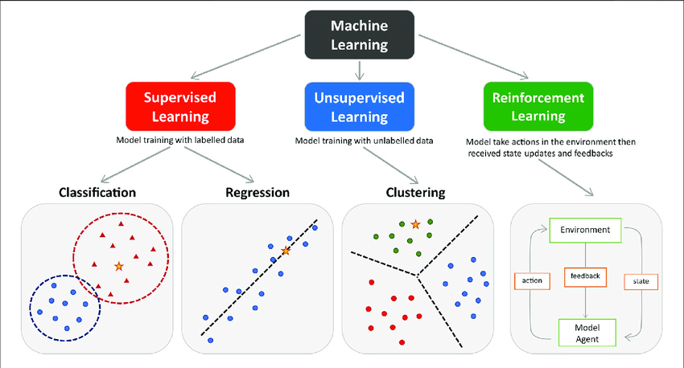**

There are many posts on KDnuggets covering the explanation of key terms and concepts in the areas of Data Science, Machine Learning, Deep Learning, Big Data, etc. In fact, it's one of the tasks that KDnuggets takes quite seriously: introducing and clarifying concepts in the minds of new and seasoned practitioners alike. In many of these posts, concepts and terminology are often expounded upon and fit into The Big Picture, sometimes miring down the key concept in exchange for defining some greater notion.

This is the first in a series of such posts on KDnuggets which will offer concise explanations of a related set of terms (**machine learning**, in this case), specifically taking a no-frills approach for those looking to isolate and define. After some thought, it was determined that these foundational-yet-informative types of posts have not been given enough exposure in the past, with future iterations likely to include:

* Deep Learning
* Natural Language Processing
* Databases
* Other interesting topics we can think of :)

# 1. Machine Learning

According to Mitchell, machine learning is "concerned with the question of how to construct computer programs that automatically improve with experience." Machine learning is interdisciplinary in nature, and employs techniques from the fields of computer science, statistics, and artificial intelligence, among others. The main artifacts of machine learning research are algorithms which facilitate this automatic improvement from experience, algorithms which can be applied in such diverse fields as computer vision, artificial intelligence, and data mining.

**2. Classification**

 Classification is concerned with building models that separate data into distinct classes. These models are built by inputting a set of training data for which the classes are pre-labeled in order for the algorithm to learn from. The model is then used by inputting a different dataset for which the classes are withheld, allowing the model to predict their class membership based on what it has learned from the training set. Well-known classification schemes include **decision trees** and **support vector machines**. As this type of algorithm requires explicit class labeling, classification is a form of **supervised learning**.

# 3. Regression

 Regression is very closely related to classification. While classification is concerned with the prediction of discrete classes, regression is applied when the "class" to be predicted is made up of continuous numerical values. **Linear regression** is an example of a regression technique.

**4. Clustering**

 Clustering is used for analyzing data which does not include pre-labeled classes, or even a class attribute at all. Data instances are grouped together using the concept of "maximizing the intraclass similarity and minimizing the interclass similarity," as concisely described by Han, Kamber & Pei. This translates to the clustering algorithm identifying and grouping instances which are very similar, as opposed to ungrouped instances which are much less-similar to one another. **k-means** clustering is perhaps the most well-known example of a clustering algorithm. As clustering does not require the pre-labeling of instance classes, it is a form of **unsupervised learning**, meaning that it learns by observation as opposed to learning by example.

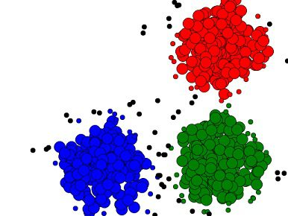

**5. Association**

Association is most easily explained by introducing market basket analysis, a typical task for which it is well-known. Market basket analysis attempts to identify associations between the various items that have been chosen by a particular shopper and placed in their market basket, be it real or virtual, and assigns support and confidence measures for comparison. The value of this lies in cross-marketing and customer behavior analysis. Association is a generalization of market basket analysis, and is similar to classification except that any attribute can be predicted in association. **Apriori** enjoys success as the most well-known example of an association algorithm. Association is another example of **unsupervised learning.**

**6. Decision Trees**

 Decision trees are top-down, recursive, divide-and-conquer classifiers. Decision trees are generally composed of 2 main tasks: tree induction and tree pruning. Tree induction is the task of taking a set of pre-classified instances as input, deciding which attributes are best to split on, splitting the dataset, and recurring on the resulting split datasets until all training instances are categorized. While building our tree, the goal is to split on the attributes which create the purest child nodes possible, which would keep to a minimum the number of splits that would need to be made in order to classify all instances in our dataset. This purity is measured by the concept of information, which relates to how much would need to be known about a previously-unseen instance in order for it to be properly classified.

A completed decision tree model can be overly-complex, contain unnecessary structure, and be difficult to interpret. Tree pruning is the process of removing the unnecessary structure from a decision tree in order to make it more efficient, more easily-readable for humans, and more accurate as well. This increased accuracy is due to pruning’s ability to reduce over fitting.

# 7. Support Vector Machines

 SVMs are able to classify both linear and nonlinear data. SMVs work by transforming the training dataset into a higher dimension, a higher dimension which is then inspected for the optimal separation boundary, or boundaries, between classes. In SVMs, these boundaries are referred to as hyper planes, which are identified by locating support vectors, or the instances that most essentially define classes, and their margins, which are the lines parallel to the hyper plane defined by the shortest distance between a hyper plane and its support vectors.

The grand idea with SVMs is that, with a high enough number of dimensions, a hyper plane separating 2 classes can always be found, thereby delineating dataset member classes. When repeated a sufficient number of times, enough hyper planes can be generated to separate all classes in n-dimension space.

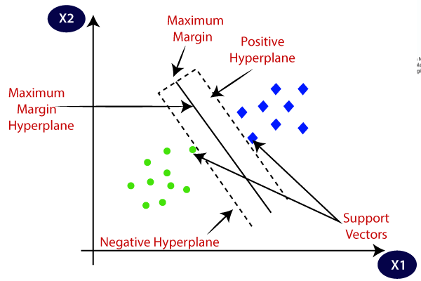

# 8. Neural Networks

 Neural networks are algorithms inspired by the biological brain, although the extent to which they capture actual brain functionality is highly controversial, and claims that they **model** the biological brain are patently false. Neural networks are made up of numerous interconnected conceptualized artificial neurons, which pass data between themselves, and which have associated weights which are tuned based upon the newtork's "experience." Neurons have activation thresholds which, if met by a combination of their associated weights and data passed to them, are fired; combinations of fired neurons result in "learning."

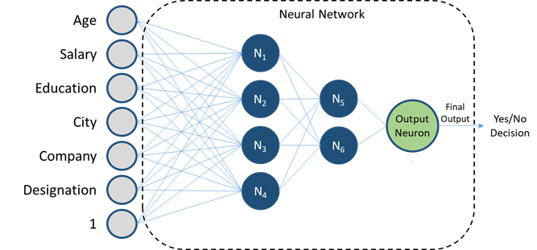

**9. Deep Learning**

 Deep learning is a relatively new term, although it has existed prior to the dramatic uptick in online searches of late. Enjoying a surge in research and industry, due mainly to its incredible successes in a number of different areas, deep learning is the process of applying deep neural network technologies - that is, neural network architectures with multiple hidden layers of neurons - to solve problems. Deep learning is a process, like data mining, which employs deep neural network architectures, which are particular types of machine learning algorithms.

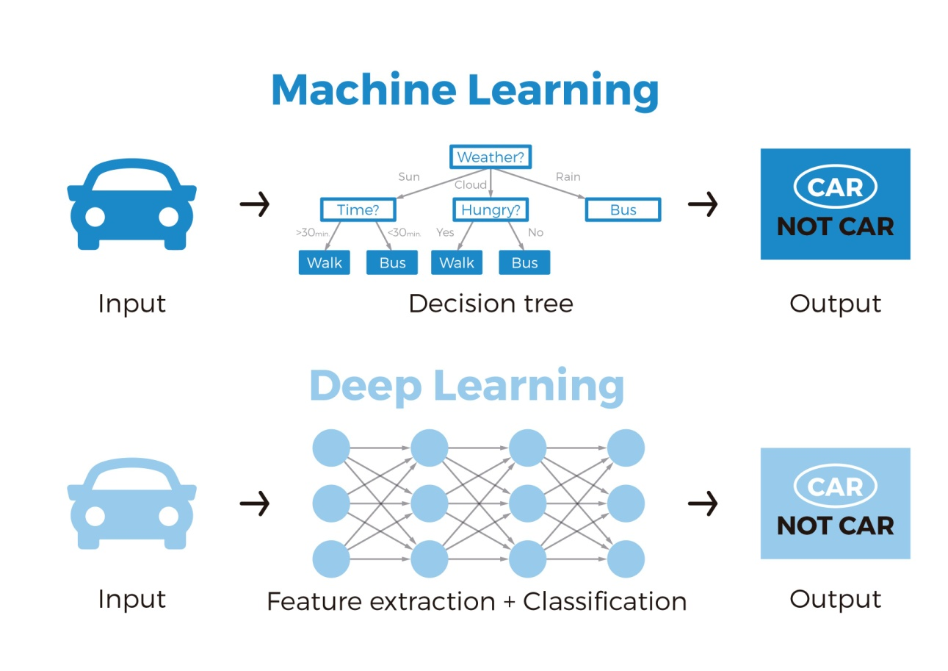

**5.1.4. Explain Inductive Learning**

Inductive Learning Algorithm (ILA) is an iterative and inductive machine learning algorithm which is used for generating a set of a classification rule, which produces rules of the form “IF-THEN”, for a set of examples, producing rules at each iteration and appending to the set of rules. **Basic Idea:** There are basically two methods for knowledge extraction firstly from domain experts and then with machine learning. For a very large amount of data, the domain experts are not very useful and reliable. So we move towards the machine learning approach for this work. To use machine learning One method is to replicate the experts logic in the form of algorithms but this work is very tedious, time taking and expensive. So we move towards the inductive algorithms which itself generate the strategy for performing a task and need not instruct separately at each step. **Need of ILA in presence of other machine learning algorithms:** The ILA is a new algorithm which was needed even when other reinforcement learning like ID3 and AQ were available.

* The need was due to the pitfalls which were present in the previous algorithms, one of the major pitfalls was lack of generalization of rules.
* The ID3 and AQ used the decision tree production method which was too specific which were difficult to analyze and was very slow to perform for basic short classification problems.
* The decision tree-based algorithm was unable to work for a new problem if some attributes are missing.
* The ILA uses the method of production of a general set of rules instead of decision trees, which overcome the above problems

**THE ILA ALGORITHM:** **General requirements at start of the algorithm:-**

1. list the examples in the form of a table ‘T’ where each row corresponds to an example and each column contains an attribute value.
2. create a set of m training examples, each example composed of k attributes and a class attribute with n possible decisions.
3. create a rule set, R, having the initial value false.
4. initially all rows in the table are unmarked.

**5.1.5. Classify the Machine Learning**

* What is a Classifier?
* Classification Algorithms

It used to be that you needed a data science and engineering background to use AI and machine learning, but new user-friendly tools and SaaS platforms make [machine learning](https://monkeylearn.com/machine-learning/) accessible to everyone.

Machine learning classifiers are one of the top uses of AI technology – to automatically analyze data, streamline processes, and gather valuable insights.

## What Is a Classifier in Machine Learning?

A classifier in machine learning is an algorithm that automatically orders or categorizes data into one or more of a set of “classes.” One of the most common examples is an email classifier that scans emails to filter them by class label: Spam or Not Spam.

Machine learning algorithms are helpful to automate tasks that previously had to be done manually. They can save huge amounts of time and money and make businesses more efficient.

### What’s the Difference Between a Classifier and a Model?

A classifier is the algorithm itself – the rules used by machines to classify data. A classification model, on the other hand, is the end result of your classifier’s machine learning. The model is trained using the classifier, so that the model, ultimately, classifies your data.

There are both supervised and unsupervised classifiers. Unsupervised machine learning classifiers are fed only unlabeled datasets, which they classify according to pattern recognition or structures and anomalies in the data. Supervised and semi-supervised classifiers are fed training datasets, from which they learn to classify data according to predetermined categories.

Sentiment analysis is an example of supervised machine learning where classifiers are trained to analyze text for opinion polarity and output the text into the class: Positive, Neutral, or Negative. Try out this pre-trained sentiment analysis model to see how it works.

Machine learning classifiers are used to automatically analyze customer comments (like the above) from social media, emails, online reviews, etc., to find out what customers are saying about your brand.

Other text analysis techniques, like topic classification, can automatically sort through customer service tickets or NPS surveys, categorize them by topic (Pricing, Features, Support, etc.), and route them to the correct department or employee.

SaaS text analysis platforms, like Monkey Learn, give easy access to powerful classification algorithms, allowing you to custom-build classification models to your needs and criteria, usually in just a few steps.

Machine learning classifiers go beyond simple data mapping, allowing users to constantly update models with new learning data and tailor them to changing needs. Self-driving cars, for example, use classification algorithms to input image data to a category; whether it’s a stop sign, a pedestrian, or another car, constantly learning and improving over time.

But what are the major classification algorithms and how do they work?

## 5 Types of Classification Algorithms

Depending on your needs and your data, these top 5 classification algorithms should have you covered.

* Decision Tree
* Naive Bayes Classifier
* K-Nearest Neighbors
* Support Vector Machines
* Artificial Neural Networks

**5.2. Introduction to Big data**

## What is Big Data?

**Big data** is a collection of large datasets that cannot be processed using traditional computing techniques. It is not a single technique or a tool, rather it has become a complete subject, which involves various tools, techniques and frameworks.

## What Comes Under Big Data?

Big data involves the data produced by different devices and applications. Given below are some of the fields that come under the umbrella of Big Data.

* **Black Box Data** − It is a component of helicopter, airplanes, and jets, etc. It captures voices of the flight crew, recordings of microphones and earphones, and the performance information of the aircraft.
* **Social Media Data** − Social media such as Facebook and Twitter hold information and the views posted by millions of people across the globe.
* **Stock Exchange Data** − The stock exchange data holds information about the ‘buy’ and ‘sell’ decisions made on a share of different companies made by the customers.
* **Power Grid Data** − The power grid data holds information consumed by a particular node with respect to a base station.
* **Transport Data** − Transport data includes model, capacity, distance and availability of a vehicle.
* **Search Engine Data** − Search engines retrieve lots of data from different databases.

Thus Big Data includes huge volume, high velocity, and extensible variety of data. The data in it will be of three types.

* **Structured data** − Relational data.
* **Semi Structured data** − XML data.
* **Unstructured data** − Word, PDF, Text, Media Logs.

## Benefits of Big Data

* Using the information kept in the social network like Facebook, the marketing agencies are learning about the response for their campaigns, promotions, and other advertising mediums.
* Using the information in the social media like preferences and product perception of their consumers, product companies and retail organizations are planning their production.
* Using the data regarding the previous medical history of patients, hospitals are providing better and quick service.

**5.2.1. Define and list sources of Big data**

## The Sources of Big Data

The bulk of big data generated comes from three primary sources: social data, machine data and transactional data. In addition, companies need to make the distinction between data which is generated internally, that is to say it resides behind a company’s firewall, and externally data generated which needs to be imported into a system.  
Whether data is unstructured or structured is also an important factor. Unstructured data does not have a pre-defined data model and therefore requires more resources to make sense of it.

## The three primary sources of  Big Data

**Social data**comes from the Likes, Tweets & Retweets, Comments, Video Uploads, and general media that are uploaded and shared via the world’s favorite social media platforms. This kind of data provides invaluable insights into consumer behavior and sentiment and can be enormously influential in marketing analytics. The public web is another good source of social data, and tools like Google Trends can be used to good effect to increase the volume of big data.

**Machine data** is defined as information which is generated by industrial equipment, sensors that are installed in machinery, and even web logs which track user behavior. This type of data is expected to grow exponentially as the internet of things grows ever more pervasive and expands around the world. Sensors such as medical devices, smart meters, road cameras, satellites, games and the rapidly growing Internet Of Things will deliver high velocity, value, volume and variety of data in the very near future.

**Transactional data** is generated from all the daily transactions that take place both online and offline. Invoices, payment orders, storage records, delivery receipts – all are characterized as transactional data yet data alone is almost meaningless, and most organizations struggle to make sense of the data that they are generating and how it can be put to good use.

**5.2.2. Evolution of data/big data**

With the rising Big Data, Companies are moving towards Big Data tools and technologies. Everyone might want to know the history of big data. In this article, we will see the history of the present buzz “Big Data”.

The article will also cover the use cases of Big Data in different domains. You will also explore the different big data technologies adopted by companies for handling Big Data.

Let us start with the history of Big Data.

### History of Big Data

The history of big data starts many years before the present buzz around Big Data. Seventy years ago the first attempt to quantify the growth rate of data in the terms of volume of data was encountered. That has popularly been known as “**information explosion**“.

We will be covering some major milestones in the evolution of “big data”.

**1944:**

**Fremont Rider**, based upon his observation, speculated that Yale Library in 2040 will have “approximately 200,000,000 volumes, which will occupy over 6,000 miles of shelves… [requiring] a cataloging staff of over six thousand persons.”

**He did not predict the digitization of libraries but predicted the information explosion.**

From 1944 to 1980, many articles and presentations were presented that observed the ‘information explosion’ and the arising needs for storage capacity.

**1980:**

In 1980, the sociologist **Charles Tilly** uses the term big data in one sentence “none of the big questions has actually yielded to the bludgeoning of the big-data people.” in his article “The old-new social history and the new old social history”.

But the term used in this sentence is not in the context of the present meaning of Big Data today.

Now, moving fast to 1997-1998 where we see the actual use of big data in its present context.

**1997:**

In 1977, **Michael Cox and David Ellsworth** published the article “Application-controlled demand paging for out-of-core visualization” in the Proceedings of the IEEE 8th conference on Visualization.

The article uses the big data term in the sentence “Visualization provides an interesting challenge for computer systems: data sets are generally quite large, taxing the capacities of main memory, local disk, and even remote disk. We call this the problem of big data. When data sets do not fit in main memory (in core), or when they do not fit even on local disk, the most common solution is to acquire more resources.”.

**It was the first article in the ACM digital library that uses the term big data with its modern context.**

**1998:**

In 1998, **John Mashey**, who was Chief Scientist at SGI presented a paper titled “Big Data… and the Next Wave of Infrastress.” at a USENIX meeting. **John Mashey used this term in his various speeches and that’s why he got the credit for coining the term Big Data.**

**2000:**

In 2000, **Francis Diebold** presented a paper titled “’ Big Data’ Dynamic Factor Models for Macroeconomic Measurement and Forecasting” to the Eighth World Congress of the Econometric Society.

In the paper, he stated that “Recently, much good science, whether physical, biological, or social, has been forced to confront—and has often benefited from—the “Big Data” phenomenon.

Big Data refers to the explosion in the quantity (and sometimes, quality) of available and potentially relevant data, largely the result of recent and unprecedented advancements in data recording and storage technology.”

**He is the one who linked big data term explicitly to the way we understand big data today.**

**2001:**

In 2001, **Doug Laney**, who was an analyst with the Meta Group (Gartner), presented a research paper titled “3D Data Management: Controlling Data Volume, Velocity, and Variety.” The 3V’s have become the most accepted dimensions for defining big data.

**2005:**

In 2005, **Tim O’Reilly** published his groundbreaking article “What is Web 2.0?”. In this article, Tim O’Reilly states that the “data is the next Intel inside”.

O’Reilly Media explicitly used the term ‘Big Data’ to refer to the large sets of data which is almost impossible to handle and process using the traditional business intelligence tools.

**This is for sure the current widely understood form of Big data definition.**

In 2005 Yahoo used Hadoop to process petabytes of data which is now made open-source by Apache Software Foundation. Many companies are now using Hadoop to crunch Big Data.

The evolution of Big Data is explained in three phases.

1 Structured Data

2 HTTP Based Data

3 Sensor-Based Data

**1. Structured Data**

* The Database management system is the origin of Big Data and Data analytics. The techniques like storage, extraction, and optimization techniques used in Relational Database Management System were relied upon heavily by the Database management at that time. The first phase of Big Data evolution consisted of database management and database warehousing.
* Modern data analytics later formed as an evolution of the database management system. At the time it used techniques like database queries, database processing, and reporting tools.

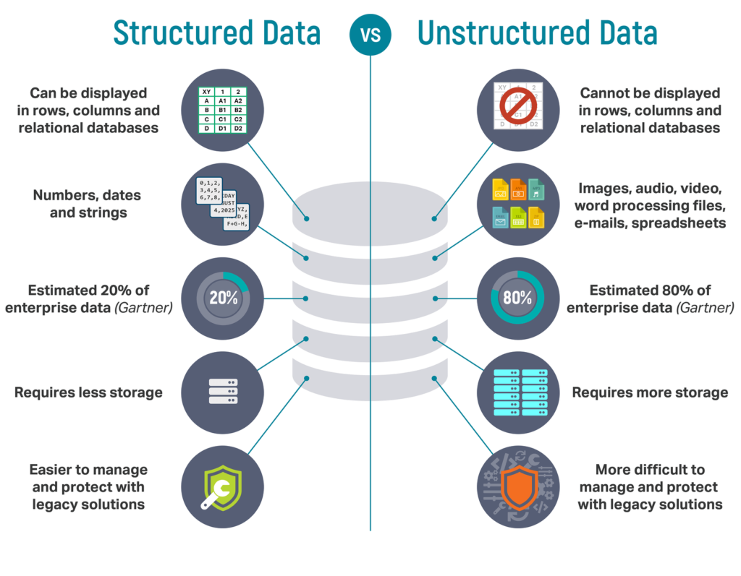

### 2.HTTP Based Data

The inception of the Internet and WWW started introducing vast new and unique opportunities in terms of data collection and analyses. The commercialization of personal computers by companies like Microsoft, Apple, and IBM, etc., and the availability of internet by internet providers made it easy for more people to access the internet which increased the web traffic through the roof.

This increase in web traffic brought new types of data collected and analyzed for various purposes. Search engines like Google, Yahoo, etc. helped collect data about trends in various industries. Similarly, the birth of social media platforms such as Facebook, Twitter, etc helped companies collect and analyze data about public behavior, consumer behavior, interests, etc. Thus, the opportunity to collect new types of data and resulting analyses opened possibilities beyond comprehension.

This massive increase in the amount of data by the ***HTTP-based web traffic*** was mostly semi-structured and unstructured data from a data analytics point of view. Due to this nature of data, the organizations needed to figure out new techniques to store, interpret, and analyze these new data types. The need to interpret the vast amount of data from social media platforms and eCommerce websites. They then convert them into meaningful information and became the need of the hour.

### 3.Sensor-Based Data

Many organizations in data analytics consider these semi/unstructured data as the focus. New opportunities to retrieve important data from mobile devices have created a whole new world of possibilities. The third phase of Big Data is dominated by biometric data by IoT devices. Devices like wearable activity trackers allow companies to track health-related data. Along with the user location tracking allows them to analyze much new useful information. Because of these internet-based sensor devices, the ***data generation*** is on a different level.

The sensors are embedded in all forms of machines. From daily appliances like washing machines, and refrigerators to cars, trucks to even warehouses to track the inventories. The possibilities of use of these data are endless. The best part is we have only begun to extract/analyze the information from these sources.

**5.2.3. List and explain the characteristics of big data – the three V‘s of big data**

If you are trying to get to grips with what is meant by big data but are finding it difficult, you’re not the only one. Big data is a common shorthand that many people don’t truly understand.

However, there is an easier way to understand it, by getting to know three main concepts.

**These are the 3 V’s of big data:** volume, velocity and variety. By fully understanding these concepts, you can get a better grasp of how big data can open doors for your business and how it can be used it to your advantage.

In this guide, we take a closer look at the 3V’s and how they relate to big data and how thy are very different from old data management processes.

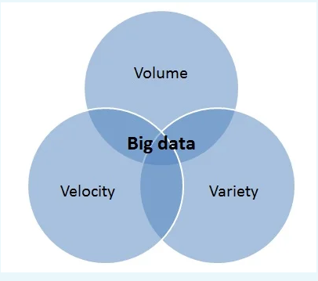

## ****Volume****

One of the key concepts to get to know when it comes to big data is **volume**.

There are a lot of companies and businesses that consume so much data, maybe because they have a lot of users or because they use [AI](https://www.optalitix.com/ai-companies/) to feed this data. This includes smart devices in our homes that are constantly learning and taking in their surroundings or something like Uber which has millions of customers at any time – and this is all adding lots of data to the mix.

To better explain this, let’s take a look at some real-life examples such as Facebook, that stores photographs.

Overall, it is thought Facebook stores a whopping 250 billion images in total. This isn’t even taking into account things such as Facebook posts – where there is thought to be approximately 2.5 trillion (and that is only from 2016 onwards).

## ****Velocity****

With big data, **velocity** refers to how quickly data is coming in. Using the Facebook example from earlier, whilst the social media giant stores 250 billion images, approximately 900 million photos are uploaded by its users each and every day.

With this colossal amount of data coming in every day, this has to be processed, filed and retrieved.

Another example of velocity is **sensor data**. With the Internet of Things taking off at a dramatic rate, we will be seeing more and more connected sensors. This will effectively mean more data being transmitted almost all the time.

## Variety

The third sector of big data is **variety**. When discussing variety in reference to big data, it means that the data can be very different from one application to another, much of it being unstructured data too.

All of the data does not necessarily fit into one neat database application as it may have in the past.

A clear example of variety in big data are emails. Messages are never identical to another, as each has its own destination, time stamp, possible attachments and different text. Emails, like audio recordings, videos and photos are all data that tends to be very varied and unstructured too.

**5.2.4. Describe Storing and selecting of Big Data**

## Big Data storage methods

There are currently two well-established big data storage methods:

**Warehouse Storage** – Similar to a warehouse for storing physical goods, a data warehouse is a large building facility which its primary function is to store and process data on an enterprise level. It is an important tool for big data analytics. These large data warehouses support the various reporting, business intelligence (BI), analytics, data mining, research, cyber monitoring, and other related activities. These warehouses are usually optimized to retain and process large amounts of data at all times while feeding them in and out through online servers where users can access their data without delay.

Data warehouse tools make it possible to manage data more efficiently as it enables being able to find, access, visualize and analyze data to make better business decisions and achieve more desirable business results. Additionally, they are built with the consideration of exponential data growth in mind. There is no risk of the warehouses being cluttered up by the increasing amount of data that is being stored.

The greatest benefit of data warehouses is the ability to translate raw data into information and insight. Data warehouses offer an effective way to support queries, analytics, reporting, as well as providing forecasts and trends based the collected data. Design and data cleansing must be supported by the right storage. Normally, data warehouses depend on large storage capacities that are robust, have lower costs, and perform well.

You might have heard of the term ‘ Hadoop’ being thrown around every once in a while but still don’t know what it is, which is fine. Although it is an entire topic on its own, we’ll explain it briefly. Hadoop is a software framework meant for distributed storage and processing of big data to handle massive amounts of data and computation. Hadoop revolutionizes big data analytics for enterprise storage. However, if you want to read more in-depth on Hadoop and its implications.

**Cloud Storage** – The other method of storing massive amounts of data is cloud storage, which is something more people are familiar with. If you have ever used iCloud or Google Drive, this means you were using cloud storage to store your documents and files. With cloud storage, data and information are stored electronically online where it can be accessed from anywhere, negating the need for direct attached access to a hard drive or computer. With this approach, you can store virtually boundless amount of data online and access it where.

The cloud provides not only readily-available infrastructure, but also the ability to scale this infrastructure quickly to manage large increases in traffic or usage.

The cloud also provides easy accessibility and usability. When you want to access your data in the cloud, all you need to do is enter your credentials and you will have access. All you need is an internet connection and a device for accessing the cloud such as a mobile phone or laptop computer. Cloud storage has greatly improved productivity and efficiency of businesses as employees are able to instantaneously share, access, and edit files remotely.

In addition to the previous benefits, cloud storage is also significantly cheaper than the physical storage of data. Data warehouses consume large amounts of power, space, resources and come with more risk. However, with cloud storage, a substantial amount of cost is saved.

**5.2.5. State the Need of Big Data**

In today’s world, social applications are extensively used. It results in rapid data growth.

On social media platforms, billions of users connect daily, users share information, upload images, videos, and many more. This rising Big Data is not an overhead anymore. Companies are using this it to achieve growth and defeat their competitors.

Here arises the question of **why Big Data is important for companies and** What is its importance?

The article first explains what is Big Data. Then we will see its importance. We will learn why companies are adopting these technologies to analyze and store vast amounts of Data.

[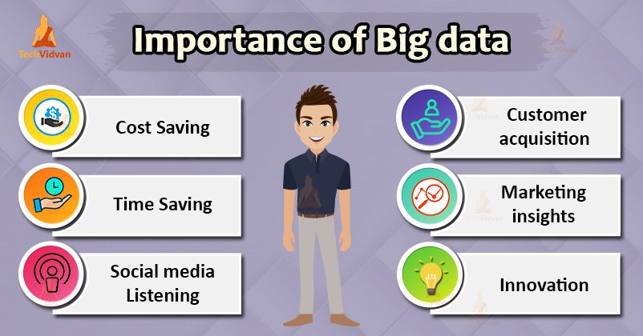](https://techvidvan.com/tutorials/wp-content/uploads/sites/2/2020/04/importance-of-big-data.jpg)

Let us first start with the Big data introduction.

**Why Big Data?**

Big Data initiatives were rated as “extremely important” to 93% of companies. Leveraging a Big Data analytics solution helps organizations to unlock the strategic values and take full advantage of their assets.

It helps organizations:

* To understand Where, When and Why their customers buy
* Protect the company’s client base with improved loyalty programs
* Seizing cross-selling and upselling opportunities
* Provide targeted promotional information
* Optimize Workforce planning and operations
* Improve inefficiencies in the company’s supply chain
* Predict market trends
* Predict future needs
* Make companies more innovative and competitive
* It helps companies to discover new sources of revenue

Companies are using Big Data to know what their customers want, who are their best customers, why people choose different products. The more a company knows about its customers, the more competitive it becomes.

We can use it with Machine Learning for creating market strategies based on predictions about customers. Leveraging big data makes companies customer-centric.

Companies can use Historical and real-time data to assess evolving consumers’ preferences. This consequently enables businesses to improve and update their marketing strategies which make companies more responsive to customer needs.

Let us now explore the reason why Big data is important?

### Importance of Big data

Big Data importance doesn’t revolve around the amount of data a company has. Its importance lies in the fact that how the company utilizes the gathered data.

Every company uses its collected data in its own way. More effectively the company uses its data, more rapidly it grows.

The companies in the present market need to collect it and analyze it because:

#### 1. Cost Savings

Big Data tools like Apache Hadoop, Spark, etc. bring cost-saving benefits to businesses when they have to store large amounts of data. These tools help organizations in identifying more effective ways of doing business.

#### 2. Time-Saving

Real-time in-memory analytics helps companies to collect data from various sources. Tools like Hadoop help them to analyze data immediately thus helping in making quick decisions based on the learnings.

#### 3. Understand the market conditions

Big Data analysis helps businesses to get a better understanding of market situations.

For example, analysis of customer purchasing behavior helps companies to identify the products sold most and thus produces those products accordingly. This helps companies to get ahead of their competitors.

#### 4. Social Media Listening

Companies can perform sentiment analysis using Big Data tools. These enable them to get feedback about their company, that is, who is saying what about the company.

Companies can use Big data tools to improve their online presence.

**5.2.6. List types of tools used in Big Data**

Big Data has become an integral part of any business for improving decision making and gaining a competitive edge over others. Therefore, Big Data technologies, such as [Apache Spark](https://www.upgrad.com/blog/apache-spark-tutorial-beginners/) and Cassandra are in high demand. Companies are looking for professionals who are skilled in using them to make the most out of the data generated within the organization.

These data tools help in handling huge data sets and identifying patterns and trends within them. So, if you are planning to get into the Big Data industry, you have to equip yourself with these tools.

## ****Big Data Tools & Technologies****

### ****1. Apache Storm****

Apache Storm is a real-time distributed tool for processing data streams. It is written in Java and Clojure, and can be integrated with any programming language. The software was developed by Nathan Marz and was later acquired by Twitter in 2011. The basic features of Storm are as follows:

* Has massive scalability
* It can process over a million jobs on the node within fractions of seconds
* Real-time data processing
* Storm topology runs until the user shuts it down or an unexpected technical failure occurs
* It guarantees the processing of every tuple
* It can run on JVM (Java Virtual Machine)
* Apache Storm supports (DAG) Direct Acrylic Graph topology
* Being open-source, flexible and robust, it can be used by medium and large-scale organizations
* It has low latency. Performs end-to-end delivery response and data refresh in seconds, depending on the data problem
* Storm guarantees data processing even if the messages are lost or nodes of the cluster die

The Apache Storm topologies are like a MapReduce job. But, here the data is processed in real-time instead of batch processing in [Apache Spark](https://www.upgrad.com/blog/apache-storm-overview/).

Storm UI daemon offers you a REST API through which you can do the following:

* Interact with the Storm cluster and obtain metrics data
* Start/stop topologies and configure information
* Even if a failure happens, each node is processed at least once

All this make Storm one of the leading Big Data technologies at present.

**2. MongoDB**

This is an open-source NoSQL database that is an advanced alternative to modern databases. It is a document-oriented database used for storing large volumes of data. Instead of rows and columns used in traditional databases, you will make use of documents and collections.

Documents consist of key-value pairs and the collections have function and document sets. MongoDB is ideal for companies who need to take quick decisions and want to work with real-time data. The Big Data technology is commonly used for storing data obtained from mobile applications, product catalogues and content management systems.

**ome of the most popular reasons for getting started with MongoDB are:**

* As it stores data in documents, it is very flexible and can be easily adapted by companies
* It supports many ad-hoc queries, such as searching by a field name, regular expressions and range queries. You can execute queries for returning fields in a document
* All fields of a MongoDB document can be indexed for enhancing the quality of searches
* It is great at load balancing as it splits data across MongoDB instances. The technology can run on several servers, and also duplicates data for load balancing in case a technical failure occurs
* You can store data of any type, such as integer, strings, Booleans, arrays and objects
* As this technology uses dynamic schemas, you can store and prepare data quickly, thus saving cost. Learn more about the [real time applications of MongoDB.](https://www.upgrad.com/blog/mongodb-real-world-use-cases/)

### ****3. Cassandra****

Cassandra is a distributed database management system that is used for handling large volumes of data across several servers. This is one of the most popular Big Data technologies which is preferred for processing structured data sets. It was first developed by Facebook as a NoSQL solution. It is now used by corporate giants, such as Netflix, Twitter and Cisco.

**The most exciting features of Cassandra include:**

* It provides an easy to use query language, so it will be hassle-free if you want to transition from a relational database to Cassandra
* Its Masterclass architecture allows data to be read and written on any node
* Data is replicated on different nodes, so there is no single point of failure. Even if a node fails to work, data stored on other nodes will be available for use
* Data can also be replicated across multiple data centres. So, if data is lost or damaged in one data centre, it can be retrieved from other data centres
* It has built-in security features, such as restore mechanisms and data backup
* This tool allows the detection and recovery of failed nodes

Cassandra is now widely used in [IoT real world applications](https://www.upgrad.com/blog/top-iot-real-world-applications/) where huge streams of data are coming from devices and sensors. It is widely used for social media analytics and while handling customer data.

### ****4. Cloudera****

Cloudera is one of the fastest and most secure Big Data technologies out there right now. It was initially developed as an open-source Apache Hadoop distribution that was aimed at enterprise-class deployments. This scalable platform allows you to get data from any environment very easily.

**The best features why choosing Cloudera will be great for your project are:**

* Offers real-time insights for data monitoring and detection
* You can deploy Cloudera Enterprise across various cloud platforms, such as AWS, Google Cloud and Microsoft Azure
* Cloudera has the capability of developing and training data models
* You can spin or terminate data clusters. This allows you to pay for only what you need and when you require it
* Offers an enterprise-level hybrid cloud solution

Cloudera offers software, support and service in five bundles that are available across multiple cloud providers and on-premise:

* Cloudera Enterprise Data Hub
* Cloudera Analytic DB
* Cloudera Operational DB
* Cloudera Data Science and Engineering
* Cloudera Essentials

**5. OpenRefine**

OpenRefine is a powerful Big Data tool that is used for cleaning data and converting it into different formats. You can explore huge data sets using this tool comfortably. The prominent features of this tool are:

* You can extend your data set to various web services
* Import data in different formats
* Handle cells with multiple data values and perform cell transformations
* You can use Refine Expression Language to perform advanced data operations
* The tool allows you to explore huge data sets easily within a matter of seconds

**5.2.7. List applications of big data**

In today’s world, there are a lot of data. Big companies utilize those data for their business growth. By analyzing this data, the useful decision can be made in various cases as discussed below:

**1. Tracking Customer Spending Habit, Shopping Behavior:** In big retails store (like Amazon, Walmart, Big Bazar etc.) management team has to keep data of customer’s spending habit (in which product customer spent, in which brand they wish to spent, how frequently they spent), shopping behavior, customer’s most liked product (so that they can keep those products in the store). Which product is being searched/sold most, based on that data, production/collection rate of that product get fixed.

Banking sector uses their customer’s spending behavior-related data so that they can provide the offer to a particular customer to buy his particular liked product by using bank’s credit or debit card with discount or cashback. By this way, they can send the right offer to the right person at the right time.

**2. Recommendation:** By tracking customer spending habit, shopping behavior, Big retails store provide a recommendation to the customer. E-commerce site like Amazon, Walmart, Flipkart does product recommendation. They track what product a customer is searching, based on that data they recommend that type of product to that customer.

As an example, suppose any customer searched bed cover on Amazon. So, Amazon got data that customer may be interested to buy bed cover. Next time when that customer will go to any google page, advertisement of various bed covers will be seen. Thus, advertisement of the right product to the right customer can be sent.

YouTube also shows recommend video based on user’s previous liked, watched video type. Based on the content of a video, the user is watching, relevant advertisement is shown during video running. As an example suppose someone watching a tutorial video of Big data, then advertisement of some other big data course will be shown during that video.

**3. Smart Traffic System:** Data about the condition of the traffic of different road, collected through camera kept beside the road, at entry and exit point of the city, GPS device placed in the vehicle (Ola, Uber cab, etc.). All such data are analyzed and jam-free or less jam way, less time taking ways are recommended. Such a way smart traffic system can be built in the city by Big data analysis. One more profit is fuel consumption can be reduced.

**4. Secure Air Traffic System:** At various places of flight (like propeller etc) sensors present. These sensors capture data like the speed of flight, moisture, temperature, other environmental condition. Based on such data analysis, an environmental parameter within flight are set up and varied. By analyzing flight’s machine-generated data, it can be estimated how long the machine can operate flawlessly when it to be replaced/repaired.

**5. Auto Driving Car:** Big data analysis helps drive a car without human interpretation. In the various spot of car camera, a sensor placed, that gather data like the size of the surrounding car, obstacle, distance from those, etc. These data are being analyzed, then various calculation like how many angles to rotate, what should be speed, when to stop, etc carried out. These calculations help to take action automatically.

**6. Virtual Personal Assistant Tool:** Big data analysis helps virtual personal assistant tool (like Siri in Apple Device, Cortana in Windows, Google Assistant in Android) to provide the answer of the various question asked by users. This tool tracks the location of the user, their local time, season, other data related to question asked, etc. Analyzing all such data, it provides an answer.

As an example, suppose one user asks “Do I need to take Umbrella?”, the tool collects data like location of the user, season and weather condition at that location, then analyze these data to conclude if there is a chance of raining, then provide the answer.

**7. IoT:**

* Manufacturing company install IOT sensor into machines to collect operational data. Analyzing such data, it can be predicted how long machine will work without any problem when it requires repairing so that company can take action before the situation when machine facing a lot of issues or gets totally down. Thus, the cost to replace the whole machine can be saved.
* In the Healthcare field, Big data is providing a significant contribution. Using big data tool, data regarding patient experience is collected and is used by doctors to give better treatment. IoT device can sense a symptom of probable coming disease in the human body and prevent it from giving advance treatment. IoT Sensor placed near-patient, new-born baby constantly keeps track of various health condition like heart bit rate, blood presser, etc. Whenever any parameter crosses the safe limit, an alarm sent to a doctor, so that they can take step remotely very soon.

**8. Education Sector:** Online educational course conducting organization utilize big data to search candidate, interested in that course. If someone searches for YouTube tutorial video on a subject, then online or offline course provider organization on that subject send ad online to that person about their course.

**9. Energy Sector:** Smart electric meter read consumed power every 15 minutes and sends this read data to the server, where data analyzed and it can be estimated what is the time in a day when the power load is less throughout the city. By this system manufacturing unit or housekeeper are suggested the time when they should drive their heavy machine in the night time when power load less to enjoy less electricity bill.

**10. Media and Entertainment Sector:** Media and entertainment service providing company like Netflix, Amazon Prime, Spotify do analysis on data collected from their users. Data like what type of video, music users are watching, listening most, how long users are spending on site, etc are collected and analyzed to set the next business strategy.

**5.3. Basics of Ethical Hacking**

Data plays an essential role in our lives. We each consume and produce huge amounts of information each day, and it can be used in industries as diverse as healthcare, banking, marketing, and many more. However, such sensitive information needs to be protected, which is where ethical hacking comes in useful. But what is ethical hacking?

Here, we take a closer look at the practice, including what it is, why it’s useful, and how you can learn ethical hacking. We’ll also explore some of the job roles and salaries available to those with the necessary hacking skills.

## ****What is hacking?****

Before we get into ethical hacking, let’s look at one of the key concepts that underlie the practice. In basic terms, hacking is the process of gaining unauthorized access to data that’s held on a computer, system or network.

Hackers, or those who practice hacking, will access systems in a way that the creator or holder did not intend. Although the typical connotation of hacking and hackers is a negative one, it can actually be a beneficial process, as we shall see.

## ****What is ethical hacking?****

Ethical hacking is the process where a professional hacker legally and deliberately tries to break into the computers and devices of an organization. In doing so, ethical hackers can test the organization's defenses, highlighting any vulnerabilities in their systems and networks.

Of course, it’s a detailed and often complex process, with many different elements to consider. An ethical hacker, sometimes known as a white-hat hacker, will look for weaknesses in a variety of different ways. They will also perform a variety of other tasks linked to general cyber security. This can include:

* Assessing vulnerabilities
* Penetration testing
* Gathering intelligence about entry points
* Scanning infrastructures to spot weaknesses
* Accessing systems/networks and exploiting vulnerabilities
* Hiding their access and evading detection
* Compiling reports and analysis for the attempts

**5.3.1. Define Ethical Hacking and List the categories of Hackers**

**Hacking** is the activity of identifying weaknesses in a computer system or a network to exploit the security to gain access to personal data or business data. An example of computer hacking can be: using a password cracking algorithm to gain access to a computer system.

Computers have become mandatory to run a successful businesses. It is not enough to have isolated computers systems; they need to be networked to facilitate communication with external businesses. This exposes them to the outside world and hacking. System hacking means using computers to commit fraudulent acts such as fraud, privacy invasion, stealing corporate/personal data, etc. Cyber crimes cost many organizations millions of dollars every year. Businesses need to protect themselves against such attacks.

## Who is a Hacker?

A **Hacker** is a person who finds and exploits the weakness in computer systems and/or networks to gain access. Hackers are usually skilled computer programmers with knowledge of computer security.

## Types of Hackers

Hackers are classified according to the intent of their actions. The following list classifies types of hackers according to their intent:

|  |  |
| --- | --- |
| **Symbol** | **Description** |
| White hat hacker | **Ethical Hacker (White hat):** A security hacker who gains access to systems with a view to fix the identified weaknesses. They may also perform penetration [Testing](https://www.guru99.com/software-testing.html) and vulnerability assessments. |
| Black hat hacker | **Cracker (Black hat):** A hacker who gains unauthorized access to computer systems for personal gain. The intent is usually to steal corporate data, violate privacy rights, transfer funds from bank accounts etc. |
| Grey hat hacker | **Grey hat:** A hacker who is in between ethical and black hat hackers. He/she breaks into computer systems without authority with a view to identify weaknesses and reveal them to the system owner. |
| Script kiddies | **Script kiddies:** A non-skilled person who gains access to computer systems using already made tools. |
| Hacktivist | **Hacktivist:** A hacker who use hacking to send social, religious, and political, etc. messages. This is usually done by hijacking websites and leaving the message on the hijacked website. |
| Phreaker | **Phreaker:** A hacker who identifies and exploits weaknesses in telephones instead of computers. |

**5.3.2. Describe Roles and responsibilities of Ethical Hackers**

## Ethical Hacker Roles and Responsibilities:

* **In-depth Knowledge of Security:** Ethical hackers should be well versed with potential threats and vulnerabilities that can hack organizational systems. Ethical hackers are hired by organizations for their expertise skills and quick resolution to security vulnerabilities. They should be cyber security professionals having knowledge of the computer systems, network and security.
* **Think like Hackers:** The primary role of Ethical hackers is to attack the system like hackers, without adopting authorized methods. They are supposed to think like hackers who want to steal confidential data /information. Ethical hackers look for areas that are most likely to be attacked and the different ways in which attack can take place.
* **In-depth Knowledge of the Organization they intend to provide Service:** Ethical hackers should be well versed with the services of the functional working of the organization they are associated with. It should have the knowledge about the information that is extremely safe and needs to be protected. Ethical hackers should be capable of finding the attack methods for accessing the sensitive content of the organization.

### ****Ethical Hackers Responsibilities:****

* **Hacking their own Systems:** Ethical hackers hack their own systems to find potential threats and vulnerabilities. They are hired to find vulnerabilities of the system before they are discovered by hackers.
* **Diffuse the intent of Hackers:** Ethical hackers are hired as a Precaution Step towards Hackers, who aim at breaching the security of computers. Vulnerabilities when detected early can be fixed and safe confidential information from being exposed to hackers who have malicious intentions.
* **Document their Findings:** Ethical hackers must properly document all their findings and potential threats. The main part of the work they are hired by the organizations is proper reporting of bugs and vulnerabilities which are threat to the security.
* **Keeping the Confidential Information Safe:** Ethical hackers must oblige to keep all their findings secure and never share them with others. Under any kind of situation they should never agree to share their findings and observations.
* **Sign Non-Disclosure Agreements:** They must sign confidential agreements to keep the information they have about the organizations safe with them. This will prevent them to give -out confidential information and legal action will be taken against them if they indulge in any such acts.
* **Handle the loopholes in Security:** Based on their observations, Ethical hackers should restore/ repair the security loopholes. This will prevent hackers from breaching the security of the organization from attacks.

**5.3.3. List And Explain The Phases In Ethical Hacking And Explain Penetrate Testing**

A penetration test (pen test) is an authorized simulated attack performed on a computer system to evaluate its security. Penetration testers use the same tools, techniques, and processes as attackers to find and demonstrate the business impacts of weaknesses in a system. Penetration tests usually simulate a variety of attacks that could threaten a business. They can examine whether a system is robust enough to withstand attacks from authenticated and unauthenticated positions, as well as a range of system roles. With the right scope, a pen test can dive into any aspect of a system.

## What Are The Benefits Of Penetration Testing?

Ideally, software and systems were designed from the start with the aim of eliminating dangerous security flaws. A pen test provides insight into how well that aim was achieved. Pen testing can help an organization

* Find weaknesses in systems
* Determine the robustness of controls
* Support compliance with data privacy and security regulations (e.g., PCI DSS, HIPAA, GDPR)
* Provide qualitative and quantitative examples of current security posture and budget priorities for management

## How Much Access Is Given To Pen Testers?

Depending on the goals of a pen test, testers are given varying degrees of information about, or access to, the target system. In some cases, the pen testing team takes one approach at the start and sticks with it. Other times, the testing team evolves its strategy as its awareness of the system increases during the pen test. There are three levels of pen test access.

* **Opaque box.** The team doesn’t know anything about the internal structure of the target system. It acts as hackers would, probing for any externally exploitable weaknesses.
* **Semi-opaque box.** The team has some knowledge of one or more sets of credentials. It also knows about the target’s internal data structures, code, and algorithms. Pen testers might construct test cases based on detailed design documents, such as architectural diagrams of the target system.
* **Transparent box.** Pen testers have access to systems and system artifacts including source code, binaries, containers, and sometimes even the servers running the system. This approach provides the highest level of assurance in the smallest amount of time.

**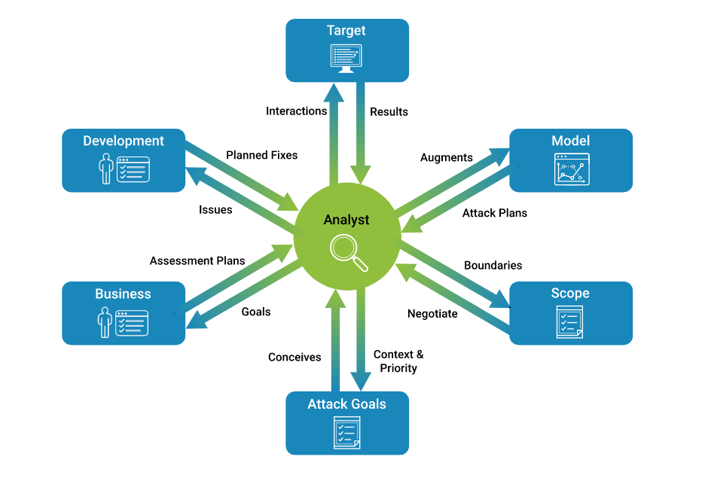**

## What Are The Phases Of Pen Testing?

Pen testers simulate attacks by motivated adversaries. To do this, they typically follow a plan that includes the following steps:

* **Reconnaissance.** Gather as much information about the target as possible from public and private sources to inform the attack strategy. Sources include internet searches, domain registration information retrieval, social engineering, nonintrusive network scanning, and sometimes even dumpster diving. This information helps pen testers map out the target’s attack surface and possible vulnerabilities. Reconnaissance can vary with the scope and objectives of the pen test; it can be as simple as making a phone call to walk through the functionality of a system.
* **Scanning.** Pen testers use tools to examine the target website or system for weaknesses, including open services, application security issues, and open source vulnerabilities. Pen testers use a variety of tools based on what they find during reconnaissance and during the test.
* **Gaining access.** Attacker motivations can include stealing, changing, or deleting data; moving funds; or simply damaging a company’s reputation. To perform each test case, pen testers determine the best tools and techniques to gain access to the system, whether through a weakness such as SQL injection or through malware, social engineering, or something else.
* **Maintaining access.** Once pen testers gain access to the target, their simulated attack must stay connected long enough to accomplish their goals of exfiltrating data, modifying it, or abusing functionality. It’s about demonstrating the potential impact.

## What Are The Types Of Pen Testing?

A comprehensive approach to pen testing is essential for optimal risk management. This entails testing all the areas in your environment.

* **Web apps.** Testers examine the effectiveness of security controls and look for hidden vulnerabilities, attack patterns, and any other potential security gaps that can lead to a compromise of a web app.
* **Mobile apps.** Using both automated and extended manual testing, testers look for vulnerabilities in application binaries running on the mobile device and the corresponding server-side functionality. Server-side vulnerabilities include session management, cryptographic issues, authentication and authorization issues, and other common web service vulnerabilities.
* **Networks.** This testing identifies common to critical security vulnerabilities in an external network and systems. Experts employ a checklist that includes test cases for encrypted transport protocols, SSL certificate scoping issues, use of administrative services, and more.
* **Cloud.** A cloud environment is significantly different than traditional on-premises environments. Typically, security responsibilities are shared between the organization using the environment and the cloud services provider. Because of this, cloud pen testing requires a set of specialized skills and experience to scrutinize the various aspects of the cloud, such as configurations, APIs, various databases, encryption, storage, and security controls.
* **Containers.** Containers obtained from Docker often have vulnerabilities that can be exploited at scale. Misconfiguration is also a common risk associated with containers and their environment. Both of these risks can be uncovered with expert pen testing.
* **Embedded devices (IoT).** Embedded / Internet of Things (IoT) devices such as medical devices, automobiles, in-home appliances, oil rig equipment, and watches have unique software testing requirements due to their longer life cycles, remote locations, power constraints, regulatory requirements, and more. Experts perform a thorough communication analysis along with a client/server analysis to identify defects that matter most to the relevant use case.
* **Mobile devices.** Pen testers use both automated and manual analysis to find vulnerabilities in application binaries running on the mobile device and the corresponding server-side functionality. Vulnerabilities in application binaries can include authentication and authorization issues, client-side trust issues, misconfigured security controls, and cross-platform development framework issues. Server-side vulnerabilities can include session management, cryptographic issues, authentication and authorization issues, and other common web service vulnerabilities.
* **APIs.** Both automated and manual testing techniques are used to cover the OWASP API Security Top 10 list. Some of the security risks and vulnerabilities testers look for include broken object level authorization, user authentication, excessive data exposure, lack of resources / rate limiting, and more.
* **CI/CD pipeline.** Modern DevSecOps practices integrate automated and intelligent code scanning tools into the CI/CD pipeline. In addition to static tools that find known vulnerabilities, automated pen testing tools can be integrated into the CI/CD pipeline to mimic what a hacker can do to compromise the security of an application. Automated CI/CD pen testing can discover hidden vulnerabilities and attack patterns that go undetected with static code scanning.

## What are the pros and cons of pen testing?

With the frequency and severity of security breaches increasing year after year, organizations have never had a greater need for visibility into how they can withstand attacks. Regulations such as PCI DSS and HIPAA mandate periodic pen testing to remain current with their requirements. With these pressures in mind, here are some pros and cons for this type of defect discovery technique.

**Pros of pen testing**

* Finds holes in upstream security assurance practices, such as automated tools, configuration and coding standards, architecture analysis, and other lighter-weight vulnerability assessment activities
* Locates both known and unknown software flaws and security vulnerabilities, including small ones that by themselves won’t raise much concern but could cause material harm as part of a complex attack pattern
* Can attack any system, mimicking how most malicious hackers would behave, simulating as close as possible a real-world adversary

**Cons of pen testing**

* Is labor-intensive and costly
* Does not comprehensively prevent bugs and flaws from making their way into production

**5.4. Virtual Reality concepts:**

### WHAT IS VIRTUAL REALITY?

**Virtual Reality (VR) is a computer-generated environment with scenes and objects that appear to be real, making the user feel they are immersed in their surroundings.** This environment is perceived through a device known as a Virtual Reality headset or helmet. VR allows us to immerse ourselves in video games as if we were one of the characters, learn how to perform heart surgery or improve the quality of sports training to maximize performance.

Although this may seem extremely futuristic, its origins are not as recent as we might think. In fact, many people consider that one of the first Virtual Reality devices was called Sensorama, a machine with a built-in seat that played 3D movies, gave off odors and generated vibrations to make the experience as vivid as possible. **The invention dates back as far as the mid-1950s.** Subsequent technological and software developments over the following years brought with them a progressive evolution both in devices and in interface design.

### Differences With Augmented Reality

Despite being a technology that originated decades ago, **many people are still unfamiliar with the concept of Virtual Reality.** It is also quite common to confuse the term Virtual Reality with augmented reality.

The main difference between the two is that VR builds the world in which we immerse ourselves through a specific headset**. It is fully immersive and everything we see is part of an environment artificially constructed through images, sounds, etc. On the other hand, in augmented reality (AR), our own world becomes the framework within which objects, images or similar are placed.** Everything we see is in a real environment and it may not be strictly necessary to wear a headset. The clearest and most mainstream example of this concept is Pokémon Go.

However, there is also a combination of both realities called mixed reality. This hybrid technology makes it possible, for example, to **see virtual objects in the real world and build an experience in which the physical and the digital are practically indistinguishable.**

### Main Applications Of Virtual Reality

That's enough about the theory that is projecting us into the future. Which sectors is Virtual Reality actually being used in today? Medicine, culture, education and architecture are some of the areas that have already taken advantage of this technology. From guided museum visits to the dissection of a muscle, VR allows us to cross boundaries that would otherwise be unimaginable.

### The Future Of Virtual Reality

Virtual Reality is one of the technologies with the highest projected potential for growth. According to the latest forecasts from IDC Research (2018**), investment in VR and AR will multiply 21-fold over the next four years, reaching 15.5 billion euros by 2022.** In addition, both technologies will be key to companies' digital transformation plans and their spending in this area will exceed that of the consumer sector by 2019. It is, **therefore expected that by 2020 over half of the larger European companies will have a VR and RA strategy.**

Nowadays, the market is demanding applications that go beyond leisure, tourism or marketing and are more affordable for users. Virtual interfaces also need to be improved to avoid defects such as clipping, which makes certain solid objects appear as though they can be passed through. Or to minimize the effects that VR produces in people, among them motion sickness, which consists of a dizziness induced by the mismatch between the movement of our body and what is being seen in the virtual world.

The big technology companies are already working to develop headsets that do not need cables and that allow images to be seen in HD. They are developing Virtual Reality headsets in 8K and with much more powerful processors. There is even talk that in the next few years they could integrate Artificial Intelligence. The latest 5G standard can also provide very interesting scenarios for the evolution of VR. This standard will allow **more devices and large user communities to be connected.** In addition, its almost imperceptible latency will make it possible for consumers to receive images in real time, almost as if they were seeing them with their own eyes.

All this means that Virtual Reality is no longer science fiction. It is integrated into our present and, in the coming years, it will lead to advances that will shape the future.

**5.4.1. Define the terms Virtual Reality, Telepresence, Cyberspace, Telexistence, HCI (Human-**

**Computer Interaction), Haptics, Hapticstechnologies, augmented reality and mixed reality**

The **definition of virtual reality** comes, naturally, from the definitions for both ‘virtual’ and ‘reality’. The definition of ‘virtual’ is near and reality is what we experience as human beings. So the term ‘virtual reality’ basically means ‘near-reality’. This could, of course, mean anything but it usually refers to a specific type of reality emulation.

We know the world through our senses and perception systems. In school we all learned that we have five senses: taste, touch, smell, sight and hearing. These are however only our most obvious sense organs. The truth is that humans have many more senses than this, such as a sense of balance for example. These other sensory inputs, plus some special processing of sensory information by our brains ensures that we have a rich flow of information from the environment to our minds.

Everything that we know about our reality comes by way of our senses. In other words, our entire experience of reality is simply a combination of sensory information and our brains sense-making mechanisms for that information. It stands to reason then, that if you can present your senses with made-up information, your perception of reality would also change in response to it. You would be presented with a version of reality that isn’t really there, but from your perspective it would be perceived as real. Something we would refer to as a virtual reality.

So, in summary, virtual reality entails presenting our senses with a computer generated virtual environment that we can explore in some fashion.

# What Is Telepresence Technology?

The advancement of technology comes a lot of change in the way we are able to communicate, connect and even go about business and execute our obligations. One such technology that has brought a revolution in the communications industry is telepresence. To the untrained most of the telecommunication technology that use video are one and the same thing. This is not entirely true. While for instance telepresence and video conferencing may have some similarities, they are not the same.

## So what is telepresence technology?

Telepresence technology is a set of robotic technology that provides stimuli to a user’s senses that makes them feel as though they are in or having an effect in another place other than their true location In telepresence technology, users have an opportunity to affect a remote location. A user can have their position, actions, and movements and even voiced transmitted to another location. The information in this sense is transmitted to and from between the user and remote location. One of the most popular and mainstream application of telepresence technology is telepresence video conferencing. This is the most sophisticated level of video telephony which allows a very improved sense of fidelity of both sound and sight than you will have in traditional video conferencing. It is quite interesting that mobile telephony technology has made it possible to move telepresence technology from the boardroom to allow the use of hand held devices despite the user’s location.

**what is Cyberspace**

Cyber space is the virtual computer world that could be an object that is floating around a computer network or system. Cyberspace has now extended to the global computer networks as well. Like for example, you would have sent an email to your friend. It means that you have sent a message through cyberspace.

1. What Exactly is Cyberspace?
2. What is the use of Cyberspace?

## 1) ****What Exactly Is Cyberspace?****

Let us delve deep into understanding whatCyber spaceactually is. Cyberspace is where users are allowed to share varied information, swap ideas and interact, play games, and engage in various social forums. They can conduct business here and indulge in various activities. It is any feature that is linked on the internet. Every kind of a virtual interface that creates some form of digital reality is cyberspace. Global content can be used for various purposes that could include entertainment and commerce. It is how human society makes it is what defines cyberspace. So what is cyberspace? Cyberspace exists when the stakeholders hold virtual meetings. The use of smart phones brings the sense that there is growth in cyberspace.

Also, massive gaming players online is an example of cyberspace. Here people do not sit face to face but get connected through the digital world. They look at their device from a remote location. Cyberspace also comes into the picture when there is language translation that occurs automatically in the blink of an eye.

In a nutshell, when you define cyberspace, cyberspace is everything that uses the internet. It is evolving and also promises to get more diverse as years come by.

## 2) ****What is the Use of Cyberspace?****

Now let us talk about what use cyberspace has for us. We live in an internet era and the indispensability of the internet is something that we cannot deny about. The expanding computer network, technologies, and the internet have evolved into what is known as cyberspace. It is a virtual environment where there is communication between computer networks.

Cyberspace brings in many uses. It lets you do everything possible through the internet. Be it education, military, finance, or even education today everything is connected to what is known as cyberspace. There is not a single sphere in our life that is not connected to social media.

The internet has made it efficient to store and to handle data. It has made man’s life organized and more systematic. Be it for e-banking or booking tickets or even to work online, cyberspace is everywhere.

**What Is Telexistence**

Telexistence is a fundamental concept which refers to the general technology that enables a human being to have a real-time sensation of being at a place other than where he or she actually exists, while being able to interact with the remote environment, which may be real, virtual, or a combination of both. It also refers to an advanced type of teleoperation system that enables an operator at the control to perform remote tasks dexterously with the feeling of existing in a surrogate robot working in a remote environment. Telexistence in the real remote environment through a virtual environment is also possible.

This book is the first book on telexistence written by the inventor of the concept of this emerging technology. It introduces the concept of telexistence, explains how this concept can be realized, illustrates precisely real examples of the realization of the concept, and determines its future advancement.

**what is Human- Computer Interaction**

HCI (human-computer interaction) is the study of how people interact with computers and to what extent computers are or are not developed for successful interaction with human beings. A significant number of major corporations and academic institutions now study HCI. Historically and with some exceptions, computer system developers have not paid much attention to computer ease-of-use. Many computer users today would argue that computer makers are still not paying enough attention to making their products "user-friendly." However, computer system developers might argue that computers are extremely complex products to design and make and that the demand for the services that computers can provide has always out driven the demand for ease-of-use.

One important HCI factor is that different users form different conceptions or mental models about their interactions and have different ways of learning and keeping knowledge and skills (different "cognitive styles" as in, for example, "left-brained" and "right-brained" people). In addition, cultural and national differences play a part. Another consideration in studying or designing HCI is that user interface technology changes rapidly, offering new interaction possibilities to which previous research findings may not apply. Finally, user preferences change as they gradually master new interfaces.

**What is Haptics**

* The haptics term comes from the greek “haptikos” meaning “concerning the sense of touch”. In the tech world haptics identifies all the technologies that provide the sensation of digital touch feedback, also called haptic feedback.
* Haptics is a particular technology because it is bidirectional. It involves an action (interaction) and a reaction (haptic feedback). Specifically, the action is the intention of the user to interact with an haptics-enabled content. The reaction is the haptic feedback that the digital content transmits to the user.
* This is one of the key aspects of haptics: interaction is almost as important as the haptic feedback. Haptics is successful when it is included in the design process of your applications.   
    
  Haptic feedback covers a wide range of possible stimulation embodiments but is broadly divided into tactile haptics technology and kinesthetic haptics technology. Tactile haptic feedback refers to sensations such as vibration, friction, or micro-deformation. Kinesthetic haptic feedback refers to sensations that provide force sensations that can stimulate both mechanical stimuli as well as stimuli related to the position and the movement of the body.

**What is Haptics technologies:**

Haptic technology is the use of tactile sensations to stimulate the sense of touch in a user experience. For example, direct applications of haptic solutions frequently include phone and game controller vibrations. Haptic science also involves any tactile feedback such as air pressure or sound waves.

Also known as 3D touch or kinaesthetic communication, this technology creates experiences using vibrations, motions, and other forces. Since touch is the most fundamental method of interaction, leveraging sensation within your products is fast becoming the newest approach for creating memorable brand experiences.

It is helpful to distinguish between haptic technology and two similar terms—haptics and haptic feedback.

* **Haptic technology** refers to the technical applications (virtual or physical) that create tactile stimulations.
* **Haptic feedback** comprises the methods in which haptic technology communicates tactile information to users.
* **Haptics** is the overarching umbrella term that describes the science of haptic feedback and haptic technology, in addition to neuroscience and physiology of touch.

**Augmented Reality**

Whereas virtual reality replaces your vision, augmented reality adds to it. AR devices, such as the Microsoft HoloLens and various enterprise-level "smart glasses," are transparent, letting you see everything in front of you as if you are wearing a weak pair of sunglasses.

The technology is designed for free movement, while projecting images over whatever you look at. The concept extends to smart phones with [AR apps](https://www.pcmag.com/news/the-coolest-ar-apps-for-your-iphone-or-ipad) and games, such as Pokemon Go, which use your phone's camera to track your surroundings and overlay additional information on top of it, on the screen.

AR displays can offer something as simple as a data overlay that shows the time, to something as complicated as holograms floating in the middle of a room. Pokemon Go projects a Pokemon on your screen, on top of whatever the camera is looking at. The HoloLens and other smart glasses, meanwhile, let you virtually place floating app windows and 3D decorations around you.

This technology has a distinct disadvantage compared with virtual reality: visual immersion. While VR completely covers and replaces your field of vision, AR apps only show up on your smartphone or tablet screen, and even the HoloLens can only project images in a limited area in front of your eyes. It isn't very immersive when a hologram disappears once it moves out of a rectangle in the middle of your vision, or when you must stare at a small screen while pretending that the object on that screen is in front of you.

**Mixed Reality**   
MR brings together real world and digital elements. In mixed reality, you interact with and manipulate both physical and virtual items and environments, using next-generation sensing and imaging technologies. Mixed Reality allows you to see and immerse yourself in the world around you even as you interact with a virtual environment using your own hands—all without ever removing your headset. It provides the ability to have one foot (or hand) in the real world, and the other in an imaginary place, breaking down basic concepts between real and imaginary, offering an experience that can change the way you game and work today.

**5.4.2. Discuss the evolution of Virtual Reality**

**What is Virtual Reality?**

The concept of virtual reality, while seemingly so entrenched in the 21st century, actually spans several decades beginning in the 1930s. The evolution from science fiction fantasy to, well, a reality, is fascinating. This excerpt from the report “*Virtual and Augmented Reality: Technologies and Global Markets*,” provides a timeline of several important highlights.

The concept of virtual reality dates back to the **1930s** when “Pygmalion’s Spectacles,” a story written by science fiction writer Stanley G. Weinbaum, presented the idea of a pair of goggles that let the wearer experience a fictional world through holographics – three-dimensional images created with photographic projection, taste, smell and touch. Stanley’s description of the experience for those wearing the goggles is uncannily like the modern and emerging experience of virtual reality, making him a creative inspiration for the field.

In the **mid-1950s**, cinematographer Morton Heilig developed the Sensorama, which was one of the earliest-known examples of immersive, multi-sensory (now known as multimodal) technology. It was a mechanical device that featured stereo speakers, a stereoscopic display, fans, smell generators and a vibrating chair.

In **1960**, Heilig’s Telesphere Mask became the first VR head-mounted display (HMD), providing stereoscopic 3D and wide vision with stereo sound. In 1961, two Philco Corporation engineers (Comeau and Bryan) developed Head sight, a television surveillance system incorporated with magnetic motion tracking connected to a closed-circuit camera and a video screen. Headsight was developed to allow the immersive viewing of an unpredictable situation by the military, but it was not actually developed for virtual reality applications. Head sight was the first step in the evolution of VR head-mounted displays, but the integration of computer and image generation was yet to be included.

In **1965**, Ivan Sutherland developed the Ultimate Display, a HMD system that could simulate reality to the point where one could not tell the difference between the real and virtual world. Sutherland’s concept included a virtual world that could be viewed through a head-mounted display and appeared realistic through 3D sound and tactile feedback. Computer hardware was used to create the virtual word and maintain it in real time, and users could interact with objects in the virtual world in a realistic way.

In **1968**, Sutherland, along with his student Bob Sproull, developed the [Sword of Damocles](https://en.wikipedia.org/wiki/The_Sword_of_Damocles_(virtual_reality)), the first AR/VR device, which featured a head-mounted display that hung from the ceiling. However, this technology was closer to virtual technology than augmented technology.

In **1969**, a virtual reality computer artist, Myron Krueger, now considered one of the first-generation virtual and augmented reality researchers, developed a series of experiences termed as artificial reality, in which he developed computer-generated environment that reacted to people. His projects were Glowflow, Metaplay and Psychic Space and led to development of the Video place technology. The purpose of this technology was to enable people to communicate with each other in a responsive computer-generated environment despite being miles apart.

Even after several changes in the development of virtual reality, the name was not used to describe the field until Jaron Lanier, founder of the Visual Programming Lab (VPL), coined the term “virtual reality” in 1987. Lanier, through VPL Research, developed a range of virtual reality gear that included the DataGlove and the EyePhone head-mounted display, which were major developments in the area of virtual reality.

In **1974**, Myron Krueger developed a projection system and video cameras called Video place, which produced shadows on a screen. It showcased the ability of being in an interactive environment for users. In 1990, the term “Augmented Reality” was coined by Tom Caudell, a Boeing researcher. Then in 1992, Louis Rosenburg, from the U.S. Air Force’s Armstrong Flight Research Center, created the first operative AR robotic system, which he called Virtual Fixtures. This was known as a premature version of today’s AR devices.

In the early **1990s**, virtual reality devices were commercially available, but the technology was still far too expensive for most people. The U.K.-based company Virtuality Group then launched a range of arcade games and machines with which players could wear a set of VR goggles and play on gaming machines with real-time immersive stereoscopic 3D visuals. In 1992, “The Lawnmower Man,” a science-fiction action-horror film directed by Brett Leonard, introduced the concept of virtual reality to a wider audience. A part of the movie was based on Jaron Lanier, the founder of virtual reality, and his early laboratory works. The actual virtual reality equipment from VPL Research labs was used in the film and the director, Brett Leonard, shared that he drew inspiration from companies like VPL.

In **1993**, Sega announced the Sega VR headset for the Sega Genesis console at the Consumer Electronics Show. The headset prototype had a head tracking device with wrap-around stereo sound and LCD screens. Sega intended to release the product at a price point of about $200 in 1993, which was equivalent to $322 in 2015. However, because of technical difficulties, the device remained in the prototype phase despite four games being developed for it.

In **1994**, Dancing in Cyberspace was the first theater production to use augmented reality. The theater presented acrobats on stage in and around virtual objects.

In **1995**, the Nintendo Virtual Boy, originally known as VR-32, was launched. It was a 3D gaming console that was promoted to be the first-ever portable console that could display true 3D graphics. The product was first released in Japan and North America at a price of $180, but it was a commercial failure despite price drops. The main reasons for this failure were the lack of graphics color (the games were only capable of displaying red graphics on a black background), lack of software support and difficulty using the console in a comfortable position. The following year, Nintendo discontinued its production and sale.

In **1998**, the 1st and Ten line computer system, which showed the original virtual yellow first down marker during a live National Football League game, was used by Sports vision; this is now a norm in all televised football games and represents a significant phase of AR history. Then in **1999**, NASA used AR technology to improve navigation through their X-38 spacecraft using a hybrid synthetic vision system.

In **1999**, Lana Wachowski and Lilly Wachowski, who are both American film directors, screenwriters and producers, directed the film “The Matrix.” The film portrays characters living in a fully simulated world, with many of them being completely unaware they do not live in the real world. “The Matrix” had a major cultural impact and brought the topic of simulated reality into the mainstream.

In **2000**, Hirokazu Kato, from the Nara Institute of Science and Technology in Japan, created AR software called ARToolKit. In 2009, ARToolKit made augmented reality available to Internet browsers.

AR technology has come a long way since its early conception, and advancements in the past several years have been even more encouraging. The last 15 years have seen several significant advancements in the development of virtual reality and augmented reality technology. Notably, compact and powerful mobile technologies have increased in prevalence while prices have simultaneously decreased.

The impressive growth of VR and AR in gaming and other applications has contributed significantly to the market over the last two decades. In **2014**, the acquisition of Oculus by Facebook was a game-changer for the VR industry. Major tech giants such as Google released interim virtual reality products like the DIY headset, which uses Google Cardboard and Google Daydream with smart phones. Companies like Samsung have taken this concept further with products such as Galaxy Gear, which contains smart features such as gesture control. It seems clear that the next few years will be key for the VR and AR industry. While these technologies have come a long way since their early conception, advancements in recent years have been even more encouraging.